Copium: Animated 2D Illustrations on the Study of Coping Mechanism of College Students During the Pandemic Using Live2D Cubism to Portray Expressions

Author
Keith Crizzaline E. Orbinar

Co-Author
Mr. Conrado Constantino V. De Jesus

Abstract
The COVID-19 pandemic has greatly impacted the education system all over the world and this took a toll on college students. The lockdown protocols caused the transition from face-to-face classes to online learning. While some students may have the resources to pursue studying, it instead further affects their mental health from being confined in the comfort of their home and causes distraction from online studying. Students who have disadvantages from the unsustainable use of online learning devices resulted in the substantially increasing number of students dropping out. The purpose of this study is to raise awareness on how the COVID-19 pandemic affected the lives of many college students and how they cope from the situation by expressing their situation. By utilizing the dynamic animation software Live2D Cubism, students who are interested in making their illustrations become animations take advantage of its unique 3D live rendering of 2D illustrations in highlighting expressions and motions.

Keywords: COVID-19, Live2D, digital illustration, emotions, coping

Introduction
At the time of isolation when the pandemic broke, social media has become the most common learning tool that aids students in this trying time, thus, further exposing every student to digital media. However, it is a double-edged sword; undeniably one of the major factors that has been affecting their studies causing a student’s distraction from completing assignments. Furthermore, a systematic review on the connectivism of social media and mental health indicated that prolonged exposure to social media has an impact and may have a relation to symptoms of stress and depression (Fazida Karim et al., 2020). With the ever-changing flow of trends, it has affected college students with their desire to keep up to suffer from the anxiety of being left out or missing out with their peers. For the same reason, it adds to the pressure placed upon them to graduate and work to provide support for their family. As college students experience social isolation from this COVID-19 pandemic, they become more vulnerable to feelings of fear, loneliness, anxiety, and stress especially when the uncertainty of their future is at stake (Hadler, 2021). Feeling the pressure of accomplishing their final year of studying before facing the real world, it is apparent that the mental health of a college student bearing their duty to a successful completion may have a substantial impact (Lim et al., 2022).

The transition of online learning that had been implemented with the COVID-19 outbreak, to isolate people and prevent the spread of the virus serving as a global pandemic, has further influenced the impact it has on a student’s mental health. Moreover, a study on the effects of social support during the COVID-19 pandemic indicated its significance, showing that individuals who perceive social support are predicted to have a better mental health, enhancing their resilience, and reducing their risk to stress, depression, and other associated negative emotions, especially the quality of their sleep (Grey et al., 2020). Thus, college students may gain their social support from family and friends, however, a supportive environment maintained in a physical classroom with their classmates and teachers cannot be said to be the same for online learning.

The proponent will take advantage of the use of digital media and the audience’s familiarity with animation as a strategy to communicate through visuals and to attract their attention. Furthermore, animation is effective in communicating a story or a message; it could evoke emotions by engaging with the audience and can be used as a medium to educate, narrate, provide information, and in this case to raise awareness. In the digital era, millennials have more than likely grown up exposed to animation using it as a tool to educational learning. Animation as a valuable tool to teach, has greatly increased in popularity due to a vast majority of visual learners and those with short attention span (Prior, 2022). Therefore, using animation can help a learner become interested in a topic and concept that is being explained or taught no matter how complex it may be. It brings a story to life, making storytelling easier to convey using moving graphics to hold an audience’s attention.

The proposed creative output will showcase animated illustrations following the story of two college students that took different paths; one who pursued online studying, and one who became a working student. The story will depict these two students, trying to struggle by juggling their life within the confines of online studying, and or work by showing the general example of how college students tried to cope with the difficulties of their own situation and needs according to the data gathered in the research design of the study.

The creative framework visualizes the thought process of the proponent and how it will assess the creative process of the study. In this section, a visual overview detailing how the proposed creative output will be made.

Figure 1

Creative Framework
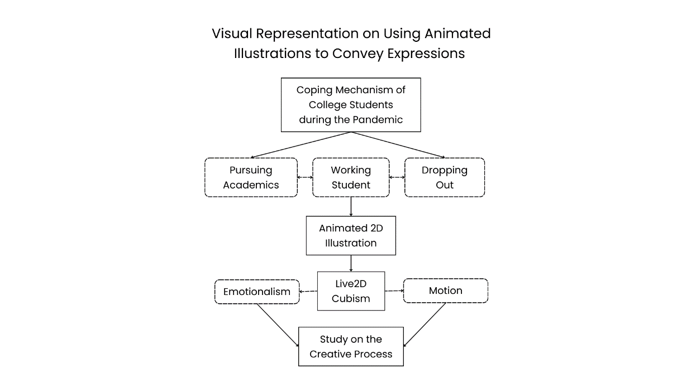

The transition of online learning has dealt with great trouble among students, especially college students that are preparing themselves for their future. Students needed the time to immerse and focus themselves on practical learning, hence the special need for physical classes. However, when COVID-19 Pandemic came, these students became confined in the comfort of their own homes therefore becoming a problem of their comfortability to study and focus as well as being limited and restricted. Thus, the study begins with the problem on the coping mechanism of college students, followed by determining the decisions they made during the pandemic. In line with this, the proponent will make an Animated 2D Illustration using Live2D Cubism for a more dynamic expression of Emotionalism and Motion. Therefore, the proponent will study and assess the creative process in exploring the unique tools that the software has to offer in enabling 3D-like rendering.

Emotionalism is a theory that focuses on the expressive qualities of an artwork, and its prerequisite is for a work of art to elicit a response from the audience, provoking them into action or calling for their attention. It should evoke emotions, moods, and feelings, convey the ideas of the artist, and help the viewer understand the message expressed by the artwork. The Emotionalism Theory will be effective to the creative output of this study by utilizing a series of animated digital illustrations to portray the habits and coping mechanisms of college students while communicating the emotions from the pressure that they felt during the COVID-19 pandemic through motion. By the end of the research, the proponent will produce a comprehensive study regarding the creative process of the rigging and animation in the software Live2D and its usefulness for creatives interested in this field.

The research aims to raise awareness by studying and understanding college students’ coping mechanisms and for future researchers to gain additional information in the field of studying how the COVID-19 pandemic has affected college students. In addition, the paper will determine how the students’ ways to cope helped them to strive during the pandemic despite the harsh conditions and bringing forth the results through animation to raise awareness. Furthermore, to deliver a story with animation as a medium, it is best to better understand the audiences’ thoughts and feelings for them to empathize with the flow of the story. Simultaneously, this project aims to contribute to digital animation by taking advantage of the study to learn and explore the use of the animation software Live2D Cubism for the project’s creative output. Thus, this study will help encourage animators and students alike who are afraid or unfamiliar, to delve into this form of dynamic animation.

For the research design, qualitative research will be used as the method to collect data. The proponent conducted an online structured interview to gather information regarding the livelihood, habits, and coping mechanisms of the respondents in accordance with their experiences during the COVID-19 pandemic. Furthermore, the research used the snowball sampling method in seeking potential participants by requesting referrals from respondents for individuals that fit the requirements of the topic.
Thus, the proponent will have a target of ten (10) college students as respondents in the National Capital Region (NCR) within the city of Manila, that have either continued their online studying or had dropped out. The interview questions are as follows:
- How did you feel about the strict lockdown brought by the COVID-19 Pandemic?
- How did you respond?
- What was your decision regarding your studies within the first year the pandemic occurred?
- Pursued online studying.
- Became a working student.
- Dropped out.
- What was the reason that influenced your decision? Was it personal or familial?
- What adjustments did you have to make after choosing such a decision throughout the pandemic? How did the pandemic affect your mental health?
- What were the challenges you faced throughout the pandemic?
- Did you form a habit(good&bad), interest(s), or some other ways to cope with the pandemic? If so, what were they?
- Did the COVID-19 Pandemic put more pressure on you as a college student? How and why?
- Do you have any other thoughts or insights that you would like to share regarding your experience striving in these trying times?

As the story focuses on the experiences that college students felt during the COVID-19 pandemic, the creative output’s target audience are college students, parents, and professors. However, the research study will target multimedia arts students on encouraging the use of Live2D Cubism for students to learn and explore the methods and program tools to use in contribution to the study of the creative process of using the software.

For the design process, the study will focus on the aspect of Multimedia Arts following the Eastern 2D Animation style to produce an animated short film as the creative output. The digital animation will be a 1-to-2-minute sequence of events with a resolution of 1920x1080 pixels, featuring the various scenarios that students are experiencing throughout the pandemic and their coping mechanisms to facing and battling against it. The student’s behavior and ways to cope that is shown as the present will hint the mental stress and pressure of being a college student within the pandemic one-by-one as the scenarios progress, revealing the result of the path they took as a student. The animation is titled “Copium”, a fictional drug that came from an amalgamation of the terms ‘cope’ and ‘opium’ by which became a satirical term of joke or meme, online that describes what a person consumes when they suffered a loss or disappointment. It became more popular during the pandemic and has now become a commonly used term when someone copes with something.

Figure 2

Do This in Your Style (DTIYS) Lo-fi
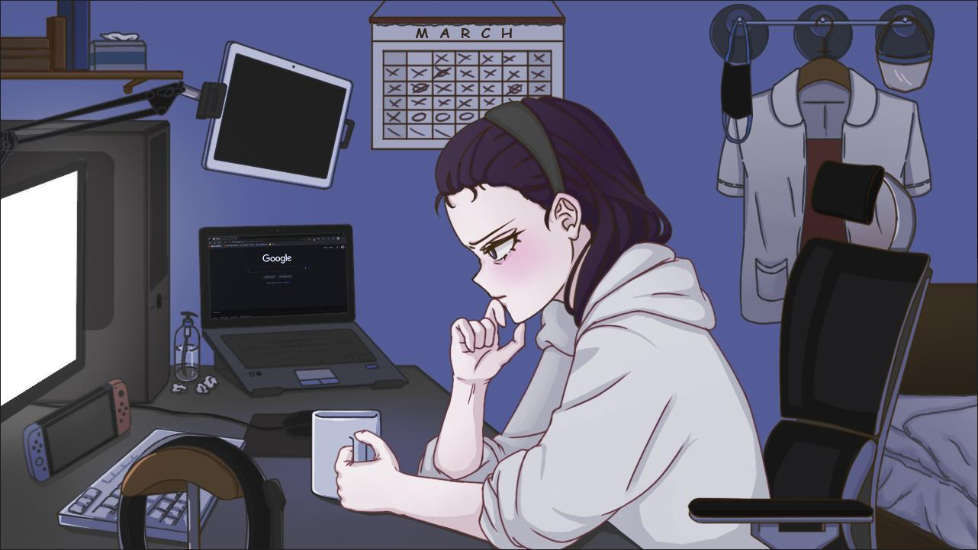
Note. This sample animated video is a midterm submission for the subject Scenography. https://drive.google.com/drive/folders/1R9M3Xx1caSKLDZiu3I-hinsV_eO3G0L3?usp=sharing

The animated illustration will portray subtle movements as similarly shown in Figure 2. The method that the proponent will use to produce the expected output is by taking advantage of multiple digital drawing and editing software. Adobe Photoshop will be used mainly to sketch and draw illustrations. The illustrations will be drawn by breaking down each part of the subject such as the hair, hands, eyes, background, props, et cetera, as shown in Figure 3.

Figure 3

2D Parts of a Character Model
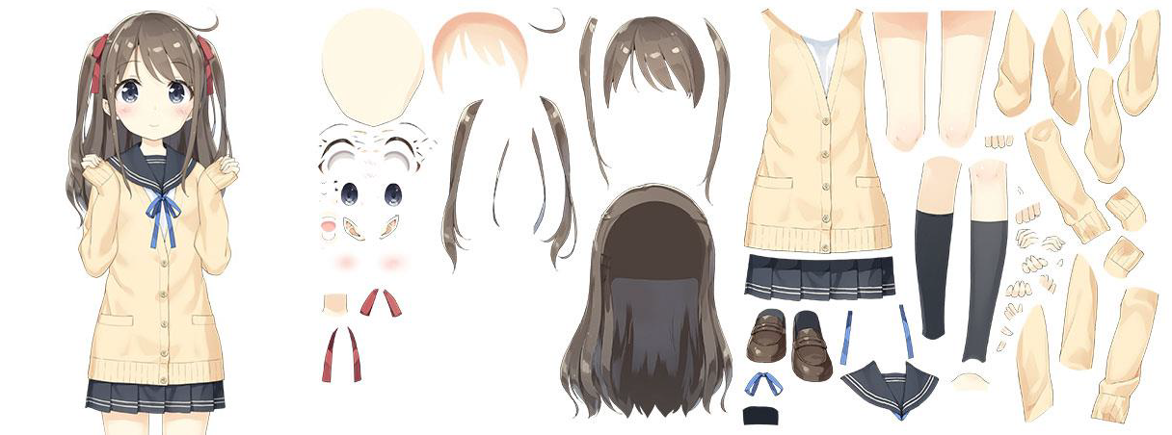
Note. The image portrays the separated body layers of Live2D Cubism’s anime girl mascot.

Each divided part will be separated and imported via the Photoshop file in the animation software Live2D Cubism. Live2D Cubism is a 2D model maker and animation software developed independently by Tetsuya Nakashiro who created the company Live2D Ltd. Without using the traditional frame-by-frame animation, the software provides real-time 2D animations using layered parts of an illustration while retaining its original appearance (Live2D Cubism). Despite the limited activities that a modeled character can engage in, by modifying software parameters of a character from various angles, a user can easily create their own moving character like how a 3D character would. Its well-known feature is its real-time motion capture that tracks movements, eye blink, and lip syncing – becoming widely popular in the world of Virtual YouTubers and has been used for video games since its recognition in 2011.

Figure 4

Model Mapping
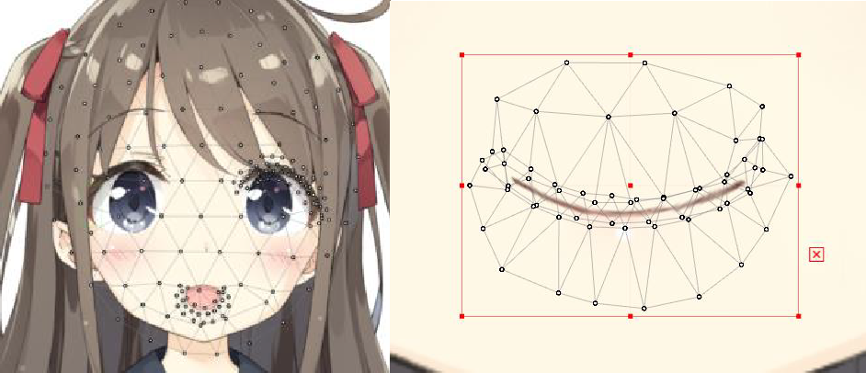

The input parts of the 2D character model will be automatically assigned a joint position mapped by the software into a mesh of polygons connected by points serving as the control points. The proponent will adjust or recreate the mapping depending on the parts that required additional care. This feature, as shown in Figure 4, allows the animator to manually define the parts and give them movement according to how the meshes are deformed and how the parameters X, Y, or Z, are adjusted by means of interpolation. The interpolation technique in animation utilizes the ability to use generated frames by animating movement from point A to B through the parameters. Simply put, in terms of frame-by-frame animation, both the key points A and B are the key frames while the in-between frames would be the interpolation that is done by computer algorithms. This would let a character make certain movements and poses without the need for frames for a smoother animation process (Business of Animation, n.d.).

Once the model has been completely mapped and assigned their own parameters, the file will be transferred to the animation part of the software. The animation on Live2D Cubism relies on the interpolation technique done through the model mapping process and is done by assigning frames by model parts. When the animation process is completed, it will be composited directly to Adobe After Effects to combine all the visual elements with the background and give additional visual effects as the final step in making the animation.

Pre-Production
The pre-production stage requires the proponent to plan and visualize what the proposed creative output will become. Therefore, to create a story for the output, the proponent gathered data using the structured interview from the ten expected respondents, assessing their responses, and applying them as the basis for the story. The proponent determined the coping mechanism of the characters which will appeal to the audience by showcasing the different experiences as scenarios of how a college student struggled to live and strive through the hurdles of the pandemic. Additionally, the animation’s story development and story treatment that will be illustrated was still in progress during this phase and the proponent consulted with their friends regarding the story and its sequences while receiving advice. A draft for the character design is also made during the process of making the story. The design of the two college students will follow their personality and situation and make them simple and easy to draw to avoid too much detail that may hinder the production phase.

Production
In this phase, the proponent has completed the character design for the characters that will be featured in the story as well as the storyboard that the animated illustrations will be following through. Once the sketches are made, the proponent starts cleaning up the line art as well as breaking down and separating the parts of the characters that will then be animated later in post-production. In line with this, the next step was to work out the base colors for the illustration following the color script that was made beforehand. After which, to finalize the production phase, the proponent will create the animation on the software Live2D Cubism.

Post-Production
The post-production stage for the creative output will focus on compositing the animated illustrations as well as editing extra effects. The proponent will be using royalty free music for the low-budget creative output.

Review of Related Literature
This chapter presents the existing related literature of the research study about the impact of the COVID-19 pandemic on college students. The following information will discuss how the pandemic affected the shift of education system on college students, determining the assessment of stress and challenges to understand how students are coping, and exploring the use of animation in raising awareness, with expressions and movement to evoke emotions for their creative output.

Impact of the Pandemic on Education
The education system has utilized the development of online learning to face the lockdown caused by the pandemic, ensuring that students will be safe and still be able to continue the pursuit of learning within the confines of their own home. This transition of education influenced by technology, however, became a challenge that aggravated the students’ mental health from being restricted due to health protocols of the lockdown.
According to a research study entitled “Students’ online learning challenges during the pandemic and how they cope with them: The case of the Philippines” conducted by Barrot, Llenares and del Rosario (2021), the greatest challenge that greatly impacted the students during their online learning experience was the environment by which they study at home, instead of their learning competency with technological literacy. On the other hand, electronic devices and internet connections became unsustainable due to the socioeconomic status of families that do not have the resources to such learning modalities. It affected the mental health of students and teachers alike from the uncertainty of the situation while also serving as the catalyst to experiences of discrimination and inequality of poorer communities (Simbulan, 2020). Hence, according to an advocacy paper published by UNESCO (2020), the risk of students in all countries dropping out of school due to the disadvantages brought by the COVID-19 pandemic has increased exponentially and it is expected that the longer the students stay out of school, the less they are to return, stemming from the uncertainty of how long it will continue to have an impact on the education system.
The education system was clearly not prepared then, and the transition of online learning was not adapted well to accommodate all students, plus, a reformation such as the hybrid learning were only taken into action when the challenges of the pandemic died down after two years which was faster than expected. Students who opted to drop out of school did so to cope with the pandemic, knowing fully well that they are held back from the limitation of their resources. It added on to their stress that the longer the pandemic is not solved, the longer their years of missing out on school will be, leading to an imbalance of irregular students or even deciding not to go back to school anymore.

Stress and Coping of College Students
Students have become prone to feelings of stress and negative emotions during the pandemic and according to Lazarus and Folkman (1984) in Stress and Coping, “the interaction between a person and their surroundings that they see as exhausting their resources, putting their wellbeing in danger, is known as psychological stress.” (Lazarus & Folkman, 1984, p.19). The relationship has two phases which are cognitive appraisal and coping. Firstly, cognitive appraisal pertains to the situation or environment that one is in should be cognitively recognized as the source of stress that threatens one’s well-being and challenges one’s personal growth. Secondly, the assessment of the cognitive appraisal answers a person’s coping resources; whether physical, social, psychological, or material. It refers to how one will be able to exert the effort to master, reduce, or tolerate the internal and external demands caused by the stress from one’s situation (Berjot & Gillet, 2011).
In this study, the appraised situation that college students are in would pertain to the COVID-19 pandemic that threatens the students’ well-being, following the health protocols and abiding the strict lockdown. Meanwhile, the environment would be the isolation within the confines of their home which challenges the student’s personal growth from being unable to properly give the necessary support that a school environment provides. After assessing what challenges the students are faced with, it serves as the foundation of this study’s goal to further understand the coping mechanisms that college students did through the stress of challenges brought by the pandemic.

Animation for Awareness
According to a research study on the “Evaluation of The Impact of An Awareness-Based Animation on Students’ Knowledge About Mental Illness” (2020), animations are a powerful tool for promoting awareness as perceiving a visual message has a 58% rate higher than learning through audio (Plot, Roškar & Tomc, 2020). Kwasu and Ema (2015) stated that animations, if done with proper planning, becomes a provider for knowledge that will effectively help learners. Students and scholars affirm that animation helps battle out an audience’s boredom by having their sense of sight and hearing capabilities active, and their imaginations with their sense of touch which will enhance their conceptual thinking and comprehension.
Therefore, the use of visuals has the power to make an impact to capture an audience's attention which may then be directed on the concept and emotions that are most likely to move them to action with the aid of a compelling animation. This further proves that animation is just as important to teaching and learning to raising awareness and not just a simple means to a medium of entertainment while it also appeals to any age and group of people.

Appraising Emotionalism
Through pieces of art that show characters experiencing emotions, an effective emotionalist artwork will be able to convey the artist's message. An emotionalist artwork aims to call for an audience’s attention or to provoke a call for an action – it is either alarming or realistic to gain their interest and make an impact on their emotions (Transect Science, 2019).
The main relation for emotionalism to be classified as one lies between the artwork and audience. However, the emotion expressed may not necessarily be the same as the emotion that an audience may experience as identity may also be referred to one’s own identification of emotions (Fasula, 2021). Furthermore, a person’s response stems from their cognitive appraisal of the situation before the emotions are distinguished, much like how in this study, students are first appraised before determining their coping mechanisms. As a result, the elicited response from the audience's emotions may also differ from each other regarding how they assessed the situation. In any case, by approaching the theory of emotionalism, the proponent will utilize animation and will prove to effectively communicate emotions and struggles of coping through subtle change of expression and movement.

Expression of Emotion and Movement
Humans are generally able to detect movement even from our peripheral vision as it is within our instinct that naturally draws our attention towards movements. In general, digital animations utilize a human’s imagination by creating movements using frame rates in a two- dimensional space. However, in this study, the proponent will first draw a whole piece of illustration per scenario by layering each component or its parts, before bringing it to life by animating the illustration as it was drawn without necessarily using frames. The creative output aims to maintain the illusion of natural movement while trying to express emotions that will relate to the reality that college students experienced during the pandemic, upon which the story of the creative output is based.
Understanding movement is one of the key factors for the creative output especially when animating an illustration as is. Although, Riki (2015) stated that animation may not exactly rely on movements alone as what makes a good animation is the story and the message conveyed itself, communicating an emotion through expression and movement is what would keep an audience’s imagination going in this study. Evoking a response and bringing a connection with them and the characters. Consequently, having the audience drawn in will trigger their active participation in analyzing the expression used and comprehending the movements within the scenario at play, constantly pondering over what the story entails.

Review of Related Works
This chapter will present the existing related works of 2D animations to observe the animation techniques as well as other mediums discussing coping mechanisms during pandemic. The following works will be useful for the inspiration of the desired outcome through distinct art styles, and the methods of communicating emotions and storytelling.

Figure 5

My Hero is You (2020)
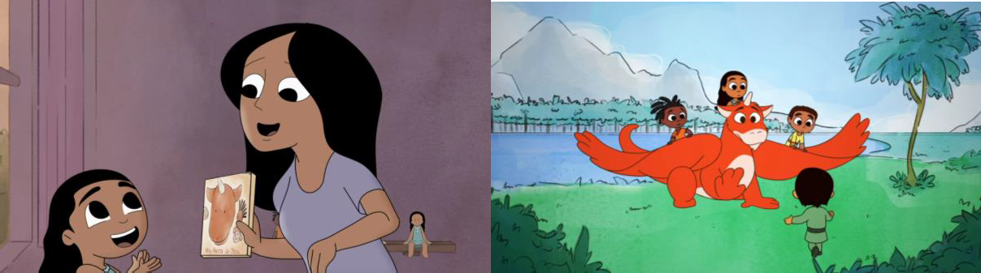
Note. The images are taken from a screenshot in the animated film “My Hero is You” on YouTube (UNICEF, 2020b).

The story was developed for kids ages 6-11 years old all over the world. It is a two-series project of the Inter-Agency Standing Committee (IASC) in collaboration with United Nations agencies, with part two titled “My Hero is You 2021: How kids can hope with COVID-19!” (UNICEF, 2020a). The animation starts with the little girl playing with her four (4) dolls on the shelf, placing them altogether as if they are socially distant, when her mother comes into her room to read the little girl a storybook. It features the return of Ario, the fantasy dragon from the storybook ‘My Hero is You’. Ario is a creature that addresses the coping mechanisms that children face to battle out their fear and frustrations. He travels around the world to help and give children hope for the future and find joy in its simplest form.
The animation aims to represent and explore the various ways of coping mechanisms that children use during the pandemic. It would help the study with creating the flow of the story, following the college students and their coping mechanism from the project.

Figure 6

FGO Mysterious Heroine X Alter (2019)

Note. The image is a screenshot from a YouTube video of a fan-made animated illustration based on an event in a game called Fate Grand Order (FGO) (Tsui, 2019).

The YouTube video was a collaboration of two creatives; the illustration was done by the artist Saruei, while it was animated by the Live2D VTuber animator Brian Tsui in 2019. The video showcased how the illustration of the character is animated as it was drawn. The whole body of the character was moving naturally according to how the illustration was imagined having movement, despite having only sat in one spot. The character’s eyes blinking, the mouth and jaw moving as the character spoke, ate, and chewed the chocolate, the legs, hands and fingers moving accordingly, and even the glasses as the character nodded. The illustration was animated using the 2D modeler and illustration animation software Live2D Cubism; therefore, the breakdown method and technique of animation will be the same as the approach of the creative output of this study. The animator Brian Tsui has also uploaded his 16-hour progress on the making of this short video and will help guide the proponent in creating their own.

Figure 7

Story Teaser: The Divine Damsel of Devastation (2022)
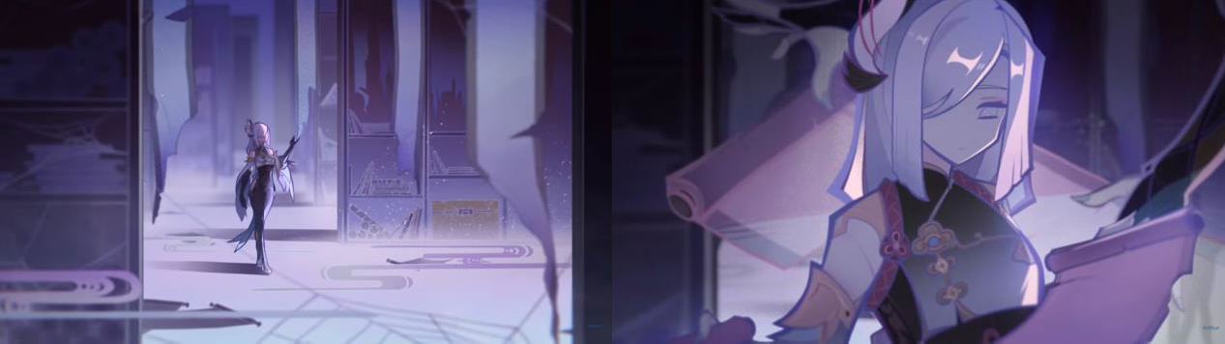
Note. The images are from a screenshot in a YouTube teaser video from the game Genshin Impact, featuring the backstory of a character named Shenhe (Genshin Impact, 2022).

In this particular part of the video, the character Shenhe is first seen alone in a deserted hallway of her previous home. Then, the transition above the scene is an image of her hands opening a scroll, before finally transitioning to another image above to reveal a close-up of her profile reading the said scroll.
This method will be used as a reference in visually narrating a brief yet continuous flow of a certain scenario for the story. Most of the animation shown in the story teaser is animated in the same style as per the aim of this project. This video is partly made with illustrated images, subtly animated as it was drawn. The gloomy mood here also makes up for another reference for the atmosphere of the project’s output.

Figure 8

Emotions Expressed Through Dance (2014)
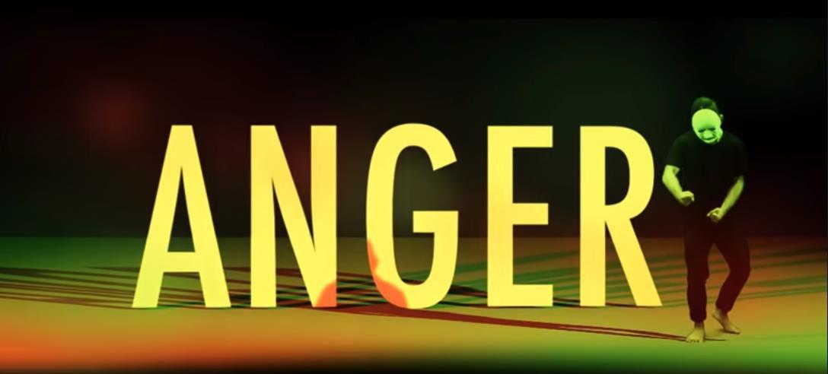
Note. The image is a screenshot taken from a 2-minute YouTube video (Fitzrovia Youth in Action, 2014).

This video features different emotions expressed through dancing. It was made to help raise and spread awareness about drugs and alcohol from the perspective of a youth. This film is intended to educate people on the fact that young people experience a wide range of moods and emotions that impact their mental health.
The video proves helpful as inspiration and reference for the creative output of this project. The proponent will make use of the video by incorporating the subtle movement of the characters through emotions.

Figure 9

SEULGI | 28 Reasons Trailer
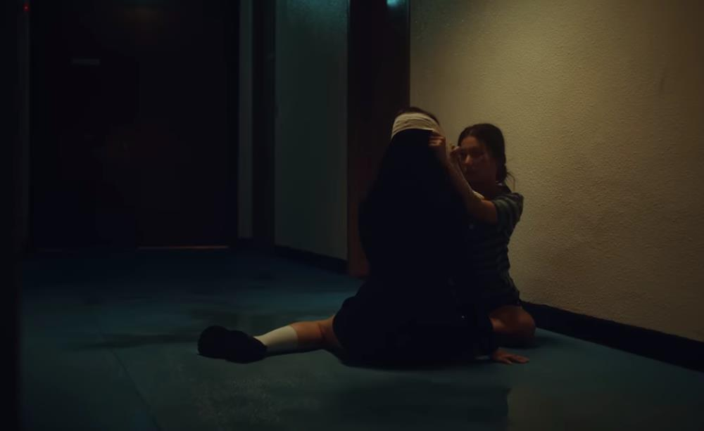
Note. The screenshot is taken from the Korean artist, Seulgi’s Mini Album promotional video.

The concept of the video greatly inspires how the story will play out in this project. It shows a sequence hinting at the past of two women that will lead all the way to the present. The released music video of the song ’28 Reasons’ stated that “People that are good or evil are not clearly distinguished and that good and evil coexist within a person” (Red Velvet, 2022). Thus, the woman who took the supposed bullying took a step to fight for herself.
The commercial video's narrative alternates between the past and present of the two women. However, the difference in this project will portray a straightforward take on progression. Just like how the proponent will plan out the story of this project by showing a sequence of the two students’ situation until it leads to their present of which the decision that affected their lives will reveal everything.
Results and Discussion
The purpose of this study was to examine the coping mechanisms employed by college students during the COVID-19 pandemic, particularly in the context of the sudden transition to online learning. To collect data for the study, the proponent designed a questionnaire using Microsoft Forms and administered it as an online survey. Through the survey, the proponent was able to gather information on the experiences of college students who employed different coping strategies during the pandemic. The questionnaire included a range of questions that aimed to capture various aspects of college students' lives during the pandemic, including their academic performance, mental health, and daily activities. By collecting and analyzing this data, the proponent was able to gain insights into the challenges faced by college students during the pandemic and the effectiveness of different coping strategies in mitigating these challenges.

Survey Results

- Age

Figure 10

Questionnaire #1 Answers
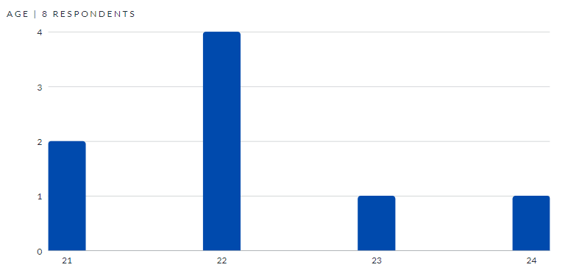

- Gender

Figure 11

Questionnaire #2 Answers
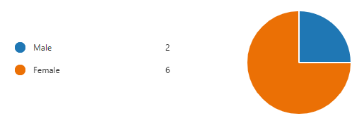

- How did you feel about the strict lockdown brought by the COVID-19 Pandemic? How did you respond?

Figure 12

Questionnaire #3 Answers
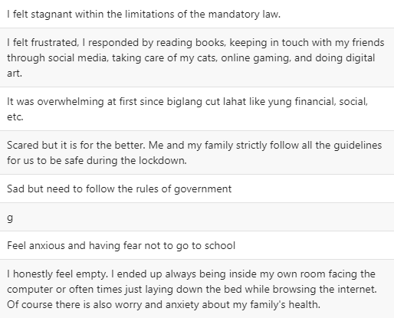

Figure 12 presents the responses of college students to the third question of the questionnaire used in this study. The results indicated that college students reported experiencing negative emotions, specifically feelings of frustration and anxiety, due to the strict lockdown measures imposed during the COVID-19 pandemic. The findings suggest that the pandemic and the resulting restrictions have had a significant impact on the mental health and well-being of college students, even when they are at home. The responses also suggest that the sudden shift to online learning, along with the isolation and lack of social interaction, may have contributed to the negative emotions experienced by college students. Overall, these findings highlight the need for greater support for college students during the pandemic, particularly with regard to mental health and well-being, and the importance of finding ways to alleviate the negative impacts of the pandemic and the associated restrictions.

- What was your decision regarding your studies in the first year the pandemic occurred?

Figure 13

Questionnaire #4 Answers
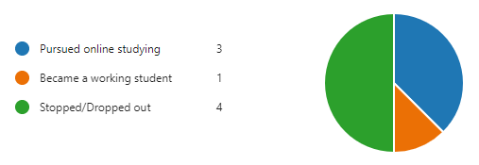

Figure 13 presents the choices that college students made as their coping mechanisms during the COVID-19 pandemic. The responses indicate that most of the respondents chose to temporarily stop their studies, while others opted to pursue online learning. Only one person decided to become a working student during the first year of the pandemic. These findings suggest that the pandemic has had a significant impact on the educational pursuits of college students, with many opting to take a break or shift to online learning due to the challenges posed by the pandemic. The decision to temporarily stop their studies may be attributed to a variety of factors, such as difficulties with online learning, financial concerns, and the need to prioritize mental health and wellbeing. The findings that only one person decided to become a working student during the pandemic may indicate that the job market was also affected by the pandemic, with fewer opportunities available for students who needed to work to support themselves.

- What was the reason that influenced your decision? Was it personal or familial?

Figure 14

Questionnaire #5 Answers
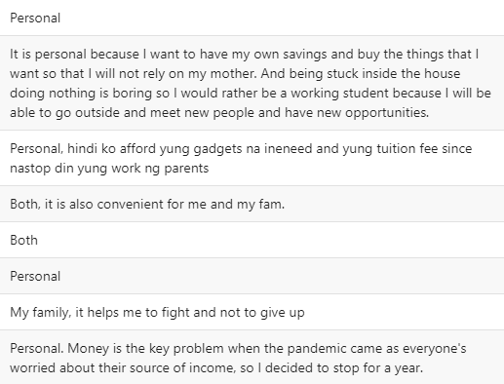

According to Figure 14, personal reasons have a significant impact on the coping mechanisms of college students during the pandemic. Financial difficulties and attending to personal and familial needs and resources were cited by most respondents as the main reasons for their choice. The shift to online learning has added to the already challenging situation faced by many college students, making it more difficult for them to manage academic requirements and household responsibilities. These personal reasons are often linked to the economic effects of the pandemic, such as job losses, reduced income, and increased healthcare and pandemic-related expenses. These obstacles have made it hard for college students to concentrate on their studies and have compelled them to prioritize their personal needs over their academic goals.

- What adjustments did you have to make after choosing such a decision throughout the pandemic?

Figure 15

Questionnaire #6 Answers
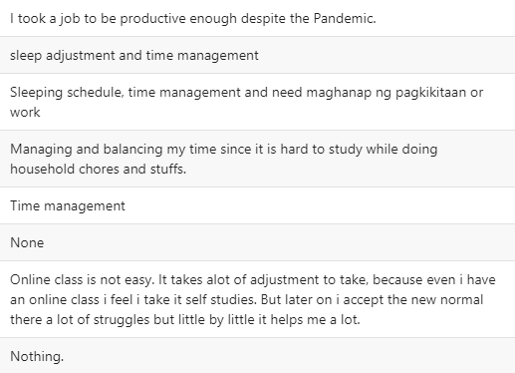

The data gathered shown in Figure 15 from the responses of college students regarding the adjustments they made to cope with the pandemic highlights the importance of time management and sleep schedule. With the sudden transition to online learning, college students found themselves obligated to balance their academic responsibilities with household chores and other personal obligations. As a result, respondents reported making adjustments to their daily routines, such as creating a schedule for studying and household tasks, as well as prioritizing sleep and rest to manage their stress levels. Effective time management has become crucial for college students to balance their responsibilities and maintain their academic performance while dealing with the challenges brought about by the pandemic.

- How did the pandemic affect your mental health?

Figure 16

Questionnaire #7 Answers
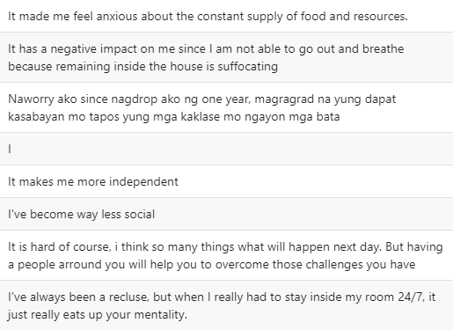
The responses of college students on the seventh question as shown in Figure 16 reflect the negative impact of the pandemic on their mental health. It is shown that college students became deprived of their freedom and social support as it further brings their mental health into a negative state. One respondent also has to constantly worry about their food and other necessary resources to survive the pandemic, while another respondent worried about their situation as an irregular student who dropped out. Meanwhile, one respondent replied positively regarding their mental health, stating that the pandemic made them more independent. It just shows that although the situation is dire, there will always be one person among the odds that will take advantage of the situation and stand up to strive.

- What were the challenges you faced throughout the pandemic?

Figure 17

Questionnaire #8 Answers
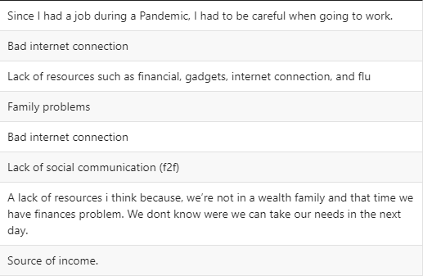
The challenges that college students faced shown in Figure 17 are divided with some having troubles with a bad internet connection and a lack of resources or facing financial instability. However, one student responded to be lacking physical social communication, while another responded to be having family problems. Even though the problems some college students are facing are personal as they are stuck in home due to the strict lockdown, there are things that a proper learning environment that college students are supposed to have which cannot be the same thing when learning inside their home which causes a rift with their personal life and college life.

- Did you form a habit(good&bad), interest(s), or some other ways to cope with the pandemic? If so, what were they?

Figure 18

Questionnaire #9 Answers
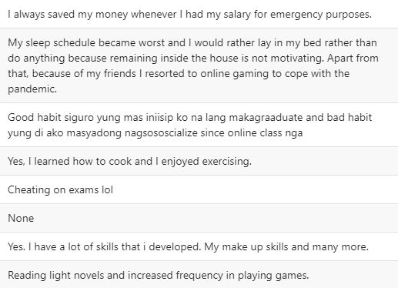

Figure 18 displays the different habits that college students developed during the pandemic as reported by the respondents. These habits reflect the ways in which college students coped with the challenges and stressors brought about by the pandemic and adjusted to the new normal of online learning and social distancing.

- Did the COVID-19 Pandemic put more pressure on you as a college student? How and why?

Figure 19

Questionnaire #10 Answers

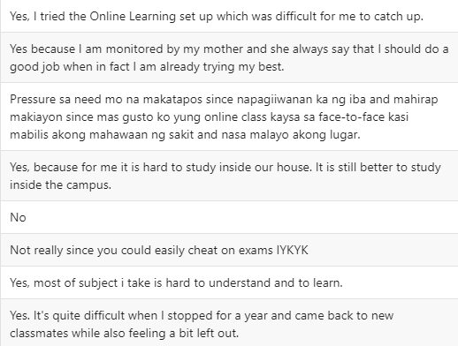

Figure 19 presents data that indicates a high level of pressure felt by college students during the pandemic. Nearly all of the respondents reported feeling more pressured as a college student, with the sudden shift to online learning. Many students found it difficult to keep up with their studies and engage with their classmates in a virtual setting. The pressure was particularly felt by students who took a break from school during the pandemic, as they often felt left out and disconnected from their peers. This pressure has added to the already challenging situation faced by college students during the pandemic and highlights the need for support and resources to help them cope with the changes brought about by the pandemic.

- Do you have any other thoughts or insights that you would like to share regarding your experience striving in these trying times?

Figure 20

Questionnaire #11 Answers

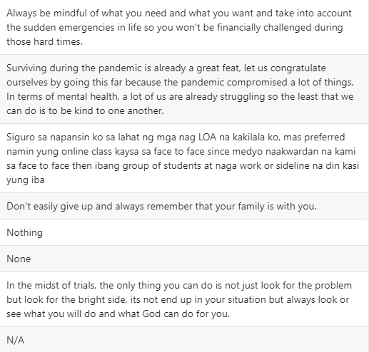

In the final question of the survey, respondents were given the opportunity to share their thoughts on their experiences during the pandemic. The responses received were incredibly valuable, as respondents shared useful advice and positive perspectives that could help lift the spirits of others. It is important to note that while the pandemic has brought about many challenges and difficulties, it has also provided an opportunity for personal growth and reflection. Respondents were able to highlight the importance of self-care and mental health during these uncertain times. Many shared their own experiences of overcoming obstacles and how they were able to develop new skills or hobbies. By sharing these positive takeaways, respondents hoped to inspire others and encourage them to stay hopeful and resilient in the face of adversity. Overall, the responses received in the last question of the survey provided a glimpse of the resilience and determination of college students during the pandemic. These responses can serve as a source of support and inspiration for those who may be struggling and in need of a positive outlook.

Conclusion
The COVID-19 pandemic has had a significant impact on the lives of college students, particularly in terms of their mental health. With the sudden transition to online learning, college students have faced increased pressure to balance their academic responsibilities with their personal lives. This has been especially challenging for those who are also responsible for household chores and other family obligations. Unfortunately, many college students have been forced to drop out of their studies due to financial difficulties or family problems that they must attend to. These challenges have only been compounded by the sense of isolation and disconnection that many students feel as they watch their peers move forward with their lives. For those who have chosen to leave school, the decision was likely a difficult one, as they faced the pressure of not only maintaining their academic performance but also managing their mental health and personal lives during an unprecedented crisis. As we continue to navigate this pandemic, it is important to prioritize the well-being of college students and provide them with the support they need to overcome these challenges and succeed in their academic and personal lives.
The results of the survey provided the proponent with valuable data on the coping mechanisms that college students used during the pandemic. With each question, the proponent was able to gain a deeper understanding of how students were able to manage the various challenges that they faced. This information was then used to create a story that will be animated for the creative process of the study. By portraying these coping mechanisms in a creative and engaging way, the aim is to help raise awareness of what college students experienced during the pandemic. The animation will serve as a powerful tool to communicate the experiences of students and highlight the importance of mental health and self-care during difficult times. By sharing this story, the hope is to provide a source of support and inspiration for other college students who may be struggling with similar challenges. Overall, the results of the survey have been instrumental in shaping the creative process of the study and will help to ensure that the final product is both informative and impactful.

Recommendations
Research Topic
Due to the smaller number of college student respondents gathered to support it, the study may be enhanced and further examined. It is significant to remember that the quantity of respondents or participants is not the only factor affecting the quality of the study. Therefore, it is difficult to determine exactly how the study could be improved without more information on the specific research question, methodology, and findings. However, it is important to keep in mind that the quality of research is not solely determined by sample size, but also by other factors such as the representativeness of the sample and the appropriateness of the research methodology for the research question.
For some research issues, a smaller sample size might be adequate, but it's crucial to take into account whether the group of college students is representative of the greater population of interest. If not, it may be difficult to generalize the results beyond this group and it may be required to expand the number of participants to include a wider range of individuals. As a result, even while the study might have provided insightful information, it might also be advantageous to further investigate and build upon its conclusions through another investigation that uses a bigger and more representative sample.

Creative Process
The process of creating a story that accurately depicts the experiences of college students during the pandemic is still in need of improvement, particularly in terms of the storytelling process. In addition, the digital illustrations that will be animated should feature more dynamic shots to effectively convey the animation's perspective and story. It is crucial for the proponent to adhere to the set deadlines to ensure that the project's requirements are met. Simplifying the illustrations does not mean that one should take advantage of free time to procrastinate, as this may ultimately put the animation process in jeopardy and lead to a delay in completing the creative process until the last minute. Therefore, time management is key to ensuring that the project is completed successfully and on time. The proponent should prioritize effective planning and efficient use of time to avoid compromising the quality of the final product. By doing so, the animation will be able to effectively communicate the experiences of college students during the pandemic and raise awareness of the importance of mental health and self-care during difficult times.

References
Business of Animation. (n.d.). Comprehensive Guide to Interpolation Animation for Animators. Business of Animation. https://businessofanimation.com/a-thorough-guide-to-interpolation-animation-for-animators/#:~:text=As%20we%27ve%20explained%2C%20interpolation,drawing%20of%20two-dimensional%20curves

Fasula, P. (2021). WHAT IS THE CONNECTION BETWEEN ARTWORKS AND EMOTIONS? Rebus Community. https://press.rebus.community/intro-to-phil-aesthetics/chapter/what-is-the-connection-between-artworks-and-emotions/

Fazida Karim, A. A. (2020, June 15). Social Media Use and Its Connection to Mental Health: A Systematic Review. Cureus. https://doi.org/10.7759/cureus.8627

Fitzrovia Youth In Action. (2014, December 12). Emotions expressed through dance. YouTube. https://www.youtube.com/watch?v=m0R-ftFBm38

Folkman, R. S. (1984). Stress, Appraisal, and Coping. Google Books. https://books.google.com.ph/books?hl=en&lr=&id=i-ySQQuUpr8C&oi=fnd&pg=PR5&ots=DgIQmvldQf&sig=qYCXu1wEhfR4zcpIssgmeIn4zeM&redir_esc=y#v=onepage&q&f=false

Genshin Impact. (2022, January 6). Story Teaser: The Divine Damsel of Devastation | Genshin Impact. YouTube. https://youtu.be/EiAhMr6IJTQ

Gillet, S. B. (2011, January 7). Stress and Coping with Discrimination and Stigmatization. National Library of Medicine. https://doi.org/10.3389/fpsyg.2011.00033

Hadler, N. (2021). Coping with the COVID-19 Pandemic as a College Student. Michigan Medicine. https://medicine.umich.edu/dept/psychiatry/michigan-psychiatry-resources-covid-19/adults-specific-resources/coping-covid-19-pandemic-college-student

Ian Grey, T. A.-H. (2020, November). The role of perceived social support on depression and sleep during the COVID-19 pandemic. Science Direct. https://doi.org/10.1016/j.psychres.2020.113452

Isaac Ali Kwasu, E. (2015, November 21). Effectiveness of Animated Instructional Resource for Learning. https://files.eric.ed.gov/fulltext/EJ1079103.pdf

Jessie S. Barrot, I. I. (2021, May 28). Students’ online learning challenges during the pandemic and how they cope with them: The case of the Philippines. Springer Link. https://doi.org/10.1007/s10639-021-10589-x

Leonard Thomas S. Lim, Z. J.-U. (2022, May 3). Assessing the effect of the COVID-19 pandemic, shift to online learning, and social media use on the mental health of college students in the Philippines: A mixed-method study protocol. Plos One. https://journals.plos.org/plosone/article?id=10.1371/journal.pone.0267555

Live2D Cubism. (n.d.). What is Live2D? – How to Make＆Use a Live2D Model. Live2D Cubism. https://www.live2d.com/en/about/

Mojca Plot, S. R. (2020). EVALUATION OF THE IMPACT OF AN AWARENESS-BASED ANIMATION ON STUDENTS’ KNOWLEDGE ABOUT MENTAL ILLNESS. https://doi.org/10.24867/GRID-2020-p75

Prior, M. (2022, May 20). Benefits Of Using Animation As A Learning Tool. Raw Pictures. https://www.rawpictures.co.uk/blog/benefits-of-using-animation-as-a-learning-tool

Red Velvet. (2022, September 12). SEULGI | 28 Reasons (Official Album Trailer). YouTube. https://www.youtube.com/watch?v=a-V1CFBGqNk&list=LL&index=39

Riki, J. (2015, June 15). Animation is Not About Movement. Animator Island. https://www.animatorisland.com/animation-is-not-about-movement/

Simbulan, N. P. (2020, June 4). The Philippines – COVID-19 and Its Impact on Higher Education in the Philippines. Head Foundation. https://headfoundation.org/2020/06/04/covid-19-and-its-impact-on-higher-education-in-the-philippines/

Transect Science. (2019, May 10). Emotionalism theory is an aesthetic and critical theory of art. Transect Science. https://transectscience.org/emotionalism-theory-is-an-aesthetic-and-critical-theory-of-art/

Tsui, B. (2019, February 16). 【FGO】Mysterious Heroine X Alter【Live2D】- Collaboration with Saruei. YouTube. https://youtu.be/69EjtxzDAXg

UNESCO. (2020, July 30). How many students are at risk of not returning to school? UNESCO COVID-19 Education Response. https://unesdoc.unesco.org/in/documentViewer.xhtml?v=2.1.196&id=p::usmarcdef_0000373992&file=/in/rest/annotationSVC/DownloadWatermarkedAttachment/attach_import_5b075951-5390-4056-9935-4163d073d5f1%3F_%3D373992eng.pdf&locale=en&multi=true&ark=/ark:/48223/p

UNICEF. (2020, April 4). “My Hero is You”. UNICEF. https://www.unicef.org/coronavirus/my-hero-you

UNICEF. (2020, August 20). My Hero is You | UNICEF. YouTube. https://youtu.be/9mrouzBgqYY

Appendices
This section of the paper will present the assets and project reports created by the proponent as a critical element in showcasing their creative process. It serves as concrete evidence of the proponent's efforts and achievements, providing a visual representation of their work which plays a role in demonstrating the proponent's abilities and expertise in their field.

Appendix A
Plagiarism Detector Report
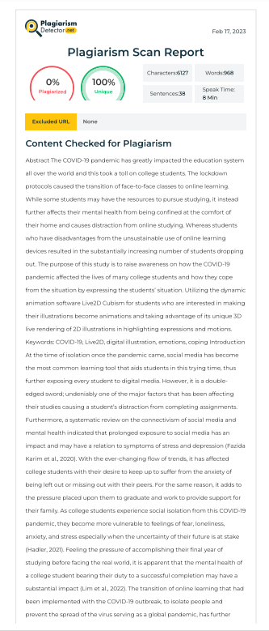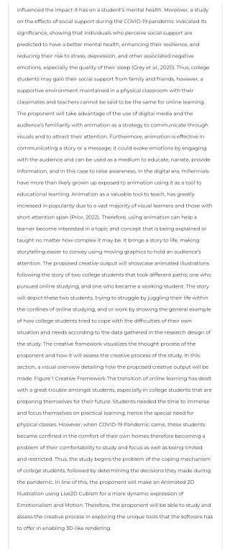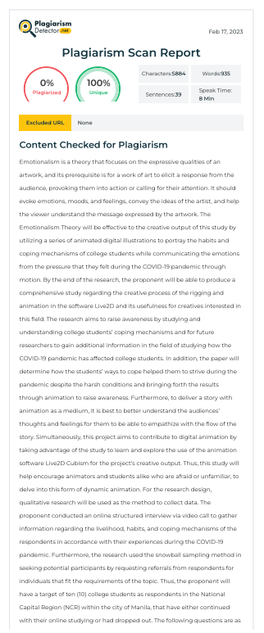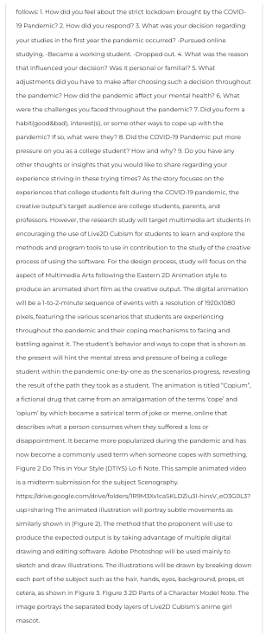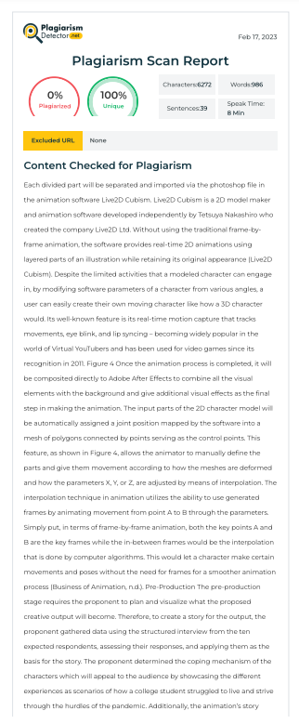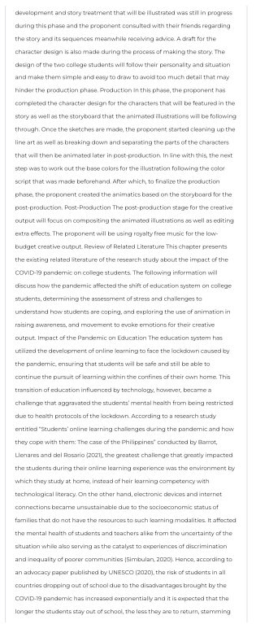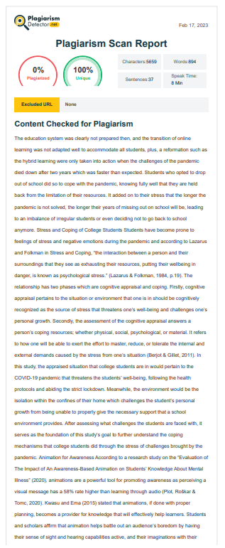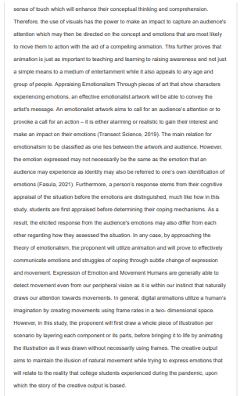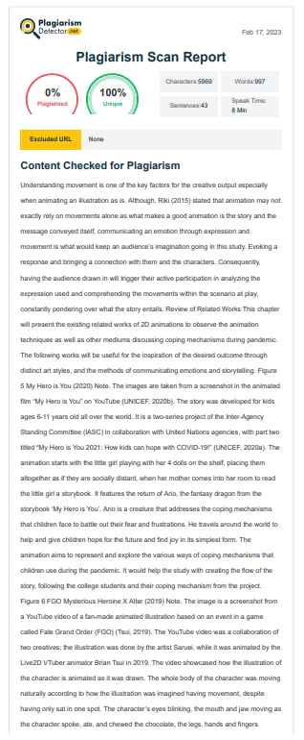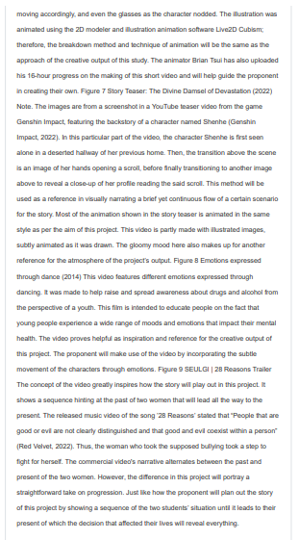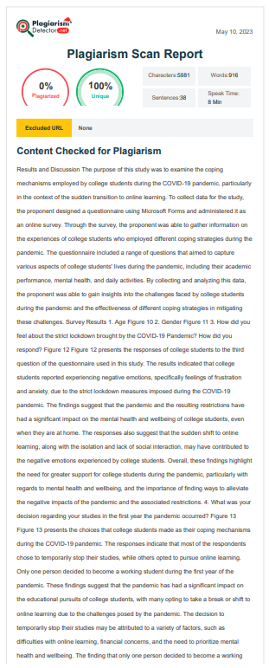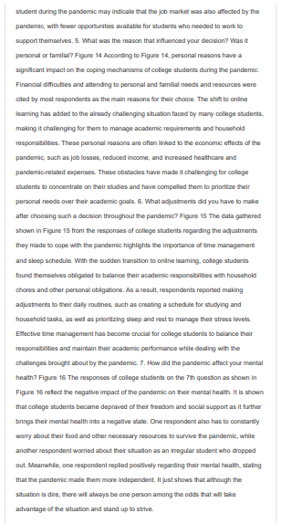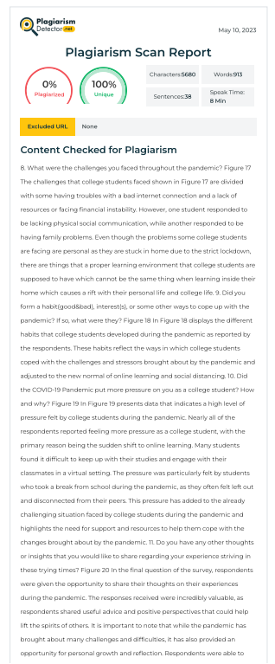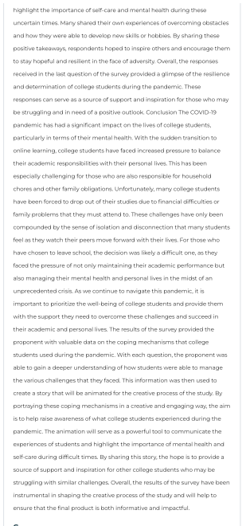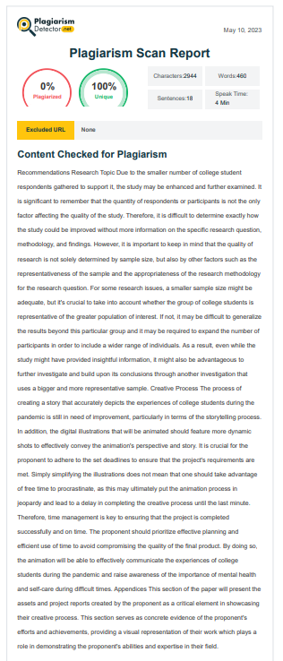

Appendix B
MMAPRO 1 Project Gantt Chart
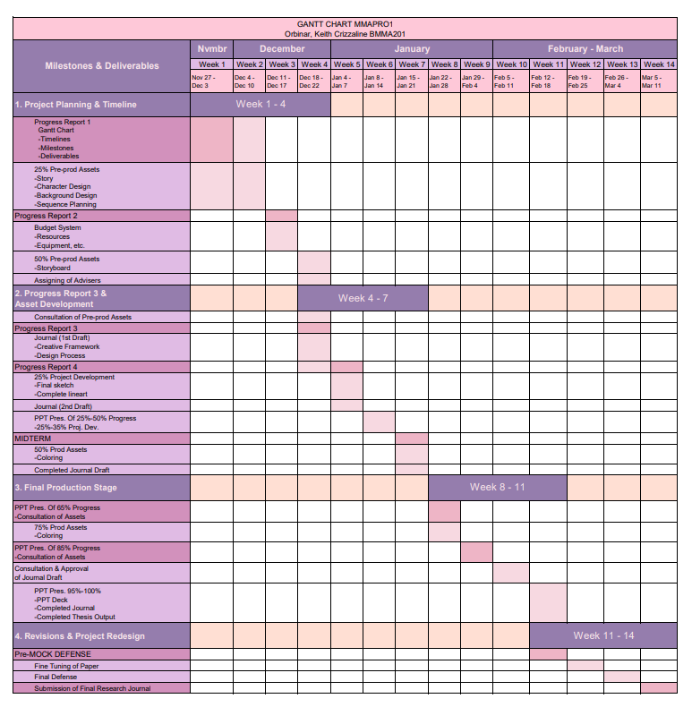
MMAPRO 2 Project Gantt Chart
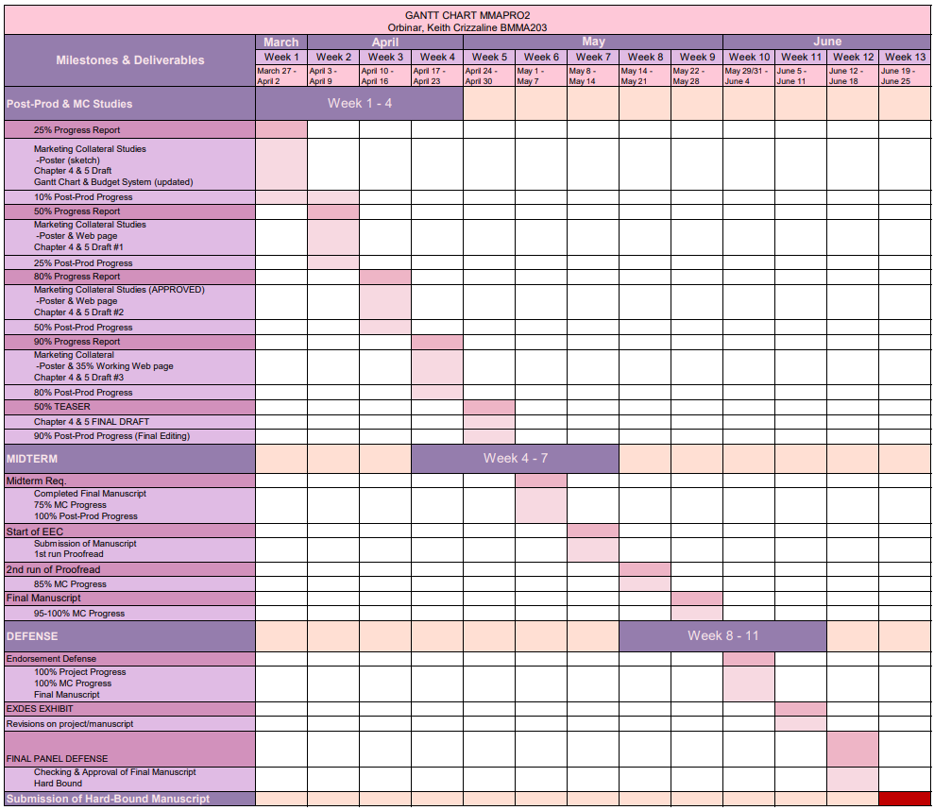
Appendix C
Visual References and Studies

Production Assets:
Character Design

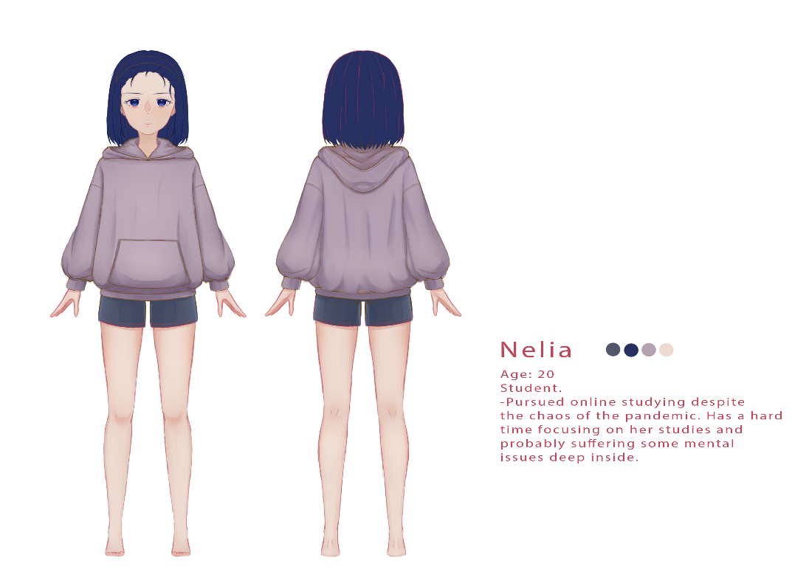
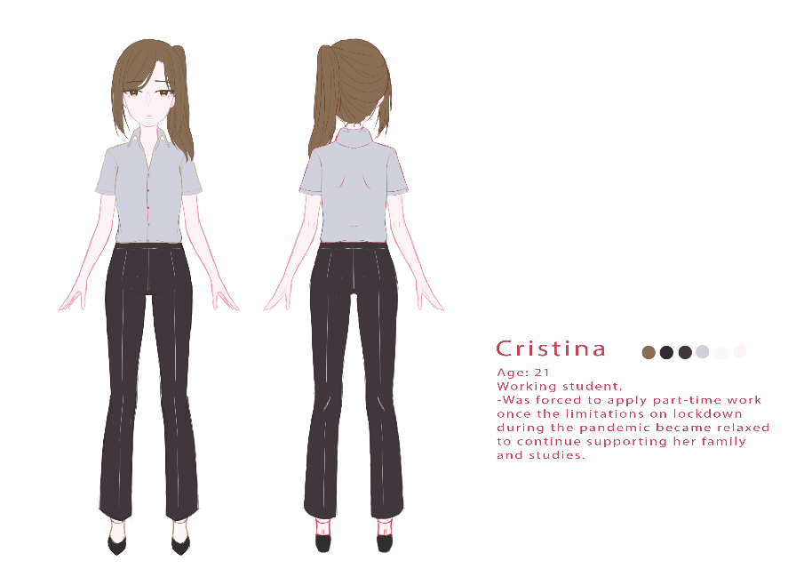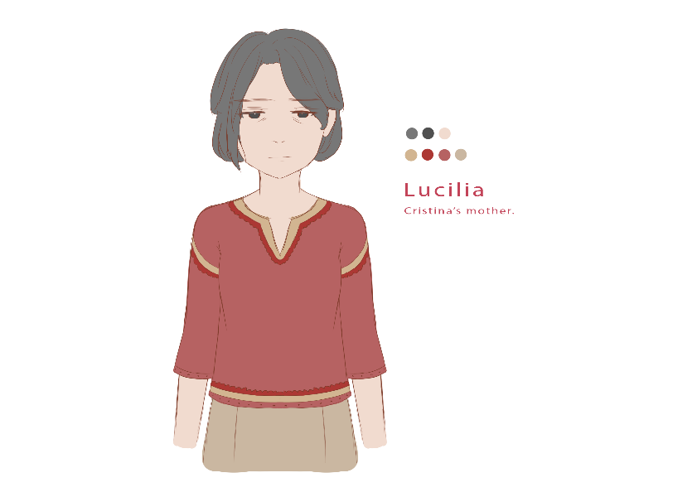

Appendix D
Project Production Documentation

Character Breakdown and Illustrations

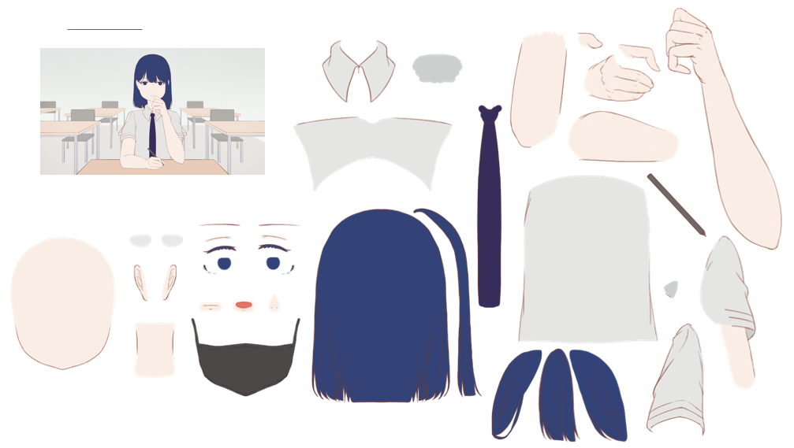
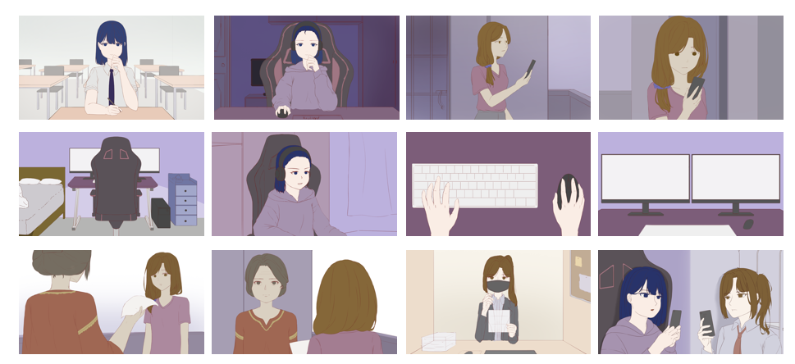

Live2D Cubism Editor
Modeling and Rigging Process:

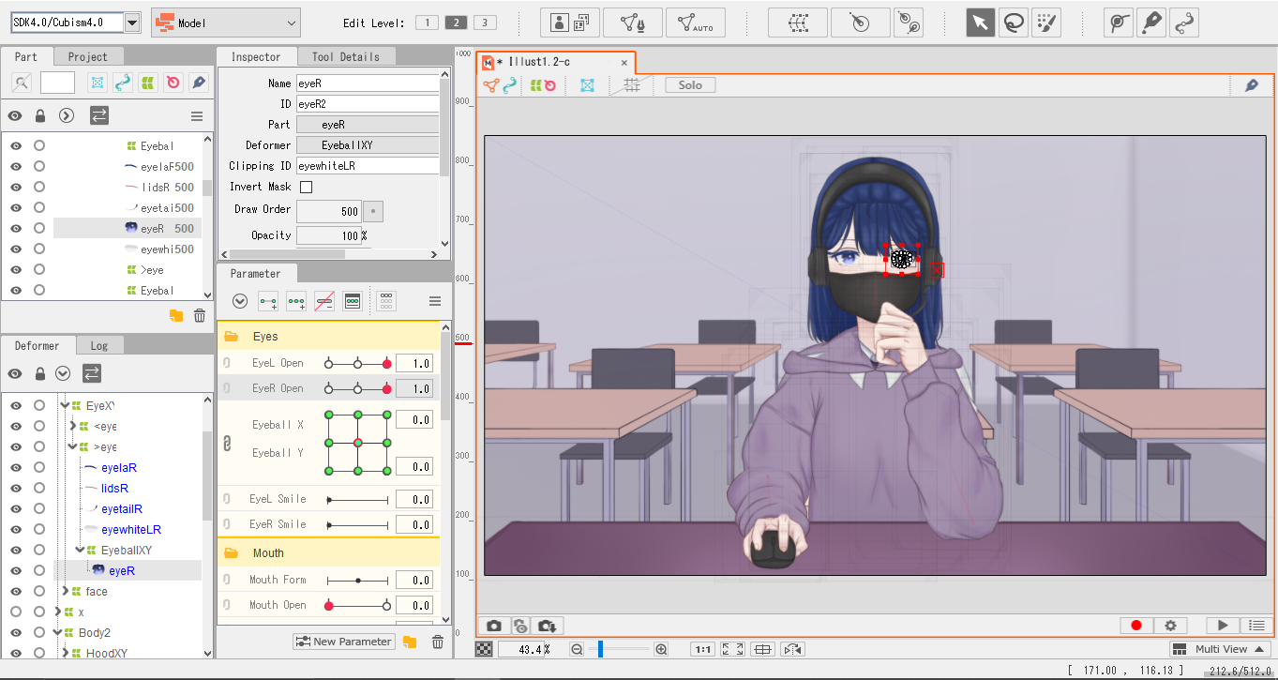

Animation Process:

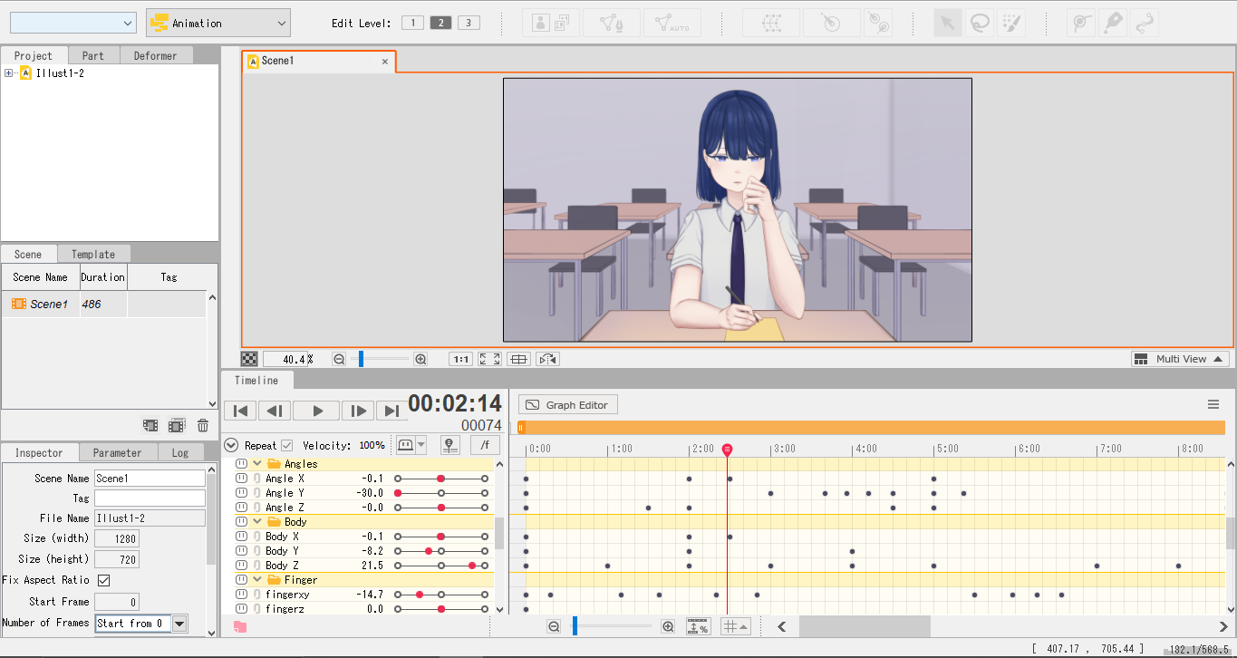

Appendix E
Marketing Collaterals

Poster

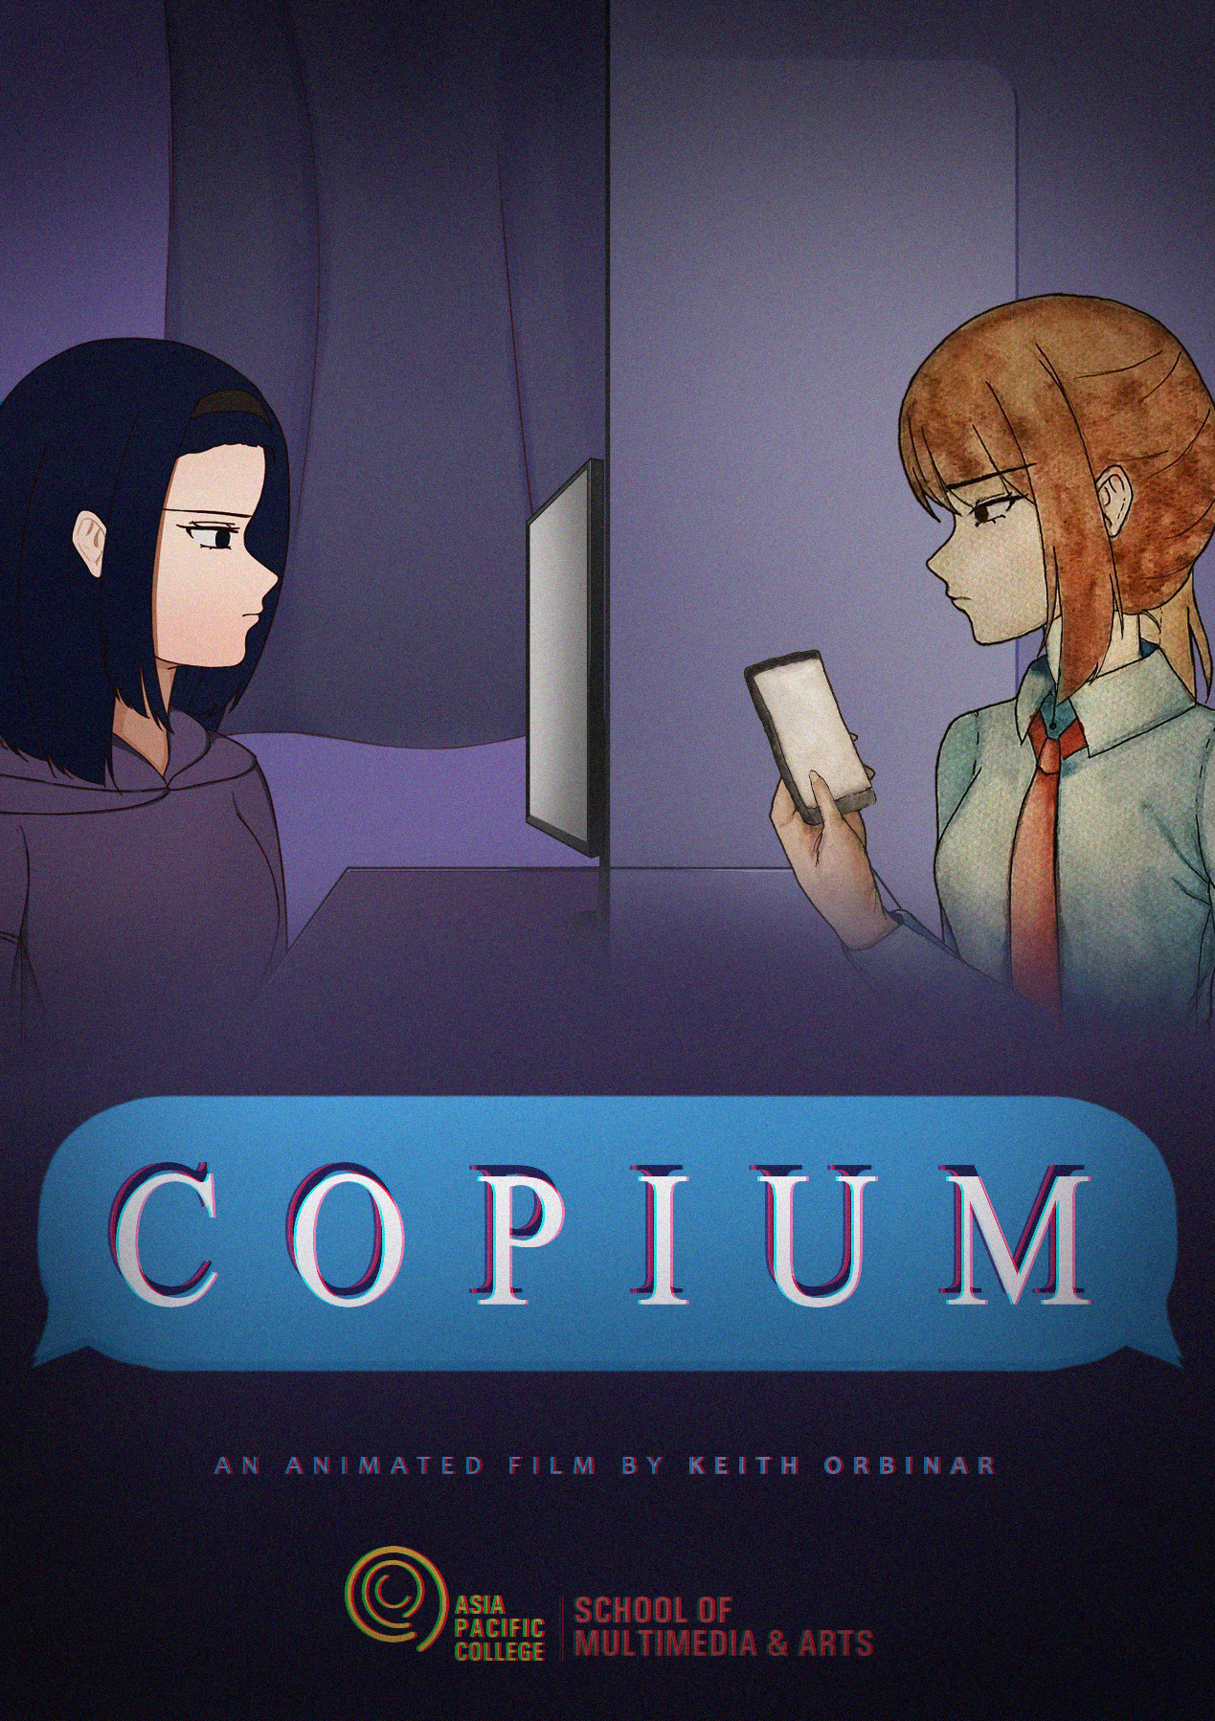

Website

