***BAHAGHARING SINULID:* A MINIATURE EXHIBIT SHOWCASING PRINTED PATTERN OF TRADITIONAL FILIPINO *YAKAN* FABRICS AS AN ELEMENT IN CREATING TRENDY FASHION CLOTHING FOR WOMEN.**

Margaux Allyson Pasturan

**Co-Authors**

Mr. Ioannis Sicuya

Ms. Agnes L. De Vera

**Abstract**

The Philippines has a rich and diverse culture, from languages down to the different traditional clothing each region has, it is indeed something that a Filipino must be proud of. However, the indigenous tribes still struggle in protecting and maintaining their own culture and traditions. Yakan weavers from the island of Basilan, are one of the Indigenous communities that works hard in keeping their tradition alive. Local designers started to make their move and help these tribes in showcasing their fabrics through the creation of their modernized pieces, but this must keep on going, to keep the flow moving until a lot of people would be able to recognize a traditional Filipino clothing. By showcasing a miniature collection of the trendy clothes incorporating the traditional Filipino fabrics in a diorama, *Bahagharing Sinulid* aims to entice young women in proving that anyone can still be trendy even if they wear clothes with elements from the Yakan fabrics on it.

***Keywords****:* Yakan, fashion, woven, miniature

**Introduction**

Earlier this year, I noticed a lot of Filipino designers like Renee Salud have been using traditional fabrics in their collections like fabrics from Cordillera region and Maguindanao which were designed to a more modern form (Garcia, 2018). There are also Inabel from the Ilocos region, T’nalak from the T’boli tribe in South Cotabato or Pina fabrics that originated in Aklan in their custom-made pieces that are quite popular among the upper class. They are mostly seen wearing it during important events like press conferences or formal dinners. Senator Pia Cayetano wore a dress made of Yakan fabric by local designer OJ Hofer with a maroon blazer at the opening of the 19th congress (GMA Network, 2022). Upon seeing these, the handwoven fabrics of our indigenous tribes can be compared with famous luxury brand apparels like Chanel and their tweed-made blazers. Tweed fabrics are handwoven, and they come in colorful threads, the same as traditional textiles here in the Philippines.

This has inspired me to design clothes that are in the trends right now and use our local handwoven fabrics as key elements to the clothes. Trends such as clothes that lean on street style fashion since the target of this output are young adults, women to be specific, is more popular to that age group. That trend was created by the youth from the streets and has been an inspiration over time. but what makes it a never-ending style is because of how it gives comfort and creative freedom to people who like to style themselves in their own way. Clothes like cropped jackets, wide-leg pants and maxi dresses are examples of fashion pieces that are currently trendy or popular. If traditional fabrics were incorporated with a trendy fashion garment and worn by a lot of young women, then a lot of people would be able to appreciate our culture more and realize that we can still be fashionable in garments that use traditional fabrics.

**Figure 1**

*A Visual Representation Framework of Using Yakan Fabrics in Creating Trendy Clothing*

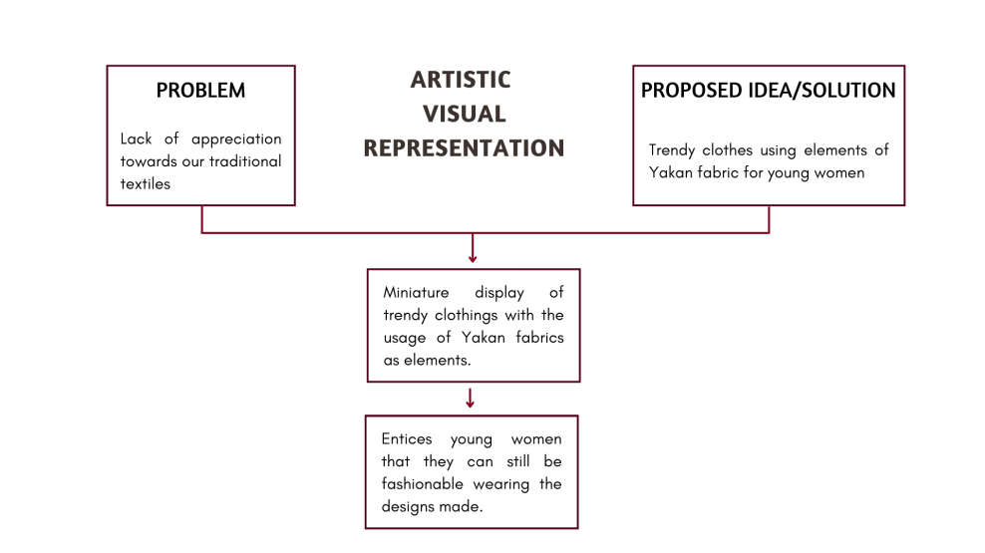

The project will start by planning out the idea for the whole output then sketching it for the clothes and the diorama where the finished outputs are displayed. Setting the sketch for the diorama aside, I will create the sewing patterns on a piece of paper and organize the patterns to check if there are any mistakes in the measurements. Then this will also serve as a guide in cutting the fabrics neatly. As an alternative for the original size Yakan fabric, I will be getting a high-quality image of a Yakan pattern and print it out on a fabric in a smaller scale. Smaller details such as zippers, buttons and threads will be chosen out carefully for each clothing piece that I will make. After this is done, I must pin the cut-out fabrics together to visualize the expected output once it is sewn together. I can sew the inner layer of the clothes that are needed like for a skirt or jacket but if it is a different piece, a shirt, then I will sew the fabrics immediately. These designs are suitable for women ages 17 to 25 years old. For trendy style, I am going to use a cropped jacket as an example of the apparel that I am going to design. These will be displayed in a diorama for the audience to visualize the ideas that I wish to convey.

According to Jean Baudrillard (2018), a French sociologist and philosopher, contemporary culture is postmodern. It is distinguished by multiplicity, detour, severe fragmentation, and indirection. He ascertains it is mass media that incite desires and object seduction, thus transforming modern society into a strong consumer culture (Habib, 2018). Post-Modernism theory will be the basis of this research, to show how much impact slow fashion can have on society and its relevance to using local materials on high quality products. The creation of the proposed output aims to prove that it is possible to integrate traditional Filipino designs into current fashion trends and that it can entice young women into including these pieces as part of their wardrobe.

**Research Design**

The theme of this project is incorporating modern designs with traditional Filipino fabrics, in order to know more about the cultures and beliefs of the Yakan tribe in Zamboanga, Philippines, I will interview a shop who sells traditional fabrics where I will be buying the Yakan fabrics from. Sellers are also responsible for selling traditional fabrics to their buyers since they might sell the fabrics to buyers who lack knowledge of the textile they are purchasing; hence, I may be able to get answers from them that is also within my reach since Yakan weavers are based in Mindanao. I will also be handing out surveys to young women ages within 17 to 25 to collect data and information for this study. I want to know the point of view of young women regarding their fashion sense and styles. They are interested in today's generation and what they think of modern designs coexisting with some traditional elements on it. From the given answers, I will get inspiration and basic ideas on what designs I will come up with the modern styles and usage of the Yakan fabric. This questionnaire will be done online, and I will specifically target young women.

**Target Audience**

My target audience are women ages 17 to 25 in general and it includes women who like to style themselves or those who like fashion, since young women in today’s generation are stylish and love to create their own outfit of the day.

**Design Process**

My creative output will be a miniature of clothes that are trendy and have an element of a Yakan fabric. For the trendy styles that will be made, I will base the designs from the answers of my interviewees and include designs that are currently existing already. This will showcase that modern and traditional can coexist in style. The type of fabrics that I will also choose will lean towards comfort since young women often go out and do their daily activities, however, I will also use fabrics that will focus on the quality rather than comfort and its lightweightness. The mannequin will be displayed like how clothes from a physical store are also displayed, such as putting them on a table or having it displayed in the middle of the store.

**Pre-Production Phase**

The pre-production phase for this project, I will create a Gantt chart to organize the tasks that I need to do in order for the output to finish on time. During this time, I have collected all the references and information I need to help create the designs for the clothes. It is also in this phase where I will have 70% of the materials I need for the main output. Towards the end of the pre-production stage, I must start sketching designs for the output.

**Figure 2**

*Materials for the Mannequin*

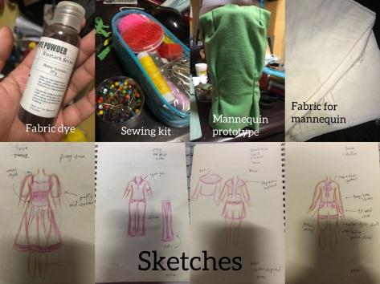

**Production Phase**

In the production phase, I will be making five mannequins in ¼ scale using canvas fabric then dye them in Bismark Brown. Its stand is made from wood and I will cover it in black felt paper, the stand measures 17.32 inches. After the mannequins, I will finalize the designs of the clothes that I will be making. Then I will start to create prototypes of the clothing pieces to ensure that the measurements are right, I will also check whether I am satisfied with the forms of the design I made. Once everything is finalized and measurements are met, I will have a digital copy of the Yakan pattern and edit its size on my computer then test the sizes out if they will create an exact replica of a regular sized Yakan fabric but in a mini version. After that, I will get its printed copy on a fabric that has the same texture as the Yakan fabric and will use the sublimation process to receive a better quality of the printed pattern. Once everything is prepared, including my fabrics, I will now sew permanently the five outfits that I have designed. For outfit number one, it is a Chanel inspired tweed jacket and skirt. For outfit number two, it will be a maxi dress that has a corset style. Outfit number three, it will be a simple hanging button shirt and a pair of denim ripped shorts that has a unique placement of buttons. For outfit number four, a Y2k inspired top partnered with a denim skirt. Lastly, outfit number five will be a sheer blouse and wide leg pants. After that I will apply additional materials such as beads, buttons, etc.

**Post-Production Phase**

For the post-production phase, I will continue the clothes that I was not able to finish during my production phase then I will start creating the diorama display for my mannequins. Its base will be made from 33 inches by 36 inches wood and three of the mannequins will stand on a 10 by 26 inches wood that serves as a table just like how clothes are displayed in stores. The other two mannequins have a three-by-three width at the bottom of its stand while they are placed on top of the base of the whole display in front of the other three mannequins. To make the display simpler, I will just apply vinyl wallpaper for the floor and create two mini clothing racks on each side. The whole theme for the diorama display is the interior of a modern clothing store.

**Review of Related Literature**

In this chapter, the sub-topics related to my thesis output Bahagharing Sinulid, discusses how fashion trends change over time and the possible impact in using traditional textile into a modern style clothing. This serves as a path in planning my output in the right direction.

**The Impacts of Incorporating the Traditional Philippine Woven Textile into the Country's Modern Style Clothing**

According to Danielle L. Castro (2022), incorporating the traditional Philippine textiles into modern style clothing that uses the fabrics itself, will be able to help support the Filipino weavers but it cannot produce high production and it will only be reachable to the upper class. Castro also mentioned that using only the design or patterns of the textiles can also help showcase the traditional designs and it is also cheaper since it can be mass produced but it is also open to imitations from different shops. Despite having a lot of advantages, using the traditional Philippine woven textiles can have a lot of disadvantages as well. As a designer or producer, they must be mindful of the meaning behind the patterns from the fabrics because it may contain a special or cultural belief from the tribe and commit a conflict with the indigenous community. One example is the death blanket of Ifugao, no one should ever use it for a different purpose other than that specific reason since it is a sacred heritage of their tribe. Another disadvantage is that buyers may commit cultural appropriation, as a seller you must know how to educate the people you sell the fabrics for but there are businesses that are unethical, and the buyer might fall victim. As a consumer, you must also do your own research before buying and using an item from a culture that is not yours.

Incorporating the traditional fabric into the modern fashion clothing can really help the weavers in improving their livelihood and being able to get the proper credits from their handwoven piece but its downside is that the local weavers would not be able to meet the high demand of the fabrics since it takes them a week or so in creating the fabrics and the upper class may be the ones to be able to gain access to these remarkable garments. Moreover, if people can practice this more and give stricter protection to the Indigenous tribes then our culture and history will be well known.

**Yakan Woven Clothing**

The Yakan tribe from the island of Basilan, Zamboanga have a rich culture and tradition in clothing. They have basic garments for men and women, beautifully embroidered on their tight-fitting shirts and the fabric used are the most expensive since they are woven and mostly with silk threads on a cotton background. Over time, there have been major changes in both the weaving of Yakan and the wearing of traditional clothing. These days, men can mix traditional and western dress for more casual situations whereas they are only used for festive events. With either a long skirt or loose pants, women wear loosely hanging thin blouses. Yakan fabrics are known for their bright and eye-catching colors with geometric patterns. The specific patterns that they weave have significant beliefs within their tribe and its motif are mostly related to nature (Insigne, 2022).

Due to the changes of the environment through time, even how the Yakan people dress have changed in the slightest but their culture and traditions remain the same. Even the materials they use in weaving their fabrics changed, they used plant fibers before but they are now using polyester-cotton. The master weavers of the Yakan community are strong willed as they try to keep the tradition alive, now, people try to make use of their fabrics as a part of their everyday living.

**Trendy Fashion**

Fashion trends tend to change over time and these come quite handy with fast-fashion. Whereas fast fashion seeks the demand and follows the pace of consumers within the industry, and they are being processed into mass production using man-made materials. Once the trend is out of season, the possibility of the unsold pieces being thrown away into the dumpster are higher in which creates a negative environmental impact. When selecting clothing pieces, consider their qualities in terms of what makes them current or classic and how that may affect your particular tastes or sense of style. It is a rare find to have an item that is trendy and its style can also last for a long period of time. Just like Chanel’s famous tweed jacket that have not gone out of style since its first production in the 1950s and its impact on today's fashion industry have made numerous companies creating replicas of the famous tweed jacket to mass produce them for the consumers. This has shown the fashion industry how great Coco Chanel’s iconic design is, it would never go out of style and it would last for a long period of time with its hype still there (Cary & Pithers, 2020).

Knowing both the trend and what might be considered timeless style would greatly help me in my output for choosing the designs for the clothes that I would make. To create an outfit that people would still think is fashionable over the years.

**2023 Fashion Trends**

Most people do not realize it but what they see at boutiques and worn by famous celebrities are a few pieces of clothes that are currently trending. Some may even have a clothing piece that has existed since then but style them differently for this year. In an article from Insider (insert year), they mentioned that we would be seeing more shades of green this spring to pre-fall. It would be difficult to style them with your other pieces, but it is a good challenge to shake up your fashion sense. One of the stylists they interviewed, Jackie Condura, said that people are still into blazers and that by 2023 people will continue giving a mix and match of outfits with it. They have also said the revival of 1990s style and Y2K may also be the reason why blazers would trend this year. For Elle, on their list maxi skirts are getting the spotlight from the fashion runways and it would be part of the trend this spring. Maxi skirts and maxi dresses are also currently getting popular, it has become part of a lot of street style fashion by many and have styled differently in a unique way. Lastly, sheer clothing pieces are also having their comeback this year. Its fabric is perfect for spring- wherein it is also good for the weather here in the Philippines. It is lightweight and can be styled in different ways, it may be in dress form or even a turtleneck.

**Figure 3**

*Chanel Look 29 in Pink and White Cotton Tweed Jacket and Skirt*

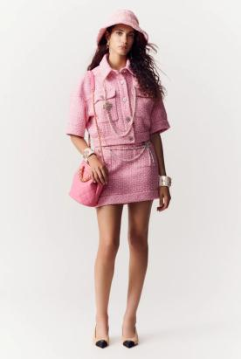

A lot of the fashion trends for 2023 are mainly a revival of existing trends from the past. It is also a great challenge for the designers to come up with a more modern approach from the vintage style of clothing pieces that have already existed. However, there are styles that are also never-ending when it comes to being trendy and one of them is Chanel tweed jackets or two-pieces.

**Diorama Display**

Often contained in a cubicle and viewed via an aperture, a diorama is a three-dimensional show that is often miniature in scale but can also be a larger scale. Dioramas use elements like straw, wood, cables, old cartoons, and the environment to create representations of objects, assets, and surroundings using a number of different visual means, and putting these ideas into practice using various tactics and methodologies (Mahmoud, 2019). We can often see dioramas in museums as they are used in recreating real life miniature displays of historic places or things with symbolic meanings. It helps the audience have a 3-Dimensional visualization of stories that they wish to see but cannot do so. Other dioramas are often used in architectural projects for engineers and clients to see the infrastructures that they are visualizing to build in real life. Besides using dioramas in an academic or business-like way, they can also be used as an aesthetic display of art and be a medium for artists to convey their feelings or emotions. From Mahmoud’s journal, it was recommended to take advantage of dioramas in tourism initiatives, creating models of the many Iraqi landscapes, ancient sites, religious shrines, and holding exhibits of them overseas serves as an attraction for travelers. This is also a great way to help tourism in the country and dioramas can also be made to be sold as a souvenir for tourists to take home to their country.

Creating dioramas can be fun but very challenging as there is too much work to do and very little details to focus on. Despite all those things, once you have seen the output and see the audience’s reactions then there is a sigh of relief and contentment for what has been done. There are a lot of approaches and artists are clever enough to grab the attention of their audiences, they are able to convey the message they want to say through their artworks.

**Review of Related Works**

The Philippines has a diverse culture and traditions but most of today’s generation have forgotten how our country has a rich heritage like the traditional fabrics of each region here in the Philippines. I will be introducing a few local designers and their works, incorporating traditional fabrics in their designs and how it may be possible in wearing it as a street style fashion.

**The Rise of Traditional Filipino Textiles**

One of the rich cultures of the Northern Ilocano is their *Inabel*, any product that is hand woven with intricate details and is made from local materials. Fashion designer Mitch Desunia has seen the potential of this traditional hand-woven fabric in bringing it global through her designs. The loss of demand for the fabrics have also made Desunia realize that these local weavers will continue to lose their income and livelihood if they cannot sell their handwoven works well, so she used this opportunity to help them and created a new collection to be shown on a runway internationally. Desunia believes that Inabel is comparable with other luxurious clothing brands more specifically the clothes that are made from tweed fabric since both the Inabel and the said fabric have a beautiful design and has an excellent durability (Manipon, 2019).

**Figure 4**

*Mitch Desunia with Her Craft*

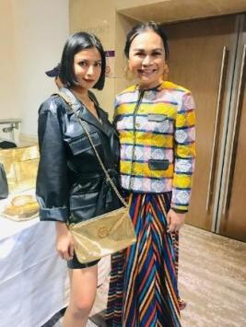

However, this would not be enough for the traditional textiles to have a continuous success in the fashion industry as well as gaining global popularity. Looking at the number of people knowing and buying these kinds of clothes are only evident to the elite class, adults to older adults, historians or those who are widely knowledgeable in the fashion/textiles field. This shows that if Filipino designers pursue traditional Filipino textiles in creating modernized clothes, local weavers and their works would be more in demand and will greatly help them in their everyday lives. Not only will it help the local weavers but this will also strengthen the culture of these indigenous tribes in the Philippines.

Desunia is a great example for incorporating traditional Filipino textiles in today’s fashion style, although it is on the fancier side, young women may still use her works as a part of their outfit for street style fashion and the jacket she is wearing in Figure 5. can be compared to blazers that mostly people use as a casual fashion right now.

**BAYO and HABI Collaboration**

**Figure 4**

*Amihan Kimono Top from BAYO in Collaboration with HABI Council*

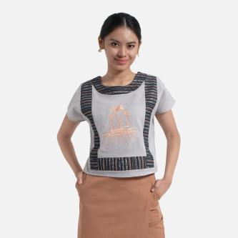

BAYO is a women's clothing store in the Philippines, showcasing high quality and affordable items that are locally made. Rather than importing goods from different countries, they offer products using local materials such as cotton and abaca which are also grown here in the Philippines. The brand is also one of those who promoted the local weavers in one of their collaborations with HABI- a council for textiles in the Philippines. Their designs are sleek and beautiful with a touch of traditional patterns in every corner of the clothing, the price is not that friendly for those who seek a cheaper product but what awaits the people is high quality clothing made by Filipino themselves. President of HABI, Laida Lim says "The collaboration with BAYO is just the start. With the HABI Connects initiative, we hope that more company owners and entrepreneurs, not just in the fashion and lifestyle sectors, but also in other sectors, would follow suit and assist our regional weaving communities.” (Andas, 2021) Towards this path, just like BAYO and other local brands or designers, the Philippines’ traditional textiles would be more in demand and will be more appreciated by a lot of the new generations making the lives of the local weavers have a better future.

The brand made a smart move in collaborating with the HABI council as they also advocate their local seamstress and support the Philippine tradition- by using homegrown materials like cotton. Since BAYO is a brand that most women know and where anyone can see the store in the malls or public spaces, it was a great strategy to further showcase the Filipino traditional textiles through them.

**Influencer Models the Traditional Fabric**

**Figure 5**

*Buko Jacket*

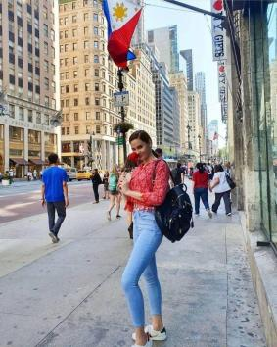

The Philippines’ Miss Universe 2018 Catriona Gray is seen wearing clothes that are made from Yakan fabrics in most of her posts on social media. As seen in Figure 6, Catriona is wearing a red buko jacket from an all-female owned brand named PNay. The beauty queen has been proudly using the shop’s products and actively encouraging people to support their business as well as appreciate more the culture and traditions of the Philippines. PNay transforms the traditional Yakan fabrics into beautiful contemporary wear that you can use in your everyday lives, keeping yourself still stylish with the traditional touch on it (Tinga, 2020).

Catriona Gray, a famous individual, used her platforms in letting everyone know whether local or not that wearing traditional fabrics can let you still style yourself along with the trends. She has succeeded in that part as people piled up in her comments asking where she bought the apparels she wore from PNay. The brand was able to create garments with the traditional fabrics into casual wear that anyone can pair with whatever clothing they have in their closets.

**Dior Digital Haute Couture**

**Figure 6**

*Le Mythe Dior by Matteo Garrone*

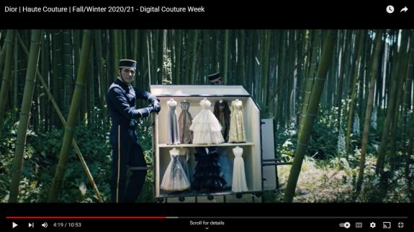

Dior has made a new way of delivering their fall/winter haute couture for 2020/21 and it is through film directed by famous Italian director, Matteo Garrone. As seen in Figure 6, their miniature collection is displayed inside a doll house-like vessel and the location is in a forest that portrays the theme of their couture which is fantasy. The Dior Fall/Winter 2020-2021 haute couture collection is offered on a miniature scale, translating the feminine form through the silhouette of a fashion doll. This is done to push the practice of tailoring to its pinnacle. In fact, this is how the dresses and costumes the designers had planned for their clients were displayed in the early days of haute couture. To the beat of composer and conductor Paolo Buonvino's music, it is consequently a return to the essence of couture, brought to life by mythological creatures that bring a special touch of magic to these works (Salessy, 2020).

**The Dior Couture Workshop**

**Figure 7***Léna Situations Visits the Dior Couture Workshop via Vogue Paris YouTube Channel*

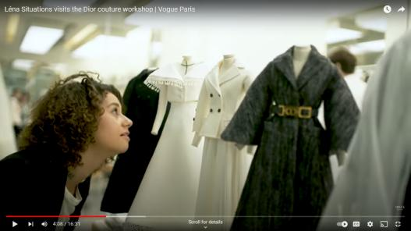

Lena takes a tour inside the workshop of Dior days before the couture fashion week and sees how the clothing pieces are made by the experts. It was shown in the video how Dior carefully does their job with passion. After sketching the designs for the couture, designers create a miniature scale to visually see the outputs before having it made for the runway.  
  
 The process that Dior did is a good approach in visualizing the designs in a more realistic manner before actually sewing real scale clothings. This kind of approach helps the audience see the designs up close rather than going to runways that require connections and invites to be able to see the ready-made collection.

**Results and Discussions**

In this section, I conducted qualitative research in the form of an online survey to know the opinions of my target audience in this thesis project. I mostly asked their own preferences and what they wish to address to designers as well as the aspiring ones. Each respondent was also asked to upload photos in order to help me have a general idea on each of their preferences in fashion.

**Online Survey Results**

1. ***Do you like styling yourself?***

**Figure 8**

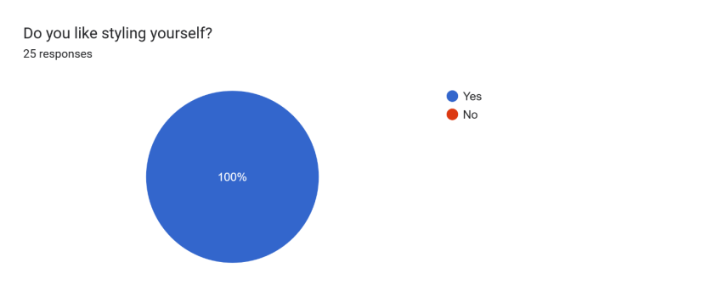

I asked the respondents if they are interested in styling themselves or they let other people give them ideas on what to wear. In most cases people who likes to style themselves tend to invest in planning on what they should wear or find the enjoyment in choosing the clothes they have to wear. If they like it then most of the young women are open to wearing the clothings that I have designed.

1. ***What do you think is the best part of your go-to outfit?***

**Figure 9**

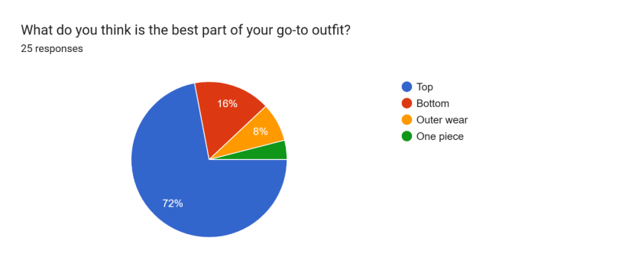

Knowing the garment that they like most in their outfit helps me in thinking about the designs and putting a lot of effort to it.

1. ***Do you know any traditional fabrics here in the Philippines? If yes, please name them. Leave N/A if none.***

**Figure 10**



**Figure 11**



Traditional Yakan fabrics are known by a few and little of them know the wide variety of Tradional Fabrics in the Philippines, knowing their answers helped me in identifying whether or not they really know the different fabrics from each ethnic groups.

1. ***From the pictures shown, do you think you can find them in one of your future outfits? (Kindly explain your answer)***

**Figure 12**

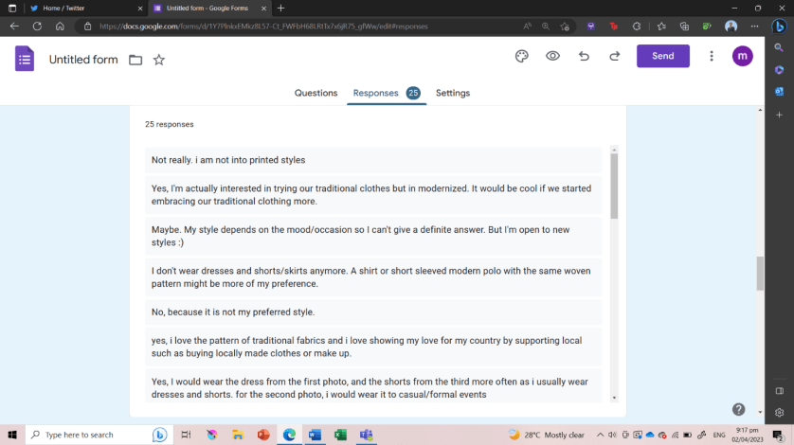

**Figure 13**

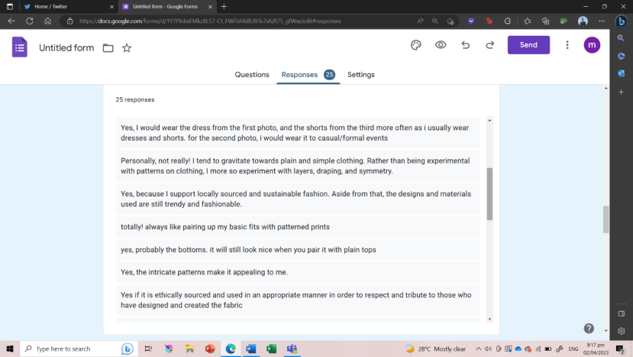

**Figure 14**

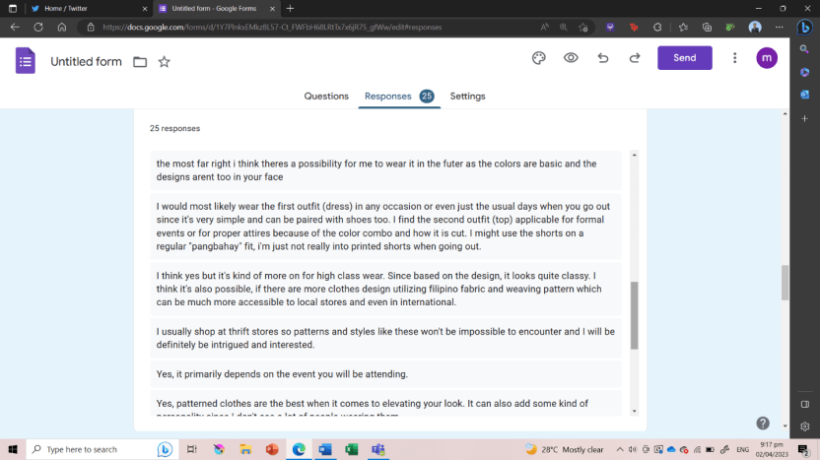

**Figure 15**

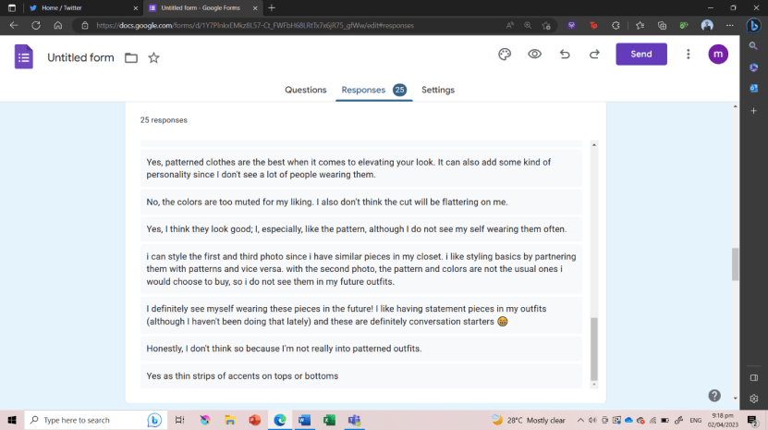

There are existing modern clothes using traditional fabrics made by local designers, however, most of the designs are suited for the age groups 30 and above but since there are younger designers now, the modern clothes have been slowly adjusting to the generation. As seen in Figures 1.5 to 1.8, most young women are willing to wear clothes that has traditional fabrics on them but there are also people who does not have the same taste.

1. ***What kind of designs or styles do you think designers should consider in creating trendy clothes that has traditional fabrics on them? (Upload sample photos)***

**Figure 16**

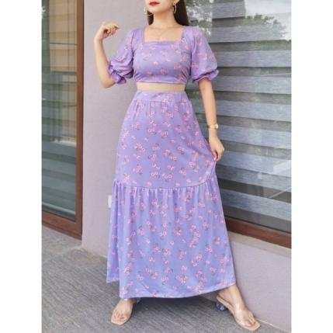

**Figure 17**

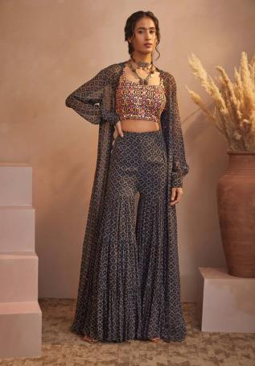

**Figure 18**

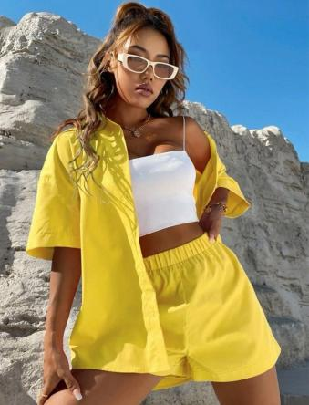

**Figure 19**

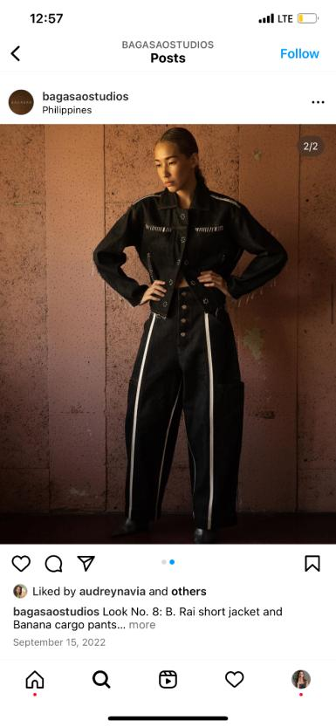

**Figure 20**

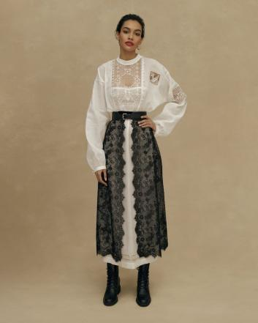

I requested the respondents to upload sample photos so that I have a better understanding on what kind of clothing styles do they want to see the traditional fabrics in and for them to wear them.

1. ***Do you think traditional fabrics can be trendy in modern clothes?***

**Figure 21**

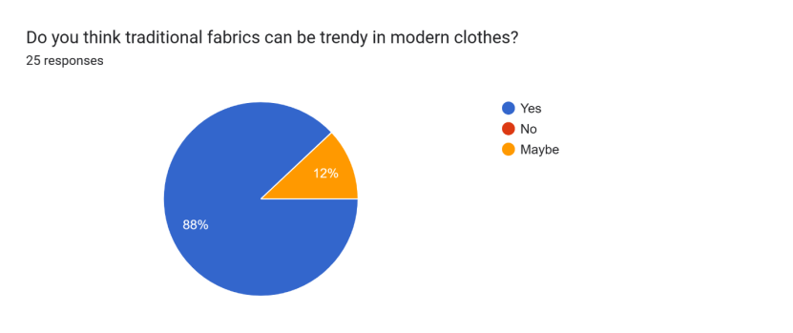

Not everyone likes how traditional elements are modernized, here I asked the respondents whether or not they think traditional fabrics can be modernized as well as be trendy.

1. ***Any suggestions for designers who wishes to create trendy clothes using Yakan fabrics***

**Figure 22**

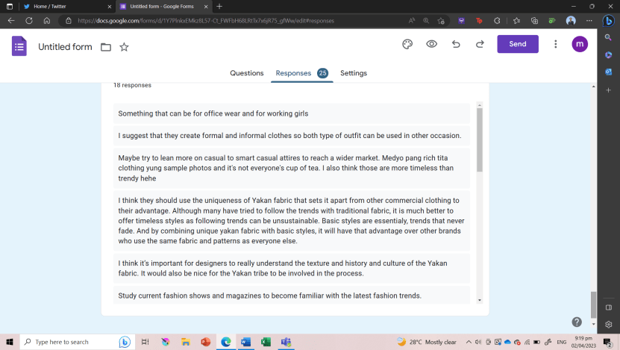

**Figure 23**

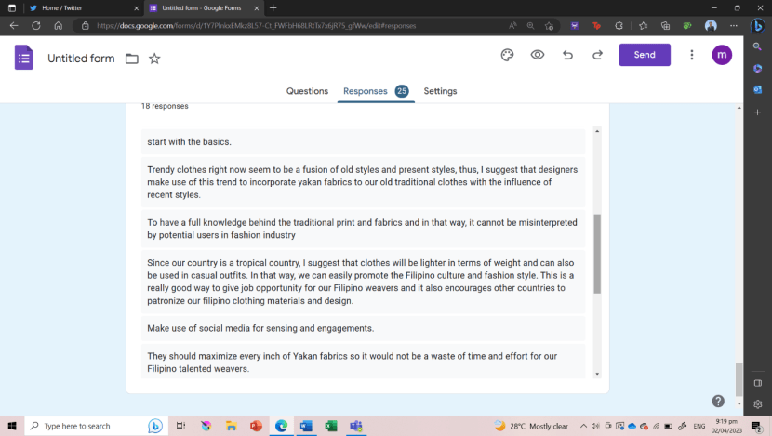

**Figure 24**

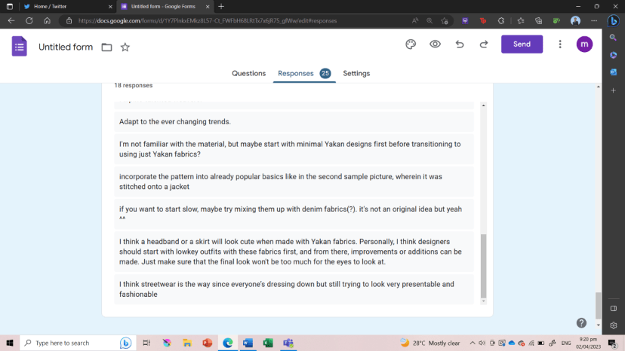

I asked the respondents to make suggestions and comments to designers who wish to incorporate traditional fabrics into their own designs. This serves as a guide in my design process and get to know my target audience better.

**Conclusion**

Using traditional Yakan fabrics require careful approach since it is a culture of an ethnic group, it holds deeper meaning and value to them so designers must always research or directly reach out to specific people from the ethnic group to help them in creating clothes that won’t overstep their boundaries. Since trendy clothes often change over time, the usage of traditional fabric elements must also adjust to depending on what type of clothing are in nowadays as well as knowing which specific age group are targeted.

Through the creative process, it is highly important that the measurements of the mannequins, clothes and diorama are all correct or else the output would not make sense and create distortion to the eyes of the audience. Especially in working with patterns just like the Yakan fabric, to make it look like a miniature version of the original, it has to be resized correctly for it to look accurate as if it is a human-sized clothing. That is why I have come up with the sublimation process so that I can get the patterns and resize them to my desired size, the other technique is painting the patterns on a fabric. However, it would consume a lot of time for me since the Yakan patterns are detailed.

From the survey results, even though they support local there are people who is not into clothes that have bright and colorful patterns on them which is also something to take into consideration in creating a clothing that has traditional fabric on it.

**Recommendations**

**Research Topic**

This research has still room for improvements as trends seem to change every year, so the audience’s opinion and views on each design may vary depending on them as well as how the younger generation may be able to accept having traditional elements like the Yakan fabric on to their clothing. Also, the survey that I have conducted before creating the designs may still improve so that it will be easier for the designer to brainstorm on how should they come up with a new design to pair with the Yakan fabric. Aside from these, make sure to include many review or related literatures as much as possible and have yourself research on the topic thoroughly as you may encounter issues like stepping on cultural appropriation while in the middle of your production process. It took me quite a long time since there was not much research on Yakan groups but it is still better to take your time in learning about a particular ethnic group. I also would highly recommend asking a friend or someone from that specific group and interview them.

**Creative Process**

The mannequins can still improve by making it easier to use in displaying the clothes. Since it is a bit bigger than a regular sized doll, creating the mannequin must include the leg part than only having the dress form mannequin to display. For the miniature display where the clothes will be placed, there should be studies on how the clothes will be shown clearly and for the audience to have a better 360 degrees view of it. At first, I have planned on placing each mannequin per one box and make it look like a fitting room from a modern clothing shop. However, it was not the most suitable display since the audience won’t have a view of the back part of the clothing which might ruin their experience. Instead, I have made the miniature into a simple mannequin display that you would often see inside clothing stores. The whole vibe of the miniature became more subtle since the clothes are the main subject and they are colorful, I chose to have clean and simple colors for the miniature display. This way, the audience will have a better view of the miniature clothes and may be able to take a closer look.

**References**

Andas, C. (2021). *Wear Filipino Textiles Everyday: HABI and Bayo Team Up to Create Modern Weaving Pieces*. Tatler. [Wear Filipino Textiles Everyday: HABI and Bayo Team Up To Create Modern Weaving Pieces | Tatler Asia](https://www.tatlerasia.com/style/fashion/habi-connects-and-bayo-collection-2021)

Cary, A. and Pithers, E. (2020). *18 Ways to Wear Chanel’s Signature Tweed Jacket.* Vogue*.* [The Enduring Allure Of A Chanel Tweed Jacket | British Vogue](https://www.vogue.co.uk/fashion/gallery/chanel-tweed-jacket)

Castro, D. (2022). The Impacts of Incorporating the Traditional Philippine Woven Textile into the Country's Modern Style Clothing*.* [10.13140/RG.2.2.25761.48481](http://dx.doi.org/10.13140/RG.2.2.25761.48481)

Chanel (2023). *Spring-Summer 2023 Pre-Collection.* Chanel. [CHANEL Spring-Summer 2023 Pre-collection — Look 29 | CHANEL](https://www.chanel.com/us/fashion/p/23P-COMMERCIAL-029/look-29/)

Espana, T. M. (2022). [Trendy Vs. Timeless: How To Know The Difference When Building A Wardrobe (msn.com)](https://www.msn.com/en-us/lifestyle/fashion/trendy-vs-timeless-how-to-know-the-difference-when-building-a-wardrobe/ar-AA13O51J)

Garcia, A. G. (2018). *How Renee Salud used PH ethnic fabrics in a special collection.* ABS-CBN News.[How Renee Salud used PH ethnic fabrics in special collection | ABS-CBN News](https://news.abs-cbn.com/life/06/26/18/how-renee-salud-used-ph-ethnic-fabrics-in-special-collection)

GMA Network (2022). *Pia Cayetano dons a bold red and green terno for the opening of 19th Congress.* GMA News.[Pia Cayetano dons bold red and green terno for the opening of 19th Congress | GMA News Online (gmanetwork.com)](https://www.gmanetwork.com/news/lifestyle/content/839268/pia-cayetano-dons-bold-red-and-green-terno-for-the-opening-of-19th-congress/story/)

Habib, M. M. (2018). Culture and Consumerism in Jean Baudrillard: A Postmodern Perspective. 10.5539/ass.v14n9p43

Insigne, Y. (2022). Yakan Tribe of Basilan: History, Culture and Arts, Customs and Traditions [Mindanao Indigenous People | Philippines Ethnic Group]. [Yakan Tribe of Basilan: History, Culture and Arts, Customs and Traditions [Mindanao Indigenous People | Philippines Ethnic Group] - yodisphere.com](https://www.yodisphere.com/2022/09/Yakan-Tribe-Cult.html)

Linea Etnika. (2022). [Linea Etnika](https://www.lineaetnika.com/)

Mahmoud, W. A. (2019). Diorama Presentation Methods. [10.21608/IJAIET.2019.181421](https://doi.org/10.21608/ijaiet.2019.181421)

Manipon, R. H. (2019). *Inabel goes luxe.* Press Reader. [PressReader.com - Digital Newspaper & Magazine Subscriptions](https://www.pressreader.com/philippines/daily-tribune-philippines/20191120/282230897528209)

Tinga, K. (2020). *Meet the female entrepreneurs behind Catriona Gray’s Yakan ensemble.* Manila Bulletin. [Meet the female entrepreneurs behind Catriona Gray’s Yakan ensemble – Manila Bulletin](https://mb.com.ph/2020/10/19/meet-the-female-entrepreneurs-behind-catriona-grays-yakan-ensemble/)

**Appendices**

This section contains images and data that serves as proof of the actions that I did for this project, from the pre-production stage for my paper and output to the final stages of it.

**Appendix A**

**Plagiarism Detector Test Results**

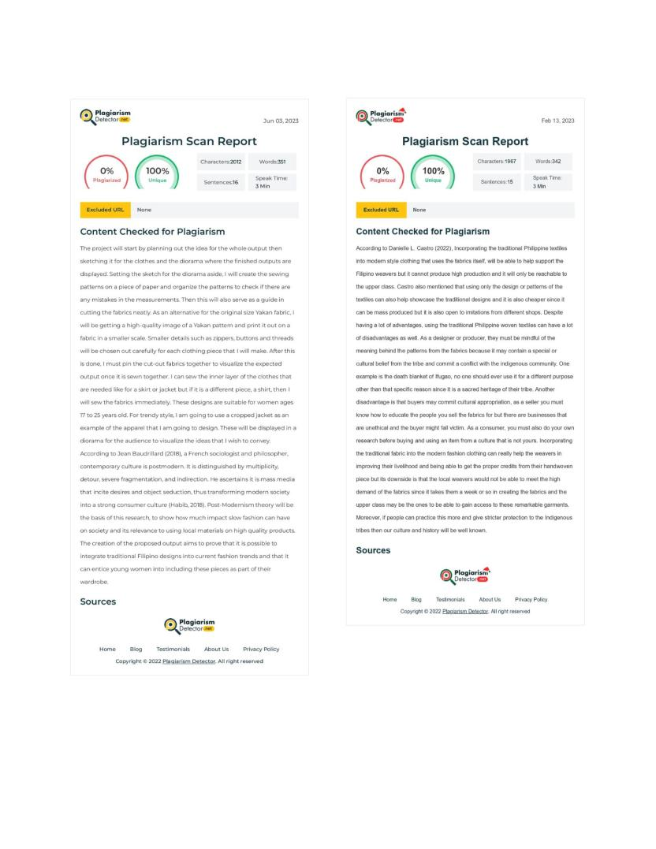

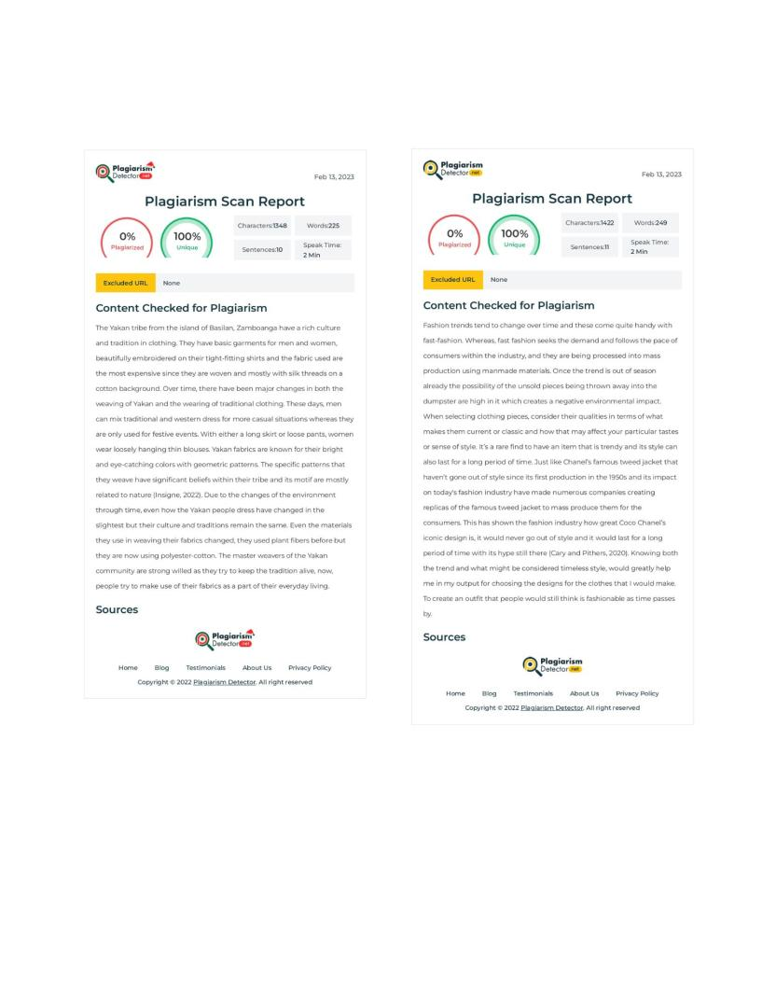

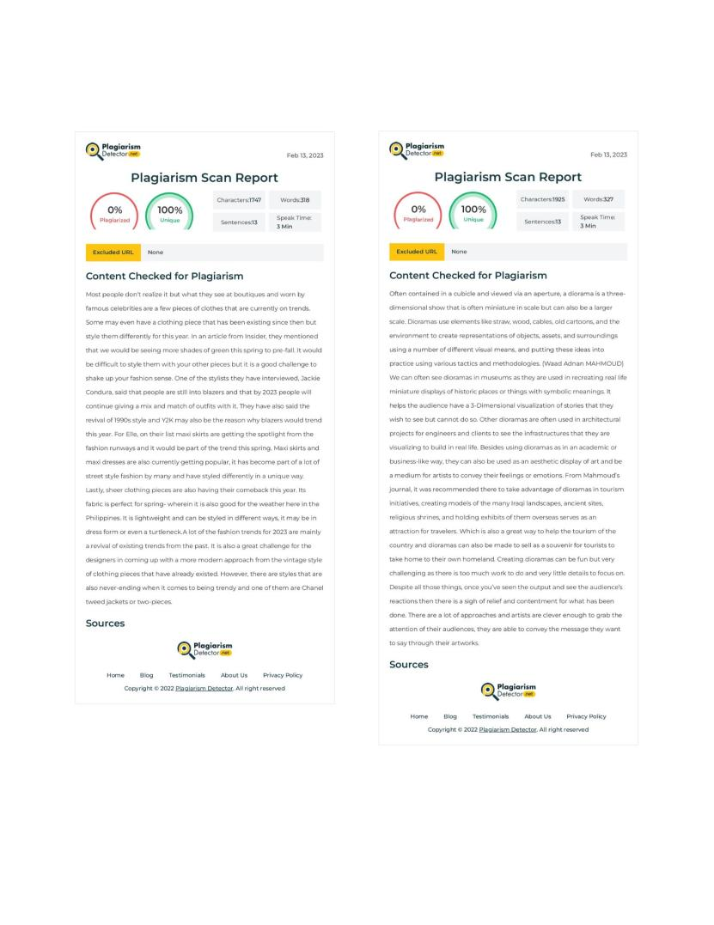

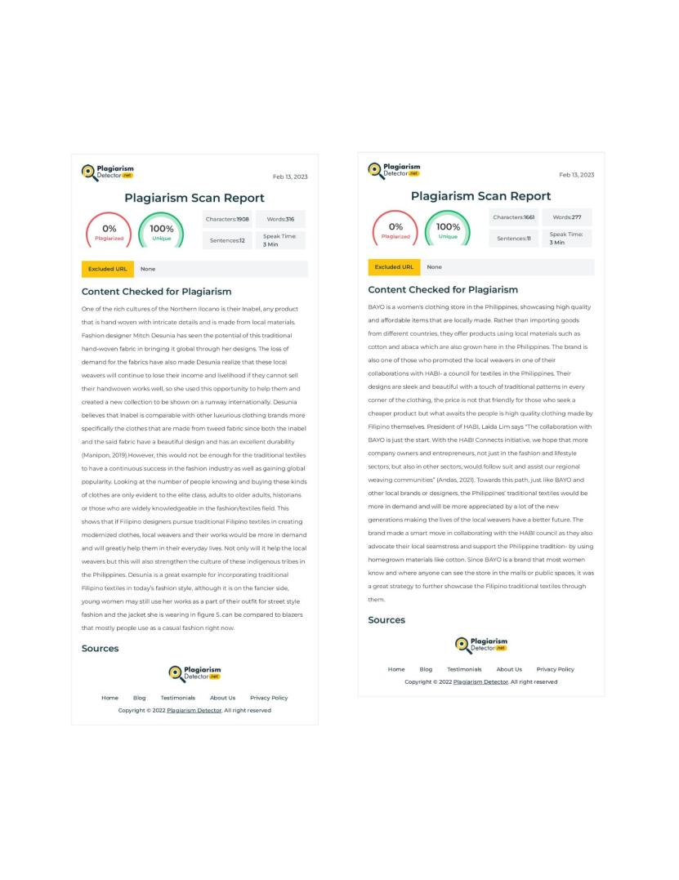

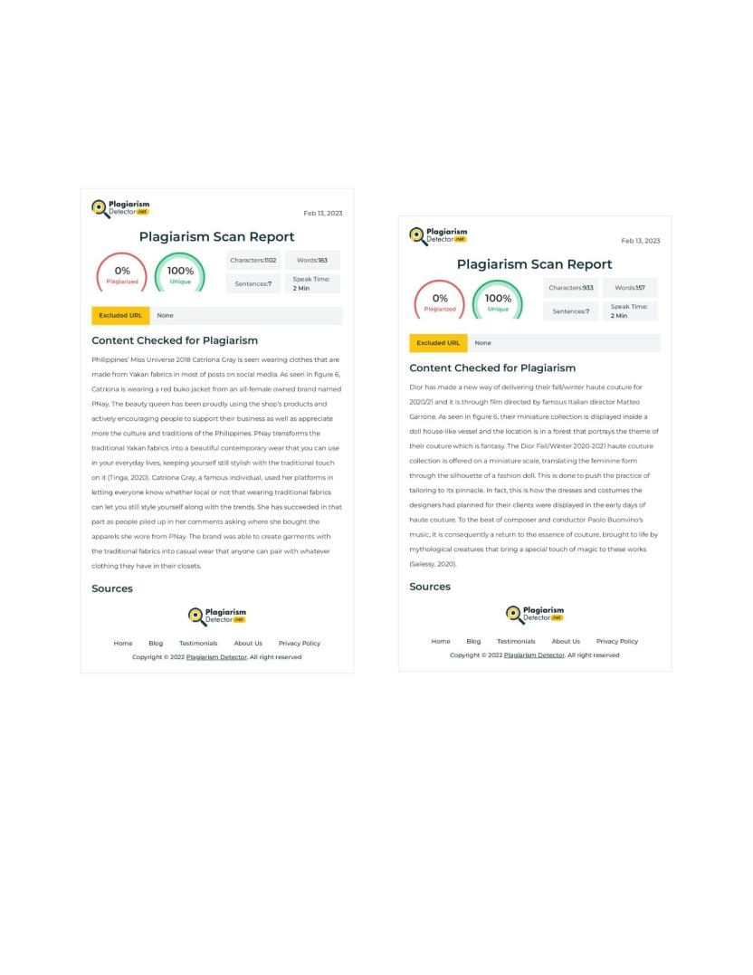

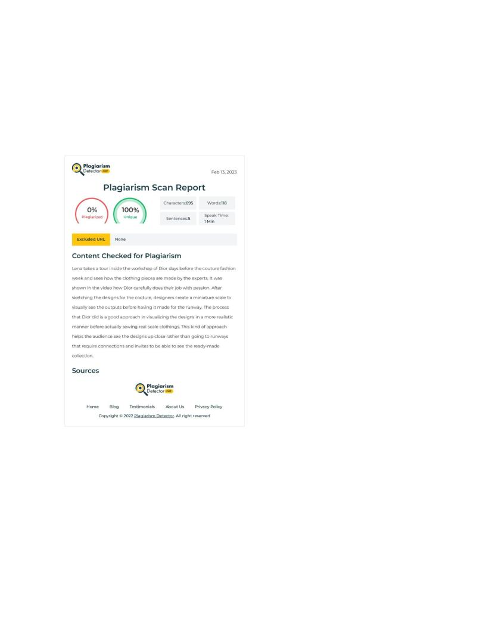

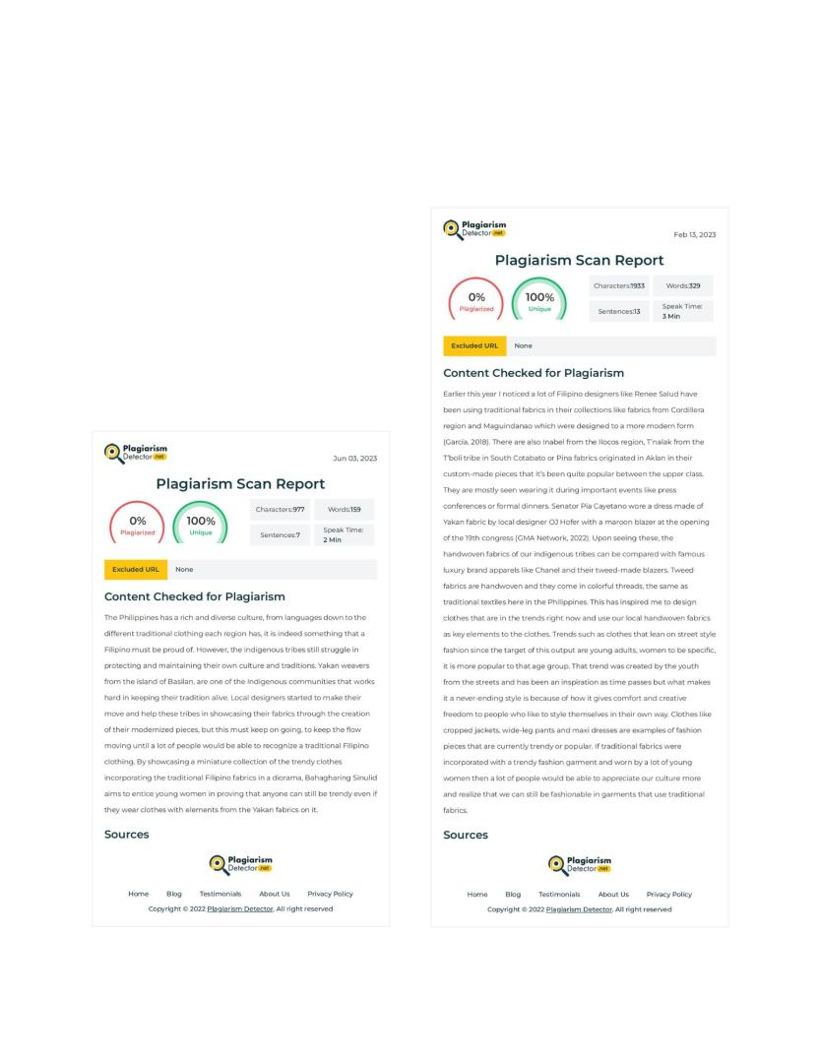

**MMAPRO1 GANTT CHART**

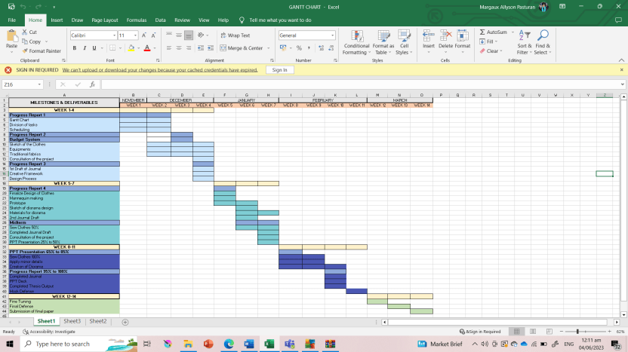

**MMAPRO2 GANTT CHART**

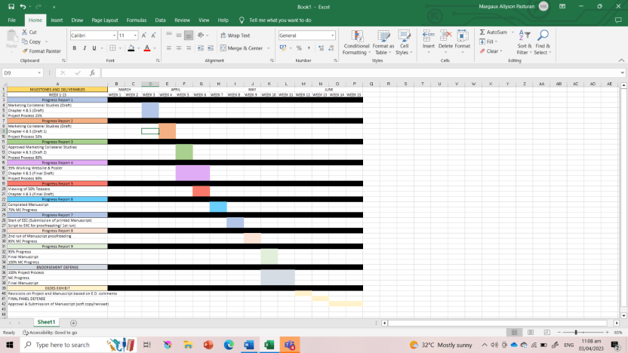

**Appendix B**

**Visual References and Studies**

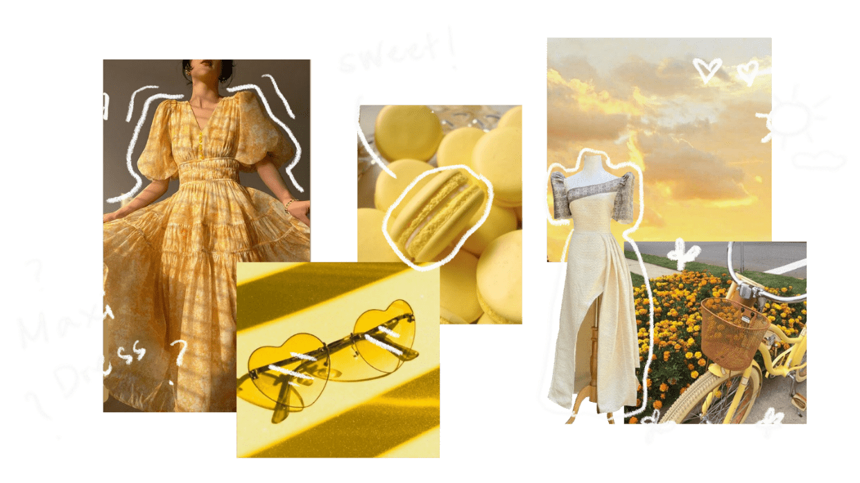

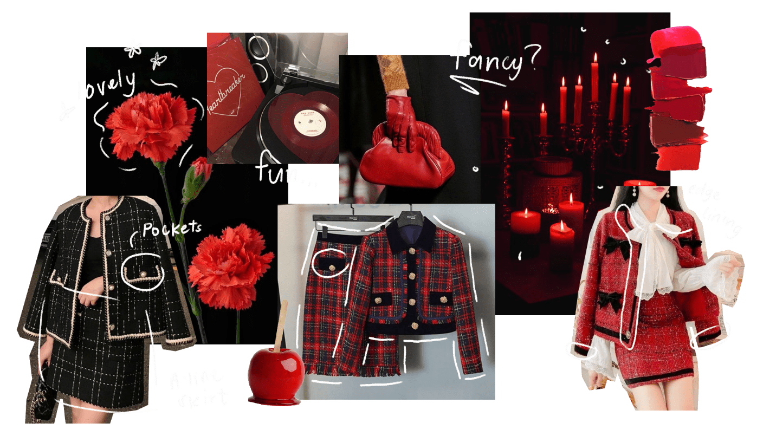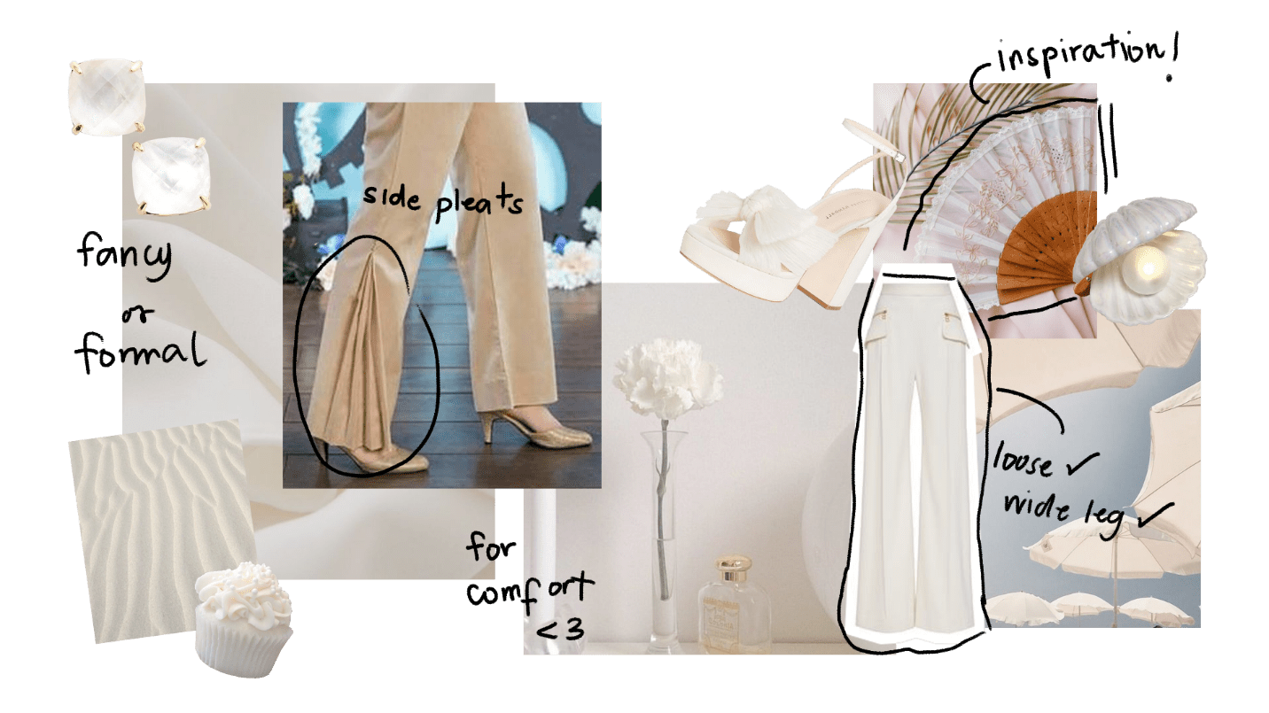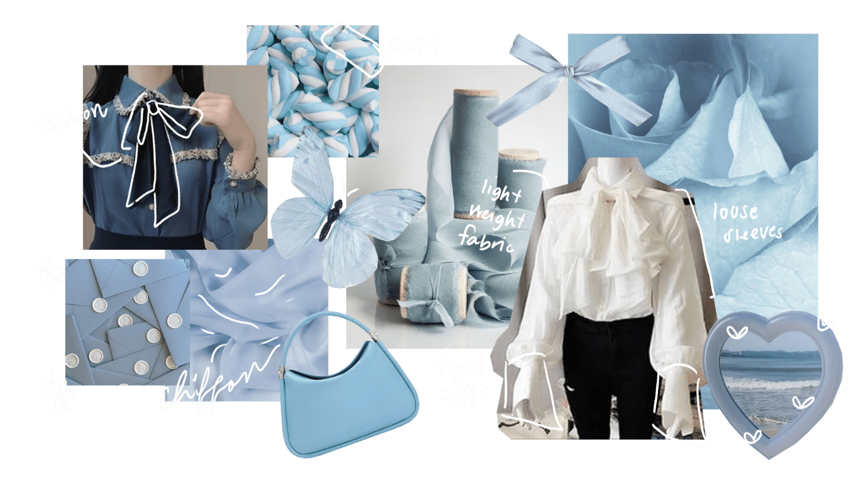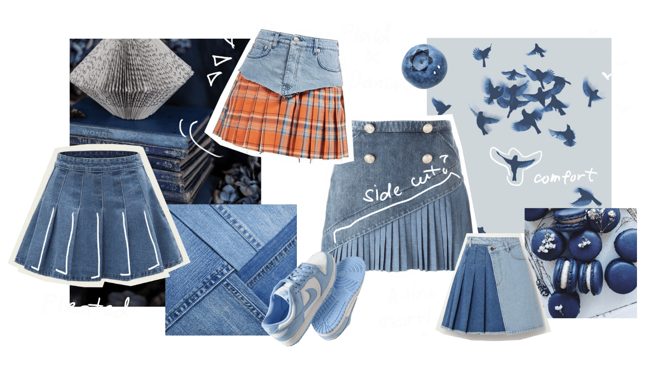

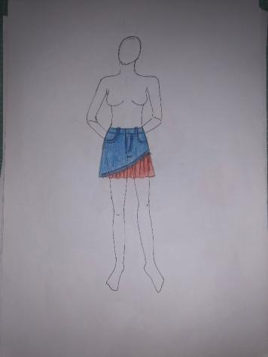 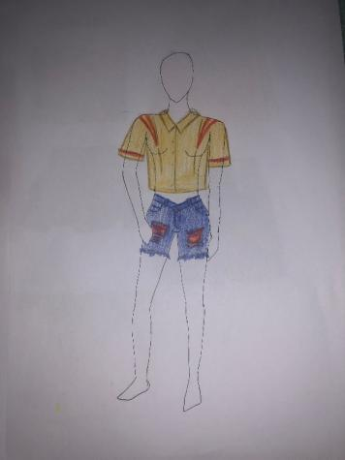

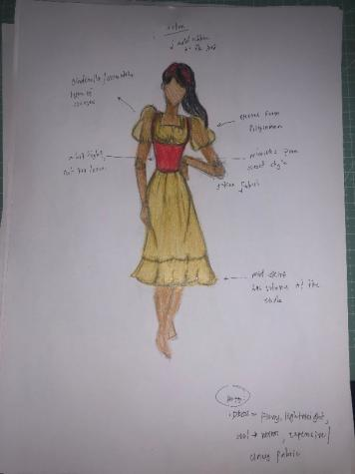 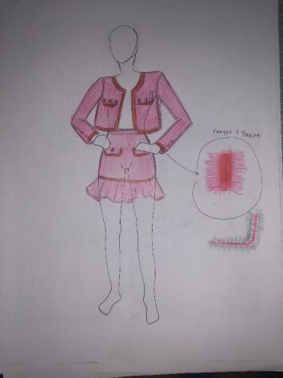

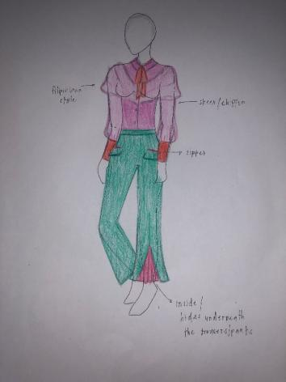

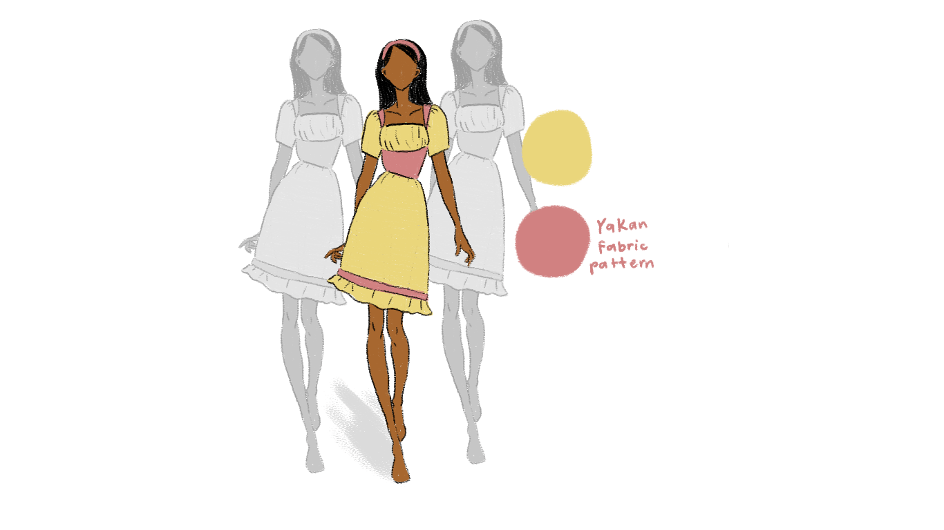

**Appendix C**

**Project Production Documents**

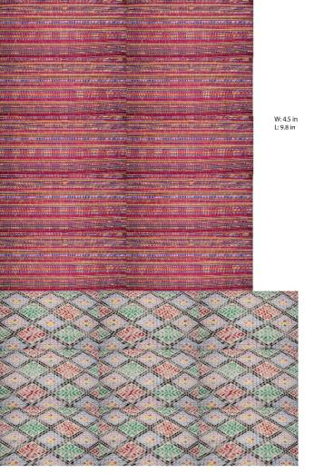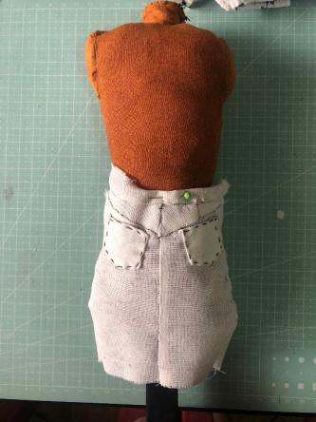

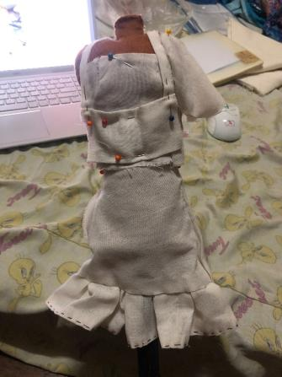 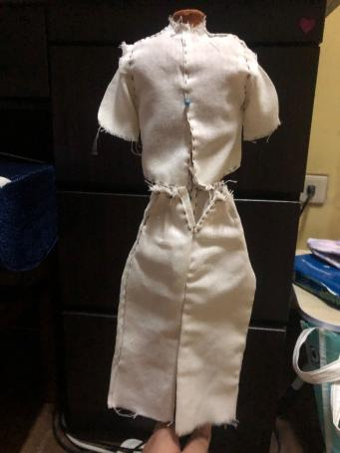

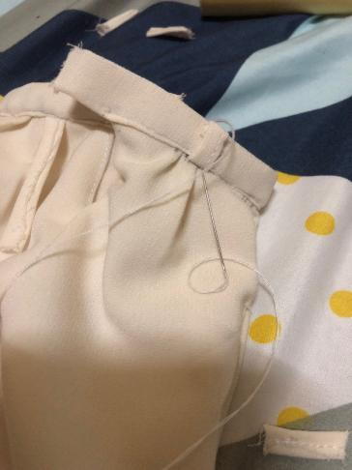 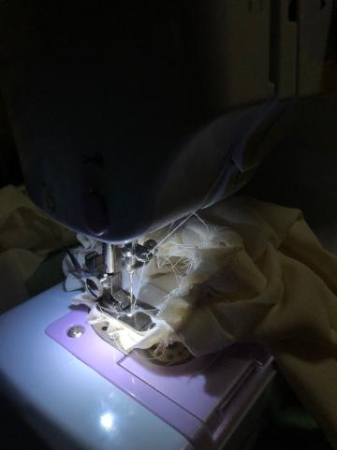

**Appendix D**

**Website and Online Collaterals**

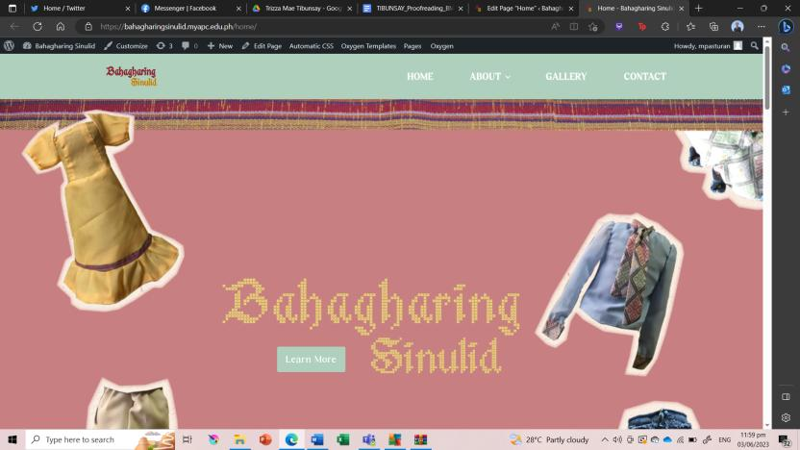

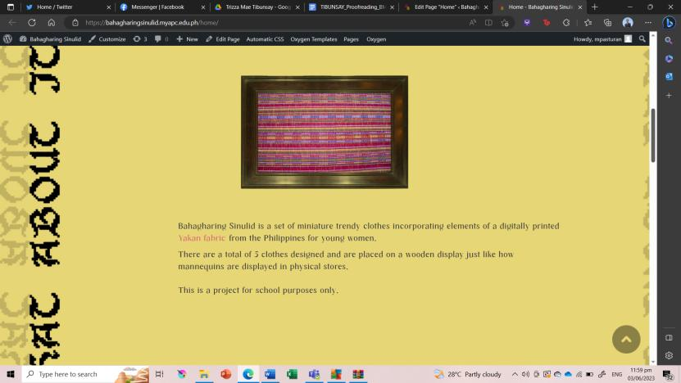

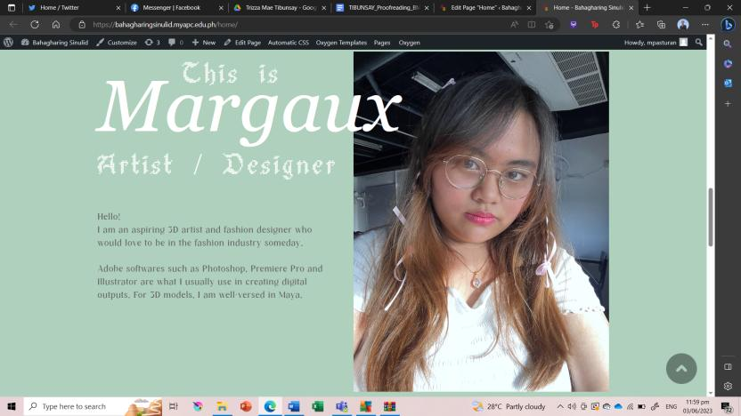

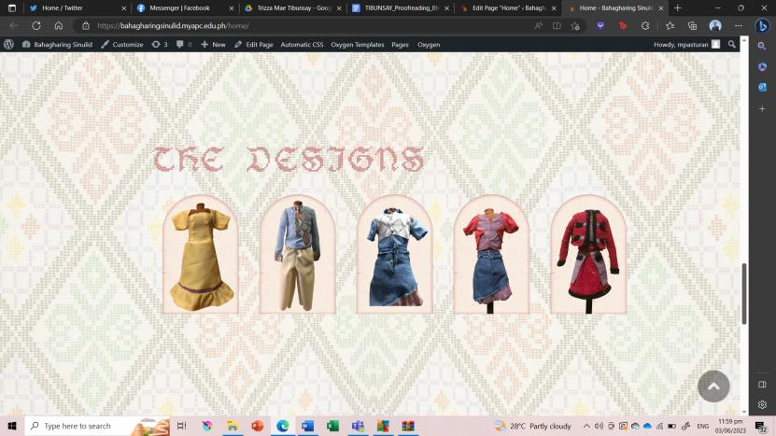



**Appendix E**

**Miscellaneous Documents**

**Preliminary Survey**

 

