Orenda: A Junk Art Representing the Environmental Impact of Plastic Packaging

Trizza Mae M. Tibunsay

Co-Author
Mr. Ioannis Emmanuel S. Sicuya

Abstract

According to an article, 38.88 million Filipinos buy consumer items online at least three times every week and accumulates 12.4 kilos of trash plastic packaging yearly, increased by 300 percent (Chua, 2020). It is expected (Dela Peña, 2021) that the volume of plastic waste manufactured by individuals will more than double, resulting in an alarming plastic issue in the nation. The study aims to relay awareness to consumers on the impact of plastic packaging on the environment through junk art by utilizing discarded plastic packaging and other materials. In line with this, I will produce a junk sculpture that will focus on the environmental impact that is influenced by the increase in plastic packaging in our country. It will also focus on the quantity of accumulated consumer waste and its impact on our environment. This project will emphasize the significance of consumers taking action to decrease their accumulated plastic waste, as well as serve as a reminder that sustainable consumption benefits both us and the environment.
Keywords: plastic packaging, plastic pollution, environmental awareness, Junk Art, consumerism

Introduction
When COVID-19 began in 2020, most Filipinos shifted to e-commerce and were seeking its convenience and accessibility. Government lockdown measures and company closures in the Philippines drove people to shop online for food, basic supplies, and other items. The inspiration for this artistic project came to me months after my family and I began using online shopping regularly. I came across a friend's stories on her social media account about how many packages her family received each day and a picture of how much plastic packaging, they threw away each week. E-commerce has become a source of comfort for everyone, but as consumers, we have forgotten our environmental responsibilities.

A significant proportion of consumers benefit from e-commerce since it helps everyone to prevent getting vulnerable to the COVID-19 virus by purchasing things through it. Furthermore, since we dwell in the era of global technological advances, e-commerce possesses the capacity to have a tremendous impact on everyone, enabling us to purchase our daily supplies and needs solely by browsing the web. Although beyond the epidemic, approximately 73% of Filipino customers are anticipated to maintain or grow their digital purchasing habits, and the government has backed it because of its economic benefits during the lockdowns (Agency Lokal, 2022).

However, it is not just e-commerce that develops during the epidemic, but also the country's plastic waste. Every Filipino accumulates 12.4 kilos of plastic trash packaging yearly, according to Greenpeace (2020). As a result, with the growth of e-commerce in the future, it is expected that the volume of plastic waste manufactured by individuals will more than double, resulting in an alarming plastic issue in the nation (Dela Peña K., 2021). The carbon emissions of e-commerce pass purchases varied between 0.67 and 7.49 kg CO2e for every parcel dispatched, according to the carbon footprint analysis (Cheah & Huang, 2022). The package of items generates the most greenhouse gas emissions in the e-commerce business, responsible for around 45% of overall projected emissions, while package cancellations contribute to a fourth of cumulative carbon emissions (Calma, 2019).

As an artist, I have far more ability than I realize when it comes to utilizing art to exert influence. I will employ installation art as a platform through which we can transcend the confines of what I believe, and as a method that allows us to ponder our existing ideas, critically assess our environment, including our duty, and shed light on issues that are overlooked or neglected. To back up my claim, the book 'Junk: Art and the Politics of Trash' written by Gillian Whiteley, an MA Sculpture Studies doctorate, states in the book that the re-use of rubbish within our eco-conscious and globalized society by bringing to the surface the world affairs of our trash and commenting on a truly fascinating junk artistic expression.

For the thesis statement, junk art is a distinctive installation art technique for addressing our nation's growing waste issue and increasing the awareness of Filipino millennial consumers about the environmental impact.

To illustrate the negative environmental effects of e-commerce in our nation, I made a junk sculpture from discarded plastic packaging and found plastic materials. The purpose of my study is to inform Filipino millennial consumers about the increase of individual plastic waste generated in the last few years since the pandemic. I also want to inform the target audience concerning the implications of plastic packaging and give them a sense of the danger or urgency of the discarded plastics by posting images of the output and its details into a website and exhibit as portion of my study's collateral. I intend to produce only one junk art sculpture since my objective is to reduce the quantity of waste generated and working with these materials requires some expertise.

To conduct this research, my primary goal is to make a single junk sculpture and examine the production process while utilizing various resources, such as used plastic packaging and discarded plastic objects. Furthermore, utilizing Joseph Kosuth's conceptual theory, I want to use junk art to symbolize the issue in relation to my sculpture and the materials I used for the final product. It stated that the audience should instead pay attention to the reasoning behind the artist's decisions rather than the work itself or how it was made, as the context is substantially more important than the techniques or style that the artist used. The principle is simple: art is expressed through a medium, not in the medium itself. It relates to my creative output because junk art is not aesthetically pleasing to the audience's eyes, and like Kosuth, I concentrated on narrating the various meanings concealed within the discarded materials.

Figure 1

Visualizing the Environmental Impact of Plastic Packaging Framework

Problem:
Booming Plastic Waste in E-commerce

Intervention:
Capstone Creation

JUNK ART

ARTISTIC VISUAL REPRESENTATION

Convey the feeling of urgency to the target audience.

Joseph Kosuth's Conceptual Theory

Materials:
Discarded Materials from
E-commerce and Found Objects.

Impact:
Reduce ecosystems' capacity to respond to climate change by changing habitats.

Impact:
Kills ocean and terrestrial wildlife, creates microplastics, produces pollution.

For the creative framework, this section outlines my way of thinking, how I assessed the issue, the proposed course of action, and how to put it into action. The methods I used to create a visual representation of how plastic packaging affects the environment are shown in this creative framework.

The problem that I see and that certain environmental groups, like Greenpeace and YSCP are addressing, is the increase in plastic garbage produced by e-commerce since the pandemic started. This is where the framework begins. However, this depends on how frequently they buy online, which might be more than twice as frequently as the average person. Online shoppers create twice as much waste as the average person. The second aspect is the effect of this plastic trash on the environment, which includes ecosystem deterioration and adverse effects on the livelihoods, ability to produce food, and social well-being of countless individuals. Additionally, plastics do degrade into even smaller plastic fragments, now referred to as "microplastics", and these tiny fragments contaminate rivers, soil, plants, animals, and even people. Therefore, I provide an intervention that uses junk art to create a visual representation of the environmental impact of plastic packaging; the discarded materials utilized are ones that we got when we purchased online.

Furthermore, I apply Joseph Kosuth's conceptual theory, which places more emphasis on the objective than the final product. Junk art is a new trend that addresses societal concerns and discarded objects as art; it challenges the traditional definition of art because it is not conventional sculpting. Using the Kosuth theory, my objective is to minimize the amount of consumer amount that we have generated because it is difficult to stop the problem from happening and because failing to act would lead to new issues in the future.

In research design, I reviewed articles on e-commerce and the rising use of plastic packaging in the Philippines while developing the creative output. I conducted a structured interview using the snowball sampling method with the initials of two millennial respondents before producing the study's output. Using the snowball sampling technique, when the first two respondents have completed the research, I asked them to find further respondents. I employ this sampling method because some respondents do not want their identities made public for a particular purpose. I disseminated the structured interview using an online form. The following questions are a sample of the format of what I will ask the respondents, primarily regarding their consumption patterns and knowledge of plastic packaging:

- How frequently do you use online shopping each month?
- How many times will the goods you ordered be packaged in plastic?
- What additional materials, outside the goods you ordered, do you receive? (Example., bubble wrap, zip lock, Styrofoam, etc.)
- What changes have you seen in the use of plastic packaging since you started using e-commerce?
- How important is it for you to understand the waste you generated while shopping online?
- How much do you know about the effects of plastic packaging on the environment?

The information acquired in these questions will also be utilized as a foundation for the materials that the respondents obtained through e-commerce and will be incorporated into the output. This information will be used in the research design and help determine whether the approach will aid the artwork's target demographic.

My target audience, to successfully address them about the damaging effects of e-commerce on the environment, I will be concentrating on the Millennial consumer age group in the Philippines. Nearly half of Filipino online shoppers are in this age bracket, which is most likely the group that enjoys online shopping, uses digital platforms often, and is more likely to be employed than other age groups.

The collected data will be extensively investigated to determine how Filipino millennial customers’ awareness on the negative impact of plastic packaging and other waste materials created by e-commerce. To determine the outcomes of the data collected through qualitative interviews and to evaluate the diverse variety of responses provided by the respondents, I will use thematic analysis and qualitative content analysis.

For my design process, the multimedia project will be expecting one (1) piece of junk art using plastic packaging, bubble wrap, and other objects found from e-commerce with a height of six feet. The sculpture's name is "Orenda", and it is a communicable mystical force that may be used to conduct the will of its owner and is found, to various extents, in all living and non-living natural entities. The means by which personal achievement is gained or accounted for is through the mystical energy of the environment. It is a befitting title for the sculpture given that the process of creating the creature serves to educate the public about the growing problem of plastic packaging, which affects not only nature but also our lives and all other living beings at present and in the future.

The sculpture shows a creature that symbolizes the world becoming contaminated by rising e-commerce waste. It represents the pollution of the environment and destructive and uncontrollable consumerism, while also depicting how we lose touch with reality with the comfort of technology. The creature may appear strange from a distance, but as we learn more about the materials, it becomes clearer how these wastes influence not just humans but also the ecosystem. Numerous eyes represent the environment's ability to see everything, including how humans are destroying the environment. Its eyes are multiple every moment it witnesses human wrongdoing. It also represents how humans tend to buy impulsively and excessively when they see a product that is pleasing to their eyes or has a discount. The discard of plastics represents how pollution is eating the whole environment as the materials start to cover its body. The use of "fragile: handle with care" means not only the materials should be managed with care but also us and the environment. It only takes a blink of an eye to make a negative impact on our lives; however, it often takes a lifetime to make a positive impact. The point is that life is fragile because it is short, and we need to manage our lives and the environment with care. The burning or melting represents the destruction of the environment. The current state of our environment requires attention, and if we do nothing and choose to disregard it, the world will not endure as much as it could. Lastly, the creature's hunched posture symbolizes the weight of pollution on the environment, which includes tainted atmosphere, water, soils, and noise. As it is well known, the number of industries has quickly risen during the last few decades. These industries also release their untreated trash into the air, land, and water, and the globe is unable to keep up with the rate at which discarded plastic products are being produced.

Pre-production Stage
The pre-production stage for the output will consist of planning out the materials and deadlines using a Gantt chart. I will conduct an interview with Filipino millennials to determine what materials I will use and how junk art can help address the environmental problem in e-commerce. I will also start to budget the expenses needed for pre-production, production, and post-production stages. Through this stage, I will start to collect plastic packaging, discarded bubble wrap, Styrofoam, plastic covers, and other found objects. I will also start to gather different kinds of glue (glue sticks and craft adhesive), wire, and other objects found.

Production Stage
The primary goal of the production step is to create the final drawings for the chosen junk art. To demonstrate the durability of the junk art, I will sand the mannequin that I use and add reinforcements to add shapes to the sculpture. Furthermore, I will make the eyes from the objects found and make textures for the skin of the junk art. After that, I will fill the mannequin from bottom to top with plastic packaging and other discarded materials. Enhancing the details and emphasizing the components I want to be visible is the final step of this stage.

Post-production Stage
The post-production stage is where I will tweak the small details that need to be enhanced in the junk art. This is the stage where I will make the platform where the junk art will be placed. When the whole process of creating junk art is finished, I will start to promote it on Instagram to prepare for a physical exhibit.

Review of Related Literature
This section discusses previous research and associated literature on the progress of e-commerce in the COVID-19 epidemic, the impact of plastic packaging, why being a responsible consumer may mitigate the problem, and how junk art can be utilized to promote awareness.

Timely E-commerce for the COVID-19 Pandemic
The Philippines prior to the pandemic had a small number of people purchasing products or services online since many individuals are skeptical about using financial online or the reliability of e-commerce sites. However, it changes when the COVID-19 Pandemic hits the Philippines with its increasing cases. The traditional retail stores closed, and Filipinos are required to be under quarantine at home. Filipinos are among the individuals who actively use and spend a long time on social media sites. Therefore, individuals have no choice but to use e-commerce to buy their needs and essentials. The article of Lokal (2022) enumerated the reasons for the booming e-commerce, which can be maintained or progress even after the pandemic, and one of its salient points is the increased utilization of digital transactions, cashless payment, and rising financial technology sites.
On the other hand, e-commerce offers personalized services that help the users to browse their preferences and options without time limit. These differ from physical stores in that they offer real-time customer service with a live agent to assist with their products. The affordability and exclusive deals of international goods and products combined with e-commerce mean efficiency and money-saving.
Further supported by the article by Llemit (2021), states that 79.8% of Filipinos purchase goods online due to special promotions and sale days of their preferred marketplace, 92.5% for the quality of the product, and 87.2% for good reviews of other purchasers. In terms of demographics, millennials are the leading factors behind e-commerce because they make up over half of Filipino customers. They are the focus of e-commerce since they are technologically proficient, actively use the internet, and fall between the working age range of 26 to 41 years old. According to 86% of this age group, using e-commerce results in cost savings, and discovering offers is the most crucial aspect of online buying. However, since the rise of e-commerce helps the Philippine economy during the lockdown, the government is taking measures to support and conveniently use it to their advantage.
This is significant since it provides the basis for the research and serves to gain a deeper perspective on the research topic. Since Millennials are the intended audience for this study, a survey interview for them was developed and assessed. I will examine millennials' consumption patterns and use them to guide my creative output.

Impact of E-Commerce
In the article of Igini (2021), today's shoppers' internet shopping consumption is not only driving the global market to its absolute limit, but also causing major environmental challenges. Item's packaging makes a significant contribution to CO2 emissions by plastic production, harming the environment and contributing massive volumes of garbage to our garbage dumps. On the other hand, the online shopping platforms became the gateway into the quarantine and lockdowns during the pandemic, a catalyst for the increase of single-use plastic by 300 percent (Chua, 2020). As stated by Oceana, single-use plastic packaging demand may double, rising from 942 thousand tons in 2019 to 2.056 million tons by 2025.
Every Filipino generates over 12.4 kilograms of packaged garbage, the majority of which ends up in landfills and breaks down gradually. Single-use plastic bags, among the most serious hazards to the environment. It requires 20 years to decompose, and their particles have catastrophic impacts, particularly on animals. Products are frequently packaged in bubble wrap; it requires 10 to 1,000 years to completely disintegrate. Constructed of low-density polyethylene film, 386242.56 kilometers of bubble wrap are manufactured (Dela Peña, 2021).
However, while e-commerce and its environmental consequences ought not be overlooked, most individuals today prefer comfort above ethics, and while corporations striving to be more ecological is a positive beginning in the appropriate approach, such adjustments cannot address the issue fully. This is significant to the study, particularly for the thesis statement, because shoppers and their usage and behavior are acts that ultimately decide market control.

Expensive Cost of Plastic Packaging
The British Plastic Federation (2022) has authored an article regarding the rationale for plastic packaging and the advantages of plastics used for consumer goods. Plastic can efficiently withstand high impact and natural phenomena such as corrosion and plastic. It is also one of the primary materials that is reused and recycled. The potential of plastic packaging in the economy was maximized in different parts of the world since a lot of companies and merchants saw this plastic packaging as an opportunity to save money in mass production as well as make the product affordable. However, recycling and reusing were not a simple solution and a great advantage of using plastic packaging instead. Companies and merchants were using this as a gateway for more cost-effective economics. Recycling requires more energy consumption, produces more soil, air, and water pollution, is inefficient and thus less effective than what it proclaims. While reusing plastic was not commonly known and developed, it needed more capital and stringent implementation because it is unsafe and unhygienic, which can possibly create more health risks.
Plastic packaging has more disadvantages than advantages, especially in our environment. According to the Worldwide Fund for Nature (2021), one plastic bag takes 20 years to degrade, and its particles are pollutants, particularly to aquatic animals. Goods from online were draped in so much plastic bubble wrap that was swamped over the riverbeds of Pasig, Laguna, and Manila Bay that could not be reused because of the air-filled cushion and took ten (10) to 1,000 (one thousand) years to decompose.
With the increase of e-commerce, plastic waste was estimated to boom by 300% and the country's lack of landfills nationwide, making 70% of Filipinos have no access to proper disposal, making 35% thrown in the streets, streams, and waterways. While 33% are properly disposed of in landfills and dumps, 16% are used, however only nine percent (9%) are recycled. On top of that, before the pandemic, the Philippines was one of the largest countries contributing to ocean plastic pollution. The answer to plastic waste calls for a shift in community, as well as a change in personal behavior.
This is important to the study since it addressed the usage of single plastic packaging and its effects on the environment and e-commerce. The study's premise that plastic packaging should be the primary material used in creative output is supported by facts and data. In any case, one person cannot start the effort to halt the manufacture of plastic; therefore, I will aim to increase awareness of the significance of lowering the amount of plastic garbage we produce.

Encouraging Responsible Consumerism
According to the article, responsible consumerism benefits not just society and the economy, but also our environment and our wellness. In addition to helping the economy and society, responsible consumption considers the effects of the many phases of the manufacturing, transportation, and disposal of items and seeks to choose the ones that have the least negative effects. Promoting responsible consumerism aims to be more ecologically friendly while also considering its social and economic.
E-commerce that respects the environment takes a lot of reflection and public engagement. It starts with little adjustments to how we shop. This is important to the research since it communicates the notion of creative output and how to stop the problem of growing plastic packaging. The research's main objective is to educate customers about the truth about plastic so they would use less of it and recycle the plastic packaging that we receive from deliveries. Consumers may adjust their consumption habits as well as those of those who surround them once they are knowledgeable of the environmental consequences that plastic packaging causes.

Aesthetic Awareness of Junk Art
One person's waste is simply another person's garbage unless it is used with innovative thinking and transformed into something wonderful and sublime. Junk art is a broad category that encompasses many different forms in which found items and discarded objects combine to create an intriguing and enduring aspect of creation that was inspired by rebellion and the idea that everything can be turned into art. Since it frequently uses things that the majority would regard to be garbage, this kind of creation truly means anything. It is the liberty to experiment with many mediums and the assertion that art emerges from a situation rather than the restrictions that tradition has imposed (Rhodes, 2022).
To support the claim, Gillian Whiteley's Junk: Art and the Politics of Trash (2010) examines how art past and currently appropriated trash art in our environmentally sensitive and globally integrated society. As Whiteley argues, assemblage has been seen as an obstructive, rebellious art style that interacted with tales of sociopolitical debate, frequently condemned as meaningless. However, it can portray what is happening towards our civilization because the true indicators of our civilization are trash, waste, and what we discard (Whiteley, 2010).
This is essential to the research because environmental awareness can be stimulated through junk art. The use of plastic and other discarded materials draws attention to the damage being done to the environment and urges people to act. The project's objective is to evoke an emotional reaction in the target audience by telling a story within the finished artwork. The products we received when doing e-commerce, such as plastic packing, and other materials, will be the materials I utilize. Since I want to recreate a useful design feature while simultaneously lessening the environmental impact of a new product after development, I will produce one piece of junk art.

How to Why of Joseph Kosuth
Joseph Kosuth is regarded as a forefather of conceptual art, which developed in the early 1970s and revolutionized the concept of the artistic medium. Additionally, it may be claimed that although art speaks of a distinct experience, its "language" remains the same. As a result, it changed the fundamental nature of art from a structural problem to a purpose problem. The beginning of the new art and the growth of conceptualism were defined by the transition from "form" to "idea" (Kosuth, 1969).
The central theme of conceptual art is the notion itself. For Kosuth, any media may be utilized to represent a conceptual artist's perspective. Conceptual art is crucial because it expands the perceptions of artists, organizations, and culture while challenging the conventional idea of what constitutes art. To get to the core or substance of the idea, item, or installation under consideration, art perception has become vaguer and tends to dematerialize it. It encouraged the creation of several new artistic movements and styles, such as installation art, discarded object art, societal issue art, and many others (Mullennix, 2022). This is significant for the research as it elicits a wide variety of emotions, which I want to do with my creative output. Since we were taught to accept conventional art as the norm, it will be challenging for the audience to appreciate and comprehend my use of conceptualism. Accordingly, in contrast to Kosuth, I will utilize a medium in junk art, which is challenging the boundaries of conventional art.

Review of Related Work
This section of the paper focuses on relating various sculpture and installation art to the study's creative output. This mostly consists of conceptualism to develop representations that make use of plastic packaging and discarded things relevant to the topic. The following works will be examined as a method for examining how I envisioned the creative output and used it as inspiration to create a depiction of the environmental effect of plastic packaging.

Figure 2

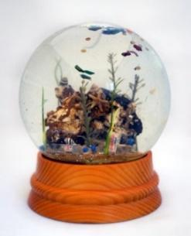
Max Liboiron, Sea Globes, (2013-2014)

In 2013-2014, Max Liboiron developed "Sea Globes'', a miniature portrayal of garbage contamination in our seas. The sculpture is made entirely of actual New York City mementos. The plastics originated from the Hudson River in south Brooklyn, while the pebbles originally came from a dump in Deadhorse Bay that shut in the 1930s and is currently submerged at sea level. Nevertheless, the sea globes are realistic depictions of New York City's coastal environment today. The artist's work stands in opposition to how the marine ecosystem is normally shown. This piece, in contrast to the brilliant colors and joyful fish, colors with dreary hues and a gloomy truth. Liboiron utilizes art to enlighten people about the problem of pollutants in the environment.
In line with this, I intend to employ discarded objects to create my creative output. I also associate this artwork with my creative output since it both raises awareness about the issue that I am attempting to highlight and expresses it through junk art. Unlike Max Liboiron, I will utilize this approach to offer and build awareness about the increase in plastic packaging and utilize items obtained through online shopping. I intend to ask family and friends for their discarded objects to completely contribute to the usage of resources, thus reducing the amount of garbage produced. Hence, I will only construct one junk sculpture. I intend to ask family and friends for their discarded items to fully contribute to resource consumption and reduce the quantity of waste generated.

Figure 3

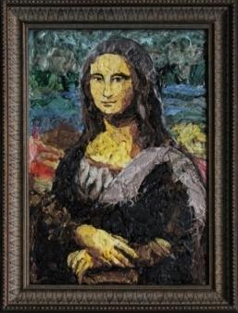
Eduardo Srur, Plastic Nature, (2019)

Eduardo Srur reinterprets renowned classic paintings in his exhibit "Plastic Nature." Srur effectively combined the method with the usage of plastic in one of his replica’s works, Leonardo Da Vinci's iconic painting Mona Lisa, since the original artist utilized a technique called sfumato, in which colors are mixed in such a delicate manner without visible transitions. The artist's goal in creating "Plastic Nature" is to inform the audience that these renowned works, like the plastics that pollute our environment, will be remembered for decades.
In line with this, plastic packaging will be a key element of the junk art produced as part of the creative output. However, unlike Srur, I will create a sculpture out of plastic packaging and other rubbish that focuses on the environmental impact of e-commerce. The technique of Srur will be my reference in making the skin of the junk art. On the other hand, the artwork is relevant to my creative output since the artist's purpose in replicating these pieces of art is not only clever but also addresses the reality of plastics.

Figure 4

Leo Sewell, Seated Leady, (2018)

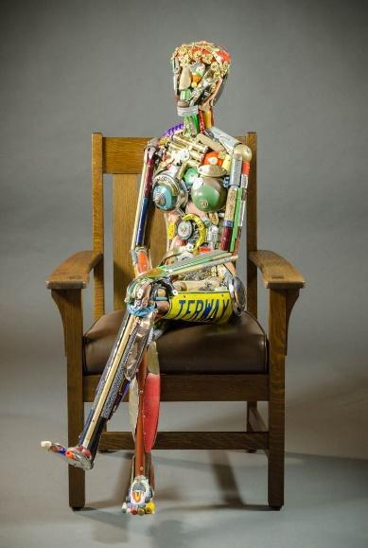

In Leo Sewell's sculpture "Seated Lady," a woman was depicted seated and was made of toys, money, and broken pieces of metal, glass, wood, and plastic. The artist has a distinctive style and is known for his assemblage work. Recognizable items made of plastic, metal, and wood make up his sculptures. These items are selected based on their color, form, texture, robustness, and patina before being put together with the aid of nails, bolts, and screws. The outdoor sculptures are made of welded-together scraps of stainless steel, brass, or aluminum.
In keeping with this, I plan to create a creature that would symbolize the environmental impact of e-commerce products using plastic packaging and other wasted stuff. Additionally, junk art will be related to the subject because it was created by asking family and friends for their plastic packaging and other leftover objects.

Figure 5

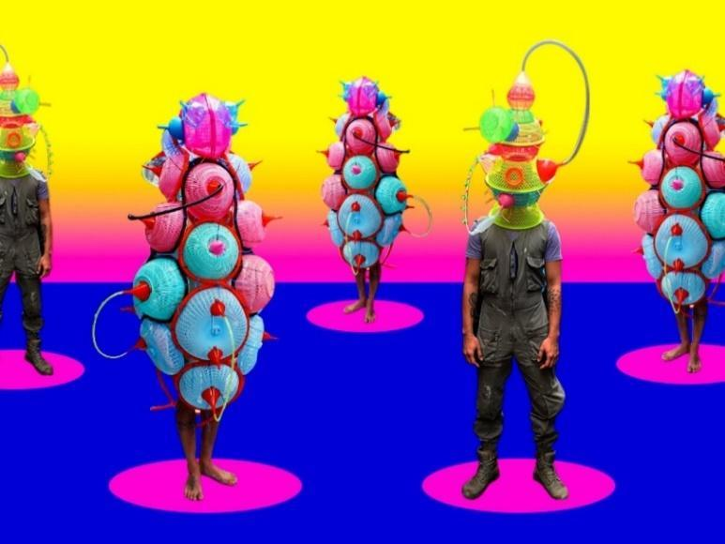
Leeroy New, Aliens of Manila, (2014)

Using the concept Humans of New York as a point of reference, Filipino interdisciplinary artist Leeroy New began his artistic exhibition Aliens of Manila in 2014 and repurposes the classic photo shoots of New York. The artist tackles the issues of emigration, assimilation, and cultural alienation in a fun yet thought-provoking manner, deeply influenced by his personal background. As a trained artist and designer, Leeroy New can transform almost anything from garbage to plastic waste to other abandoned materials into a sculpture that may be used for a different purpose. Understanding how to tackle issues using already-existing materials while guiding them in the manner we desire from a form and functionality perspective.
The artist sees that we should begin to educate ourselves to make different decisions and act in a way that is advantageous to the whole globalized world. The identities of the "aliens" and the names of the sculptures all allude to mythical figures from antiquity, but with a sci-fi twist. In line with this, I want to use sculpture to create whimsical yet provocative conceptual artwork. While Leeroy is employing the legendary figure from pre-colonial times, I want to use monsters with a sci-fi twist. I also reference the technique of Leeroy in my creature by using synthetic technique and use of objects found.

Figure 6

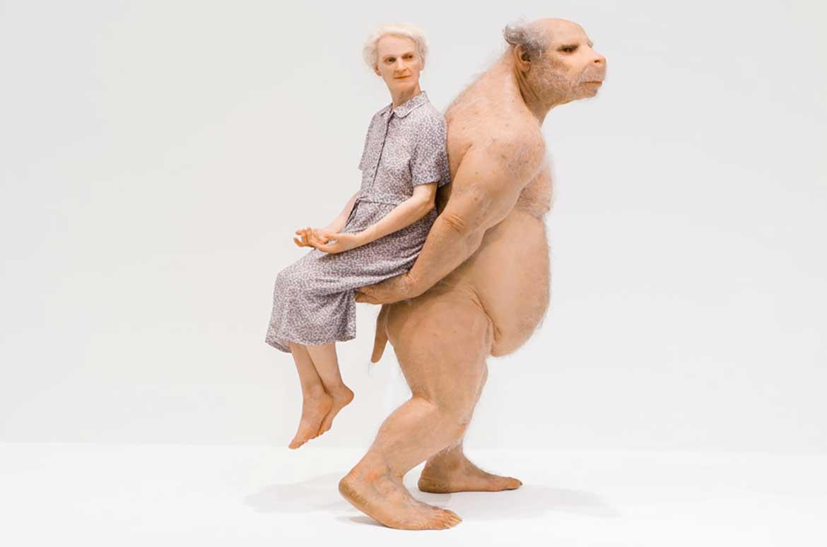
Patricia Piccinini, The Carrier, (2012)

In 2012, Patricia Paccinini used silicone, fiberglass, and human hair to create The Carrier. The artwork is thought-provoking and provocative at the same time; by hinting at the potential of the creatures we wish to make in the not-too-distant future, it draws our attention to potential futures for us. The carrier is a man with muscles and bear-like features on his snout and claws. He is balding, yet despite his bear-like build, he can easily raise the weak woman behind him. The dispute appears to be caused by some sort of connection between the lady and the carrier, both physically and emotionally.
The artist opens a discussion on our efforts to both refine or combine the human physique and integrate science. In line with this, I will create a plastic creature out of discarded materials using a compelling and clever visual depiction of plastic's environmental impact. To make a connection between human and environmental impacts, I want to create a creature that mirrors and assists us in overcoming our concerns, particularly those related to the environment.

Figure 7

Jason de Caires, Plasticide, (2017)
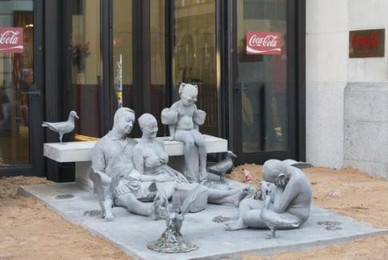

Plasticide illustrates a stark reality created by Jason de Caires Taylor in 2017 alongside Greenpeace participation, which was displayed in the National Theatre on London's Southbank. The sculpture depicts a family of four, with the parents laughing at each other; the slumped boy seemingly bored; and the daughter resting in her swimming gear at their beach picnic, encircled by a swarm of seagulls vomiting plastic. A simple family picnic is disrupted by a bleak picture of the future, in which plastic is expected to outnumber fish in the oceans around 2050. The artist wants to convey the information directly to our communities through Plasticide: the seas, and the sea animals that live in them, cannot take any further plastic. Plastic is a vivid warning of humanity's impact on the planet: startling, devastating, and nearly unbreakable. Greenpeace repurposed the piece and displayed it outside the entryway to Coca-Cola's headquarters in Central London to promote peaceful protest and raise awareness of the company's damaging activities. Coca-Cola has the largest plastic pollution impact of the six nations, producing 200,000 tons of plastic garbage, or around eight billion bottles. This successful protest ultimately contributed to the commencement of a global Greenpeace movement, which resulted in Coca-Cola announcing several significant pledges regarding plastics.
In line with this, the aim of my research is to inform the public about the growing problem of plastic packaging waste in our nation. Many environmental organizations, like Youth Strike 4 Climate Philippines (YSCP) and Greenpeace, have produced articles on the issue, but no response has yet been received from e-commerce companies. In contrast to de Caires, I would want to speak to a small focus group of Filipino Millennials with the call to action that ethical consumption is good for both the environment and us. This is essential to my research because, like Plasticide, my creative output will show how plastic affects not just the environment but also people. I will use junk sculpture to represent the environmental issue that most of us neglect.

Results and Discussion
The qualitative interview for this study was intended to gather data on the resources I will use in the junk sculpture as well as the consumer's level of awareness about plastic waste and its influence on the environment. I did six in-person interviews and ten online interviews. While conducting the interviews, I transcribed the respondents' responses into Google Forms to gather and translate the data efficiently and consistently. According to the data gathered, few millennials are aware of the difficulties or negative effects that occur from plastic waste. Most of the respondents could not refuse to purchase from e-commerce due to its benefits to them, so the data I gathered was largely favorable for creating junk art sculpture.

Preliminary Survey

- Gaano ka kadalas gumamit ng e-commerce sa isang buwan?
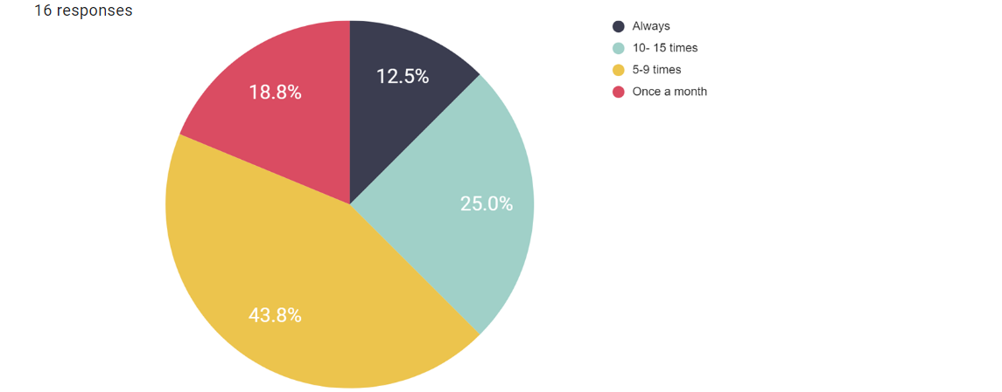

Figure 8

Number of times used ecommerce in a month

The graph in Figure 8 shows the number of times millennial consumers used e-commerce in a month. It shows that most of the respondents use e-commerce two to three times a month, but 23% of the respondents use it 10 to 15 times a month. This data helped me to know the quantity of plastic waste materials I should incorporate into the junk sculpture.

- Ano ang mga pakinabang ng e-commerce para sa iyo?
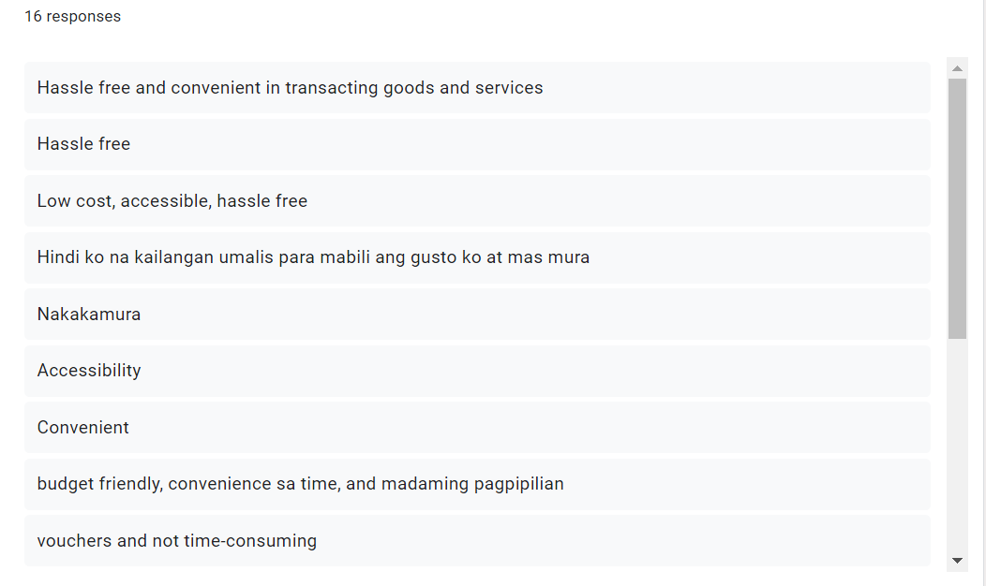

Figure 9.1

Benefits of e-commerce to the Respondents
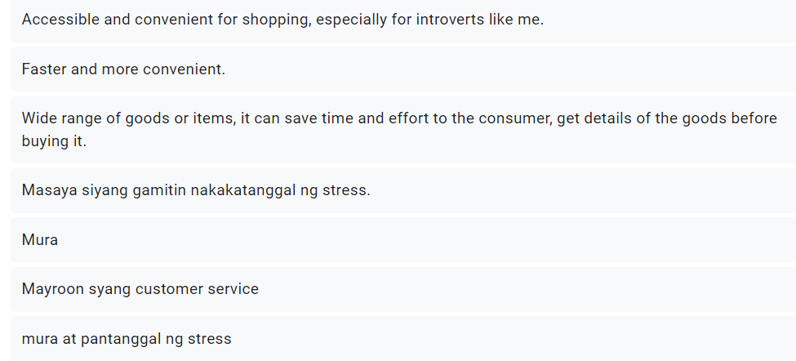

Figure 9.2

Benefits of e-commerce to the respondents

According to the respondents' answers in Figures 9.1 and 9.2, the majority of respondents use e-commerce because it is convenient, easily accessible, hassle-free, and affordable. Additionally, two respondents claimed that engaging in e-commerce reduced their stress levels. The two respondents who selected "relieve stress" utilize e-commerce between 10 and 15 times each month. Further, the data in Figures 9.1 and 9.2, which was collected in conjunction with Figure 8.

- Ilang beses ka nakakatanggap ng plastic packaging kapag nakuha mo ang produktong iyong inorder?

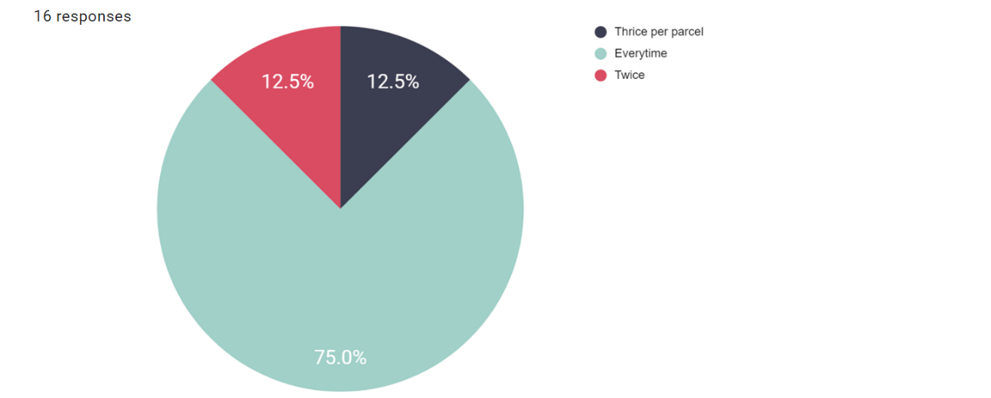

Figure 10

Number of times they receive plastic packaging when ordering

As depicted in Figure 10, consumers who shop through e-commerce websites frequently receive plastic packaging. The findings indicate that 75% of the respondents regularly receive plastic packaging, 12.5% receive it three times on average, and 12.5% only get it twice. This data shows that every respondent who makes an online purchase receives single-use plastic packaging that strengthens the thesis problem.

- Ano ang mga iba pang kagamitan na nakukuha mo bukod sa in-order mong tinanggap?

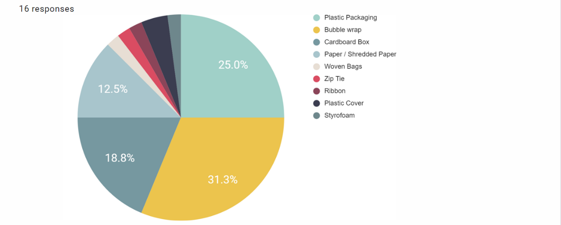

Figure 11

List of other materials they receive other than what they purchase

In Figure 11, the chart illustrates the other materials or miscellaneous items they received other than the item and/or good they purchased on e-commerce. The analyzed data shows that 31.3% is bubble wrap, 25% is plastic packaging, 18.8% is cardboard boxes, 12.5% is paper and/or shredded paper, 4.2% is plastic covers, and 2.1% is both on Styrofoam, zip ties, ribbon, and woven bags. Overall, all the data that was gathered from the miscellaneous items they received other than the item the respondents purchased was almost entirely made from single-use plastic.

- Paano umusbong ang paggamit ng plastic packaging mula noong nagsimula kang gumamit ng e-commerce hanggang ngayon?
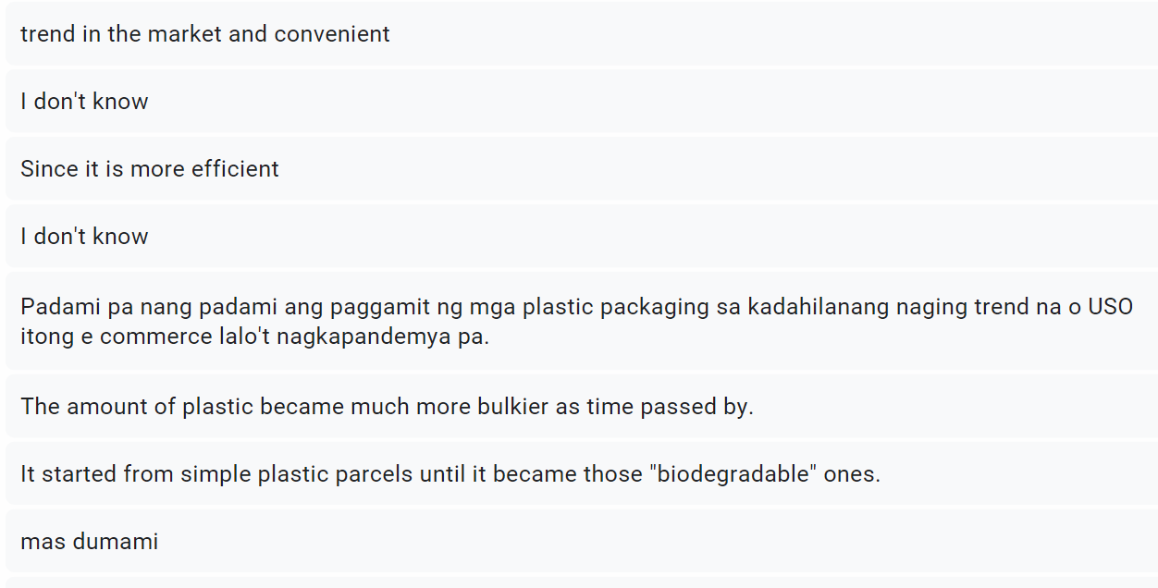

Figure 12.1

Insight into the development of plastic packaging

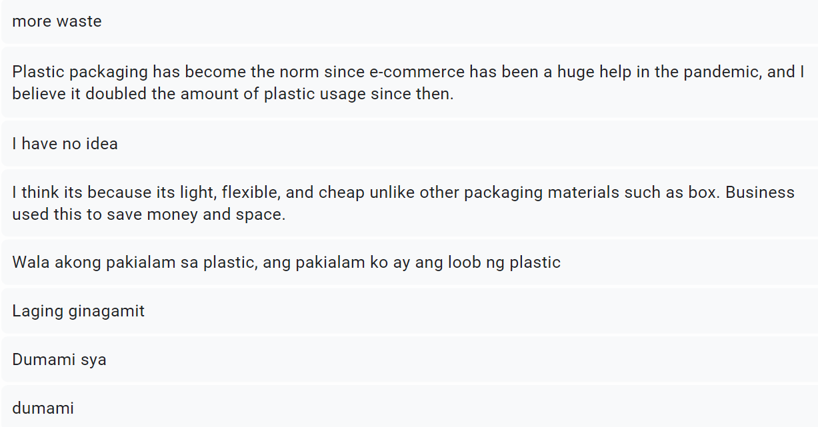

Figure 12.2

Insight into the development of plastic packaging

The content from Figures 12.1 and 12.2 is taken from the respondents' responses when asked about their observations and opinions on how plastic packaging has changed from the beginning of their usage of e-commerce to the present. The most obvious response to the question is that plastic packaging has grown more prevalent and thicker since then. According to the provided response, it became the norm or trend and greatly aided in the pandemic because it is more affordable, flexible, and water-resistant than cardboard boxes. Both the store and the client save money and space as a result. There is also another answer, which is that the common plastic package is now "biodegradable." On the other hand, some respondents claimed not to be aware of the current state of plastic growth. This indicates that while some respondents are unaware of the changes in e-commerce that have occurred since the epidemic, the majority are aware of them.

- Ano ang iyong mga obserbasyon tungkol sa paggamit ng plastic packaging ayon sa iyong nakikita?
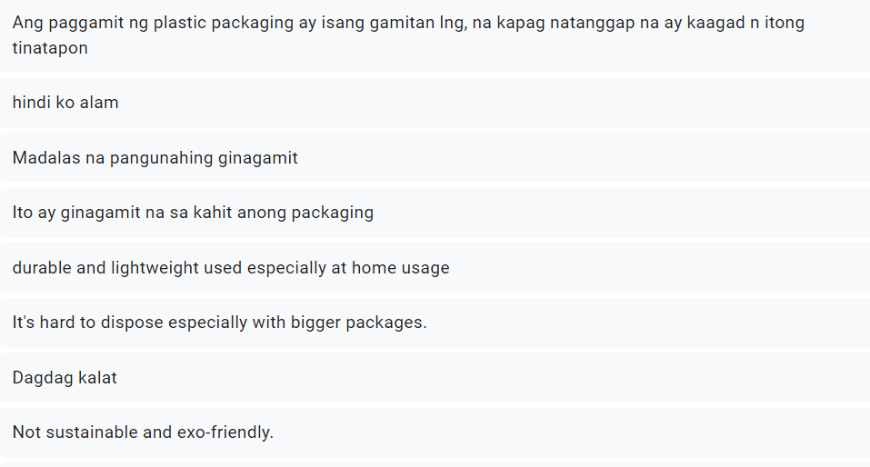

Figure 13.1

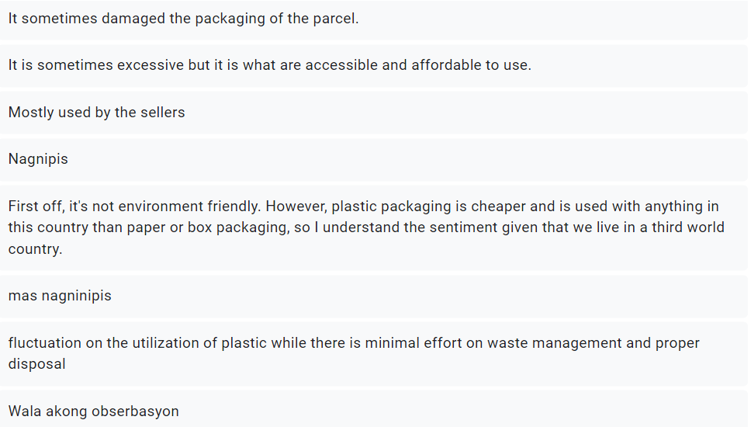
Insight about the usage of plastic packaging

Figure 13.2

Insight about the usage of plastic packaging
The given text in Figure 13.1 and Figure 13.2 are the answers of the respondents about their observations on the usage of plastic packaging. According to their responses, the most typical answer is that the respondents just put the item in the garbage since it was single-use and lightweight, and because it was cheaper, the sellers extensively use whatever the item is. It is also excessive and difficult to discard, especially with larger packets, even though it is accessible and reasonably priced to use. Additionally, other responses highlighted that it is not eco-friendly and only contributes to garbage production with no effort put into waste management or correct disposal. Despite being flexible and affordable, it is neither sustainable nor environmentally friendly, and according to the data gathered, even some respondents noted that it harmed objects and was hard to dispose.

- Gaano mo kadalas nire-recycle ang plastic packaging na nakukuha mo?
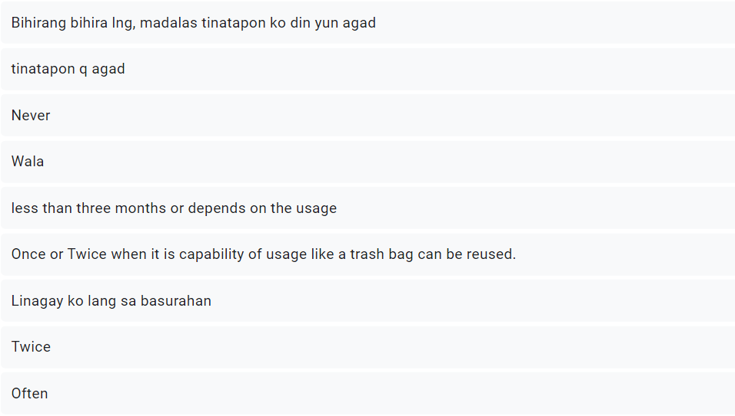

Figure 14.1

Number of times the respondents recycled the plastic
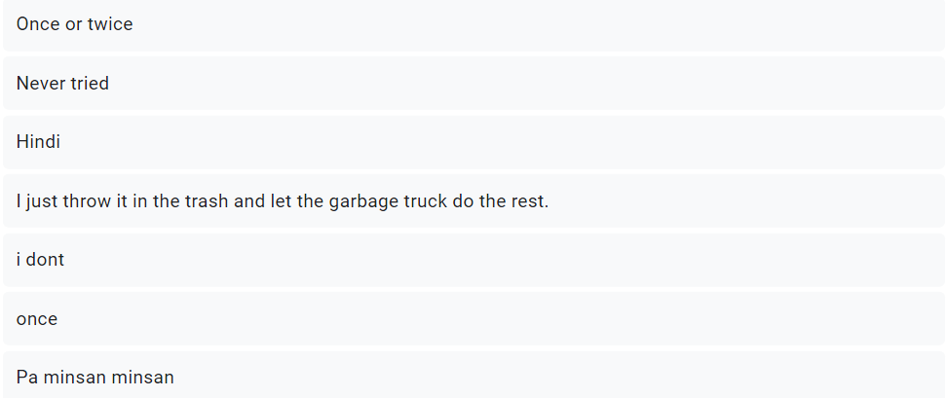

Figure 14.2

Number of times the respondents recycled the plastic

The data in Figures 14.1 and 14.2 are the respondents' answers on how frequently they recycle the plastic they receive. Half of the respondents never tried to recycle and often threw it away; 25% answered that it depended on the usage or capability of the plastic and if it did not meet the criteria, they just threw it away; 18.8% answered they recycled once or twice; and only 6.3% recycled the plastic they received. The data collected can be linked to Figure 8 since almost everyone who answered more than eight times is the one who also stated that they never tried recycling, and those who recycled once or twice are the ones who only used e-commerce once a month.

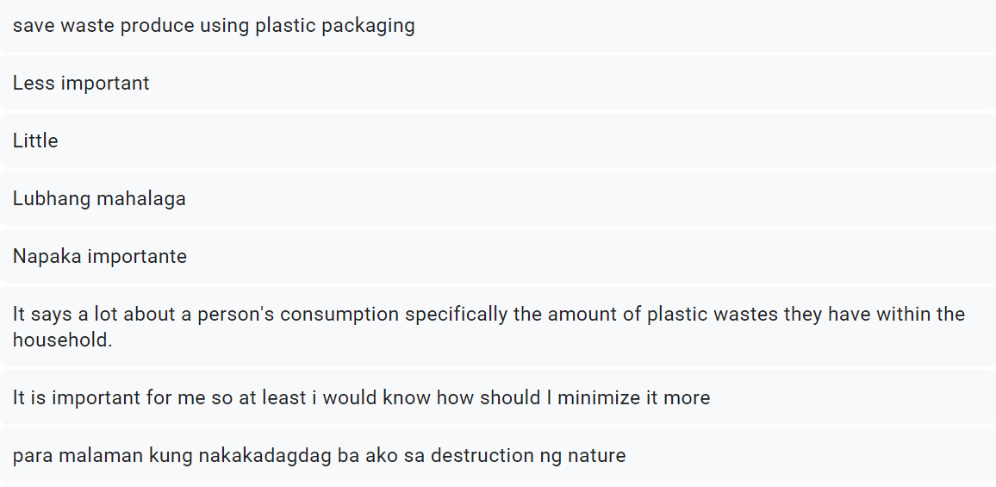
- Gaano kahalaga sa iyo na malaman kung gaano karaming basura ang iyong naiipon mula sa e-commerce?

Figure 15.1

Importance level of the respondents accumulated waste
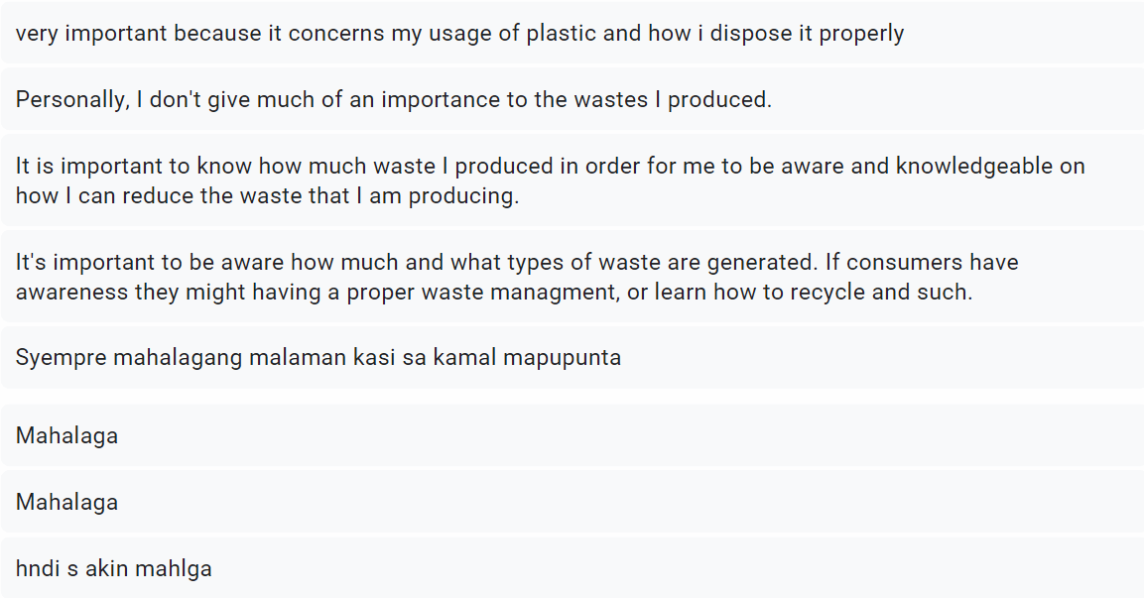

Figure 15.1
Importance level of the respondents accumulated waste

The text in Figures 15.1 and 15.2 provides the answers to the question of how crucial it is for customers to know how much garbage they have accumulated. According to their responses, 75% of them consider it essential since it helps them understand their consumption, minimize it, and dispose of it appropriately. Additionally, according to one responder, it indicates a lot about a person's consumption, notably how much plastic waste they produce in their household. However, 25% of those questioned claimed that it was less important to know how much trash they had accumulated. This data suggests that, if consumers are enlightened, they may, among other things, manage their waste appropriately or learn how to recycle.

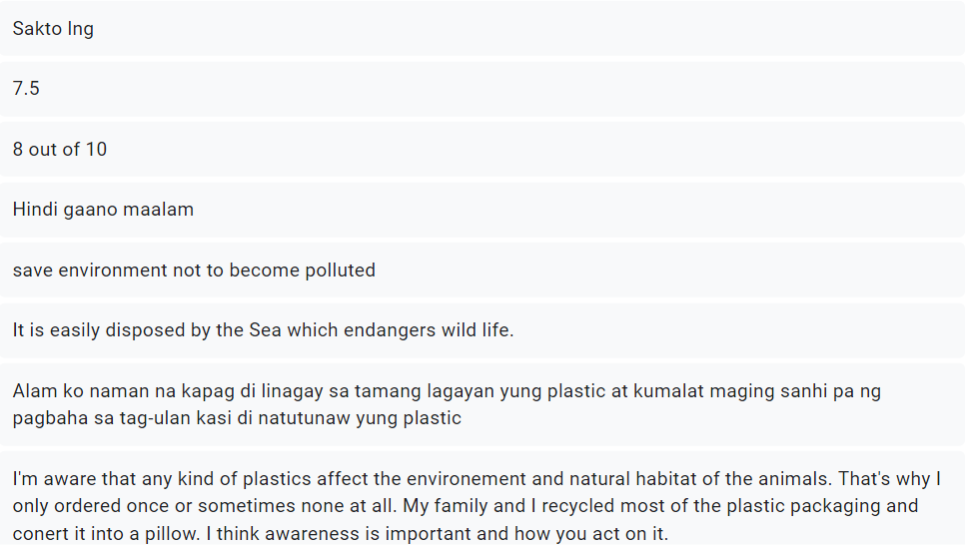
- Anong antas ng kaalaman ang mayroon ka tungkol sa epekto ng plastic packaging sa ating kapaligiran?

Figure 16.1
Knowledge about the environmental impact of plastic
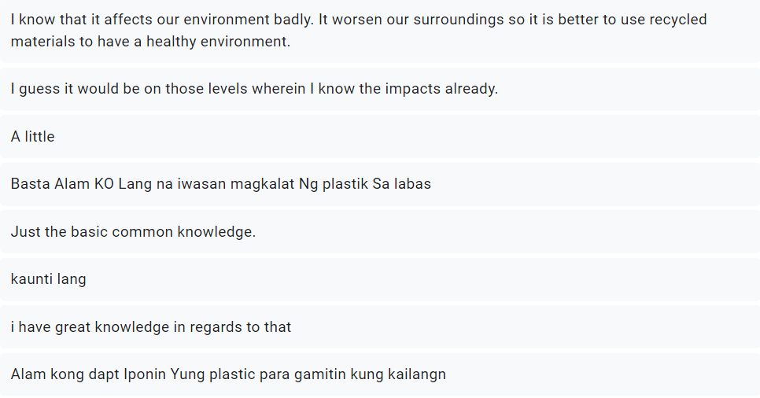

Figure 16.2

Knowledge about the environmental impact of plastic
The responses of the respondents to questions concerning their understanding of the effects of plastic packaging on the environment are shown in the given text from Figures 16.1 and 16.2. Nearly half of the public is aware of how plastic packaging affects the environment, including how improper disposal may cause flooding and harm and threaten wildlife, particularly sea life. Additionally, they said that it damages the environment, particularly because it is not naturally biodegradable. Some responders, however, are not very conscious of the effects on the environment. This implies that while most respondents are familiar with the effects of plastic packaging on the environment, others are not.

Post-Survey
      - Paano nakagawa ng impresyon sa iyo ang junk sculpture tungkol sa kung paano nakakaapekto ang plastic packaging sa kapaligiran sa sukat na 1 hanggang 5?
(Ang antas ng rating ay mula 1 hanggang 5, na may 1 na nagmumungkahi na hindi ka interesado at 5 na nangangahulugang nagustuhan mo ang sculpture.)

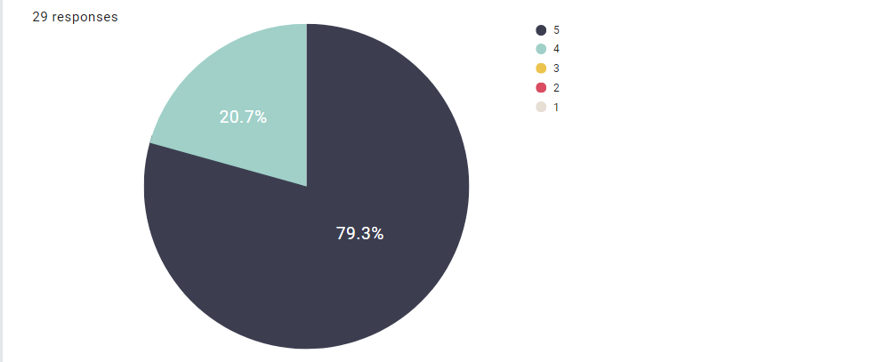

Figure 17

Audience approval of the sculpture
The graph shown in Figure 17 indicates that the majority of respondents were impressed by the junk sculpture. Twenty-three (23) of the twenty-nine (29) respondents who selected the scale of five gave it a positive rating of 79.3%, which is equivalent to the affirmative response "extremely astonished" and the maximum degree of satisfaction. While six respondents offered four-point ratings, with an average satisfaction rate of 20.7%, they indicated that the sculpture might use improvement.
      - Tungkol sa iyong tugon sa naunang tanong, mangyaring magbigay ng higit pang mga detalye tungkol sa kaganapan o pangyayari na humantong sa iyong nararamdaman o nakukuha sa sculpture.

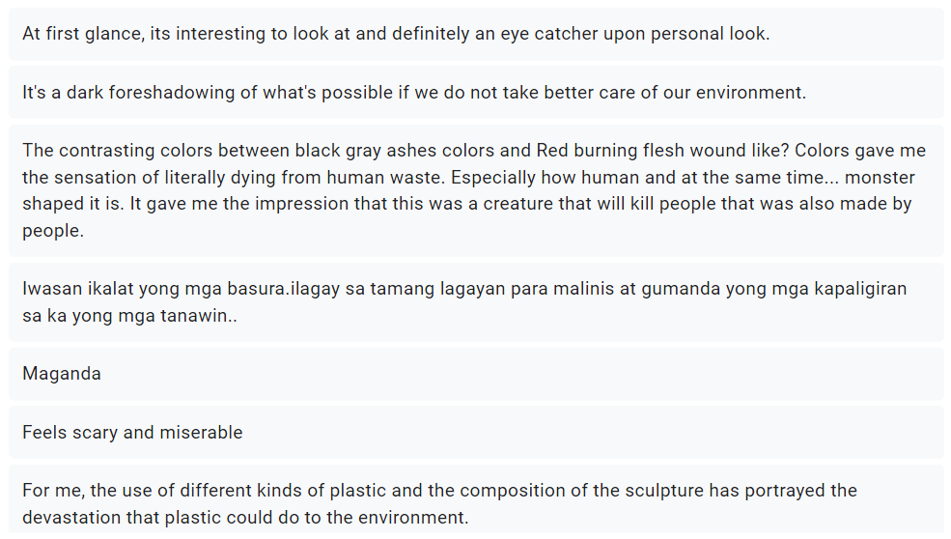

Figure 18.1

Audience feedback about the sculpture
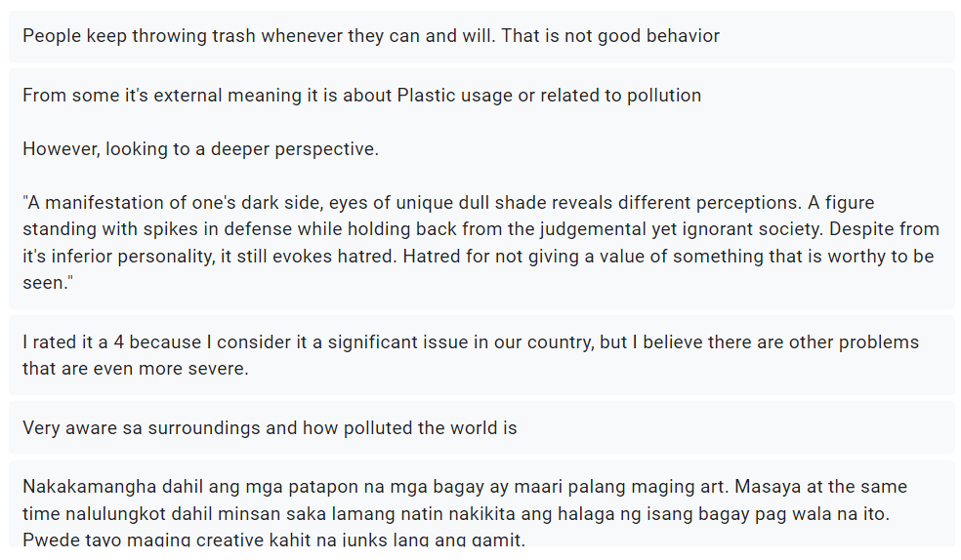

Figure 18.2

Audience feedback about the sculpture
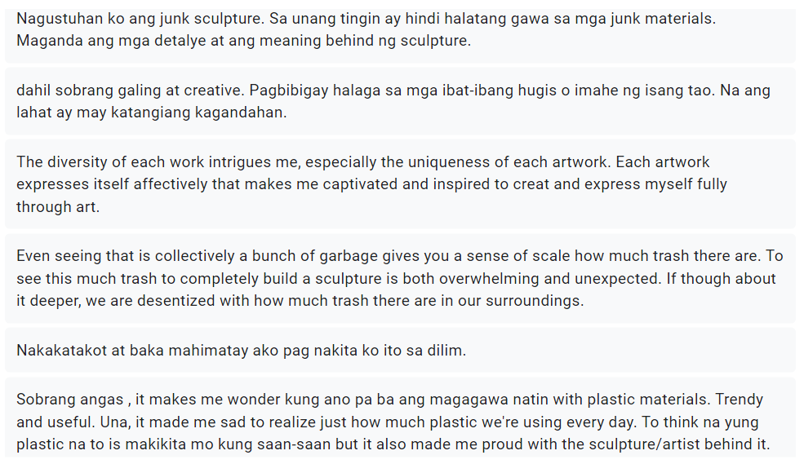

Figure 18.3

Audience feedback about the sculpture

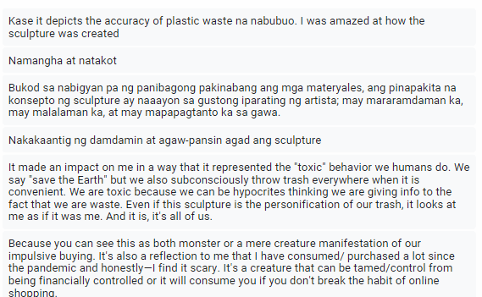

Figure 18.4

Audience feedback about the sculpture


Figure 18.5

Audience feedback about the sculpture

According to the responses provided by the respondents, as shown in Figures 18.1 to 18.5, the respondents' most frequent responses when they saw the trash sculpture were pollution, environmental waste, and how frightening it looked. However, a few of the comments provide a better understanding of the sculpture, particularly in terms of how they link the sculpture's features to its significance. Some fit with the image I intend to convey, while others offer a fresh viewpoint on the sculpture. Additionally, several of the respondents made connections between the sculpture and their purchasing patterns, habits, and the state of our society, which is what the junk sculpture aims to accomplish.

      - Nakatulong ba sa iyo ang mga materyales ng iskultura na maunawaan ang kahulugan nito? Paano?
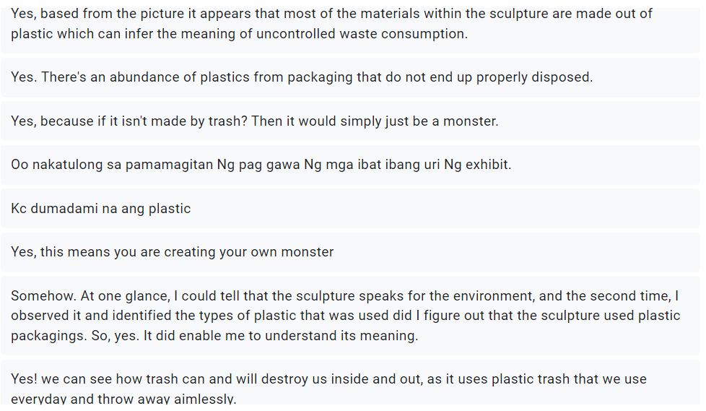

Figure 19.1

Audience feedback about the use of plastic
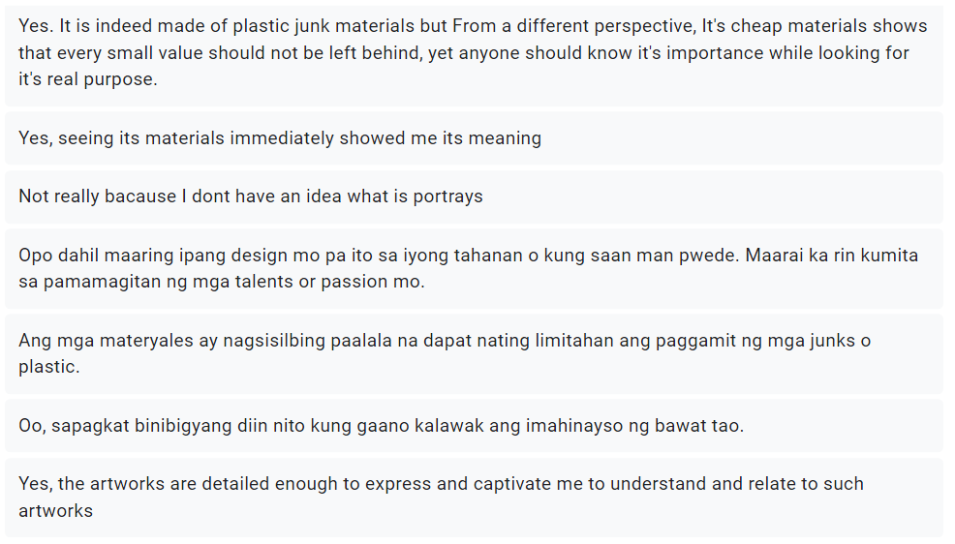

Figure 19.2

Audience feedback about the use of plastic

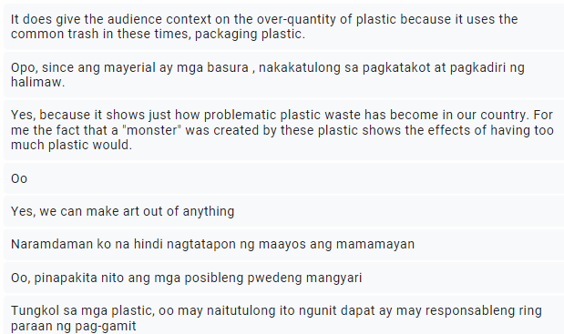

Figure 19.3

Audience feedback about the use of plastic
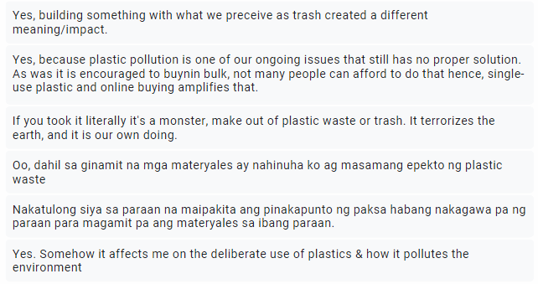

Figure 19.4

Audience feedback about the use of plastic

Most respondents indicated that the materials used to create the trash sculpture were able to assist them in comprehending the meaning of the junk sculpture, according to the responses that are shown in Figures 19.1 to 19.4. The respondents frequently responded that using plastic first conveys the message that it is for the environment. When the respondents looked at the sculpture a second time and recognized the different kinds of plastic that were employed, they realized that the artwork had plastic packaging. The answer stated that since packaging plastic is a typical component of today's waste, using plastic does provide the audience with context regarding the excessive consumption of plastic. There are responses that are compatible with what I aim to convey by incorporating plastic packaging, which refers to the "monster" generated by these plastics and highlights the impacts of having excessive plastic in our environment. Some of the responders referred to this as well as the issue of how economic conditions influence plastic pollution.

      - Ano ang mga kasalukuyang mga problema na naganap sa iyo o sa iyong kapaligiran pagkatapos suriin ang junk sculpture's pangkalahatang disenyo at kung anong mga aspeto ng sculpture ang nagdulot ng mga isyung ito pumasok sa isip mo?
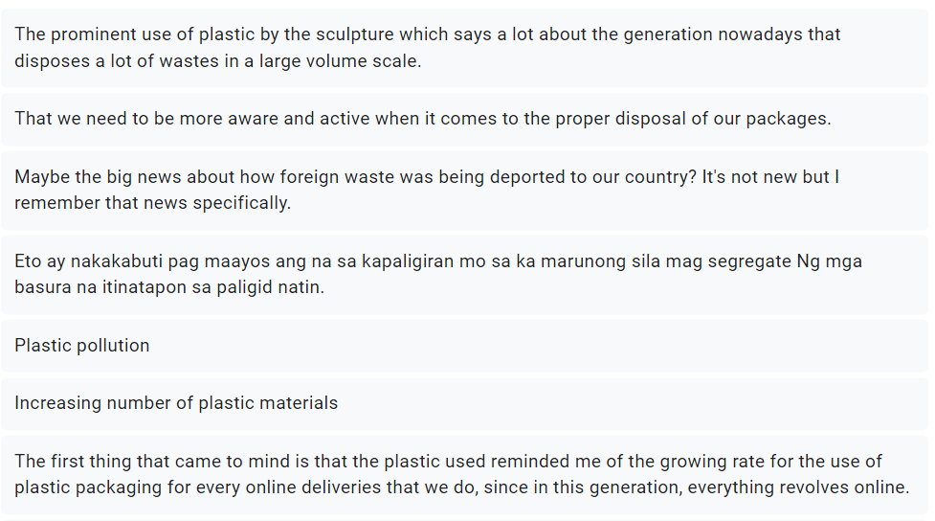

Figure 20.1

The sculpture's relevance to current events
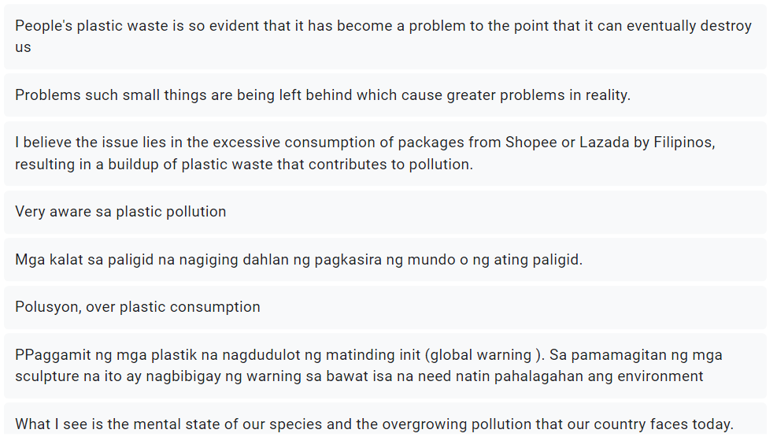

Figure 20.2

The sculpture's relevance to current events
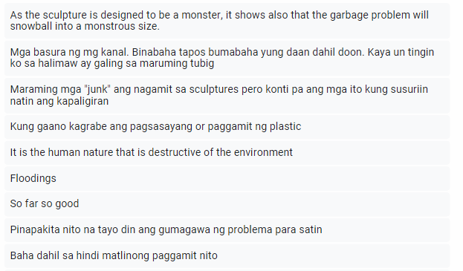

Figure 20.3

The sculpture's relevance to current events
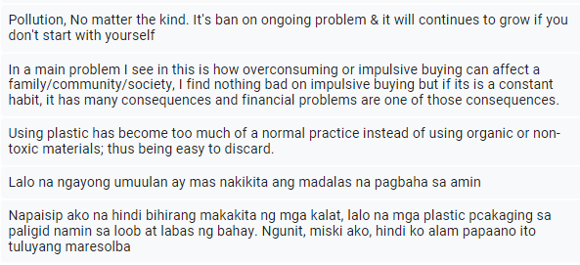

Figure 20.4

The sculpture's relevance to current events

In accordance with the responses provided by the respondents in Figures 20.1 to 20.4, the following present-day issues crossed the respondents' minds after viewing the junk sculpture: increasing plastic pollution, inappropriate plastic disposal, overconsumption, impulsive shopping, natural catastrophes, and man-made disasters. All of the aforementioned problems are associated with the particular issue I want to talk about. The responses of the respondents indicate that the junk sculpture was successful in addressing the issue of the negative environmental effects of plastic packaging. Additionally, the garbage sculptures provided a new way for the audience to become aware of other environmental issues that the nation is dealing with, particularly the interconnected impact that plastic has on the ecosystem.

      - Naniniwala ka bang naimpluwensyahan ng inisyatiba na ito ang iyong mga pananaw sa pagkonsumo at e-commerce?
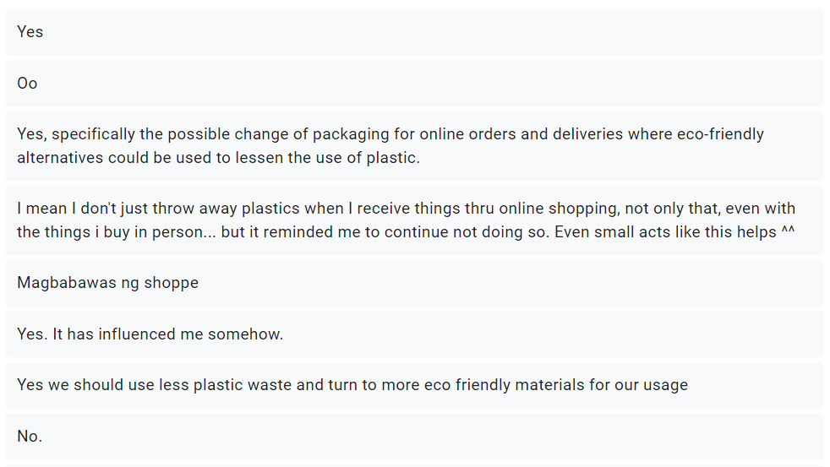

Figure 21.1

The project's influence on the perspectives of viewers
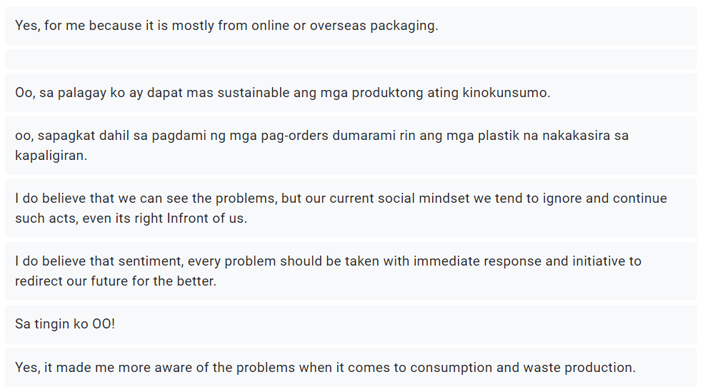

Figure 21.2

The project's influence on the perspectives of viewers

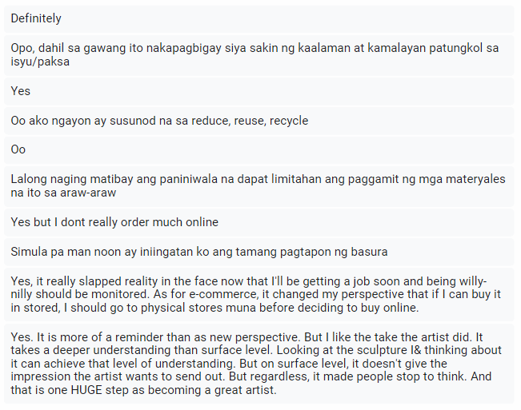

Figure 21.3

The project's influence on the perspectives of viewers

Based on the responses in Figures 21.1 to 21.3, 93.3% of respondents changed their perspective and mindset after seeing the junk sculpture. While another didn't react, and one respondent didn't change his view. The respondents whose perspectives have been altered state that they are working to replace plastic packaging with more sustainable or environmentally friendly options. However, two respondents expressed the opinion that reducing plastic use and online shopping usage was more important. Some respondents, however, focused more on the prevalent social attitude of disregard for the issue. There are also a number of respondents who plan to switch from online to in-person purchasing. One person said that it requires a deeper comprehension than the superficial level and serves more as a reminder than an alternative viewpoint. Achieving that degree of comprehension may be done by looking at the artwork and reflecting on it. However, the respondent claims that although it didn't initially convey the message I intended, it nonetheless caused others to pause and consider.

Conclusion
With its accessibility, affordability, and broad selection of products available with only a few clicks, e-commerce provides us with comfort and convenience. The responses of the respondents, however, indicate that more than half of consumers are unaware of the harmful impacts of plastic on the environment. In the initial interview, it was also shown that 80% of the respondents had never attempted recycling but would if their needs or capabilities were satisfied. As a result, I investigated the best approach to portray the increasing plastic waste problem and convey the issue to the target audience: the use of trash itself. Additionally, I use the information gathered from their responses about the materials I am going to utilize as well as how I will apply the plastic in junk sculptures. Since the objective is to increase consumer awareness of the environmental impact of plastic in the environment, the participants claim that junk art aids in communicating the problem of growing plastic waste pollution. So, using various plastic materials found in e-commerce, I created a junk creature that illustrates the environmental impact of plastic packaging and aids in increasing consumer awareness of the effects of plastic waste on the environment.

Recommendations

Research Topic
The technique and approach to the issue of this study still have room for improvement. First, I made the decision to do both online and in-person interviews. However, I discovered that most respondents were uncomfortable with either video calls or live interviews, so I advised that respondents' comfort and anonymity be given priority before conducting either type of interview. Finding a greater number of individuals who are willing to participate in an in-person interview, in contrast, is significantly better since it elicits in-depth data regarding their feelings and actions toward a certain issue.

Creative Process
Regarding the quantity of outputs, the production process, and the budget, the procedure of making the litter monster may be enhanced. Firstly, be realistic while deciding on your creative output because the work you want to produce may not be possible given your constraints, such as time. In addition, there is just one monster I created because I only have money for one mannequin. Furthermore, since I only utilize a small number of plastics and can only use things connected to plastic, the creature can still be enhanced if I collect a significant amount of plastic. In addition to the materials, I was able to identify just five plastic packaging colors: white, orange, blue (which is more inclined toward dark blue), black (which is frequently used by different merchants), and just one red plastic packaging. Furthermore, I am still trying to figure out how to make textures without using a heat gun because they are vulnerable to fire. I was only able to use it on a portion of the monster, though. Furthermore, since plastic has just a glossy texture, experimenting with other materials to give it other textures, such as Scotch-brite, a nail sander, and sandpaper, results in a variety of holes and a gritty texture. Finally, according to the Gantt chart and budget method may significantly improve my efficiency while producing the output, particularly if you are producing trash, recycled, and life-size output. To effectively convey the issue in an approach that the intended audience can understand, future researchers will need to refer to these suggestions.

References

B, K., & L, B. (2019, June 26). WHO ARE THE PHILIPPINES' ONLINE SHOPPERS?. Philippines’ eCommerce Shoppers at a Glance. https://janio.asia/articles/who-are-philippines-online-shoppers/
Calma, J. (2019, December 26). Free returns come with an environmental cost. The Verge.
www.theverge.com/2019/12/26/21031855/free-returns-environmental-cost-holiday-online-shopping-amazon
Cheah, L., & Huang, Q. (2022). Comparative Carbon Footprint. 593.
Chua, J. (2020, December 11). Responsible e-shopping in the time of COVID-19. GreenPeace.
https://www.greenpeace.org/southeastasia/story/44250/responsible-e-shopping-in-the-time-of-covid-19/
Dela Peña, K. (2021, October 15). Online shopping rise brings phenomenal volume of plastic wastes. Inquirer.
https://newsinfo.inquirer.net/1502399/online-shopping-rise-brings-phenomenal-volume-of-plastic-wastes
Igini, M. (2021, December 17). The Truth About Online Shopping and its Environmental Impact.
https://earth.org/online-shopping-and-its-environmental-impact/
International Trade Administration. (2021, September 11). eCommerce. Philippines - Country
Commercial Guide. https://www.trade.gov/country-commercial-guides/philippines-ecommerce
Kosuth, J. (1969). The Function of Art. Art After Philosophy, 18.
Llemit, K. A. (2021, July 8). New study shows how pandemic affects Filipino shopping habits.
https://www.philstar.com/lifestyle/shopping-guide/2021/07/08/2110815/new-study-shows-how-pandemic-affects-filipino-shopping-habits
Lokal. (2022, June). Why is E-commerce Booming in the Philippines? Agency Lokal.
https://www.agencylokal.ph/why-is-e-commerce-booming-in-the-philippines
Masigan, A. (2020, August 02). Business World. The state of e-commerce in the Philippines.
https://www.bworldonline.com/editors-picks/2020/08/02/308793/the-state-of-e-commerce-in-the-philippines/
Mullennix, B. (2022). The Beginner’s Guide To Conceptual Art: What’s The Big Deal? Artistry Found.
https://artistryfound.com/the-beginners-guide-to-conceptual-art/
Rhodes, E. P. (2022, April 1). The Origins of Trash Art. The Outer Realm.
https://www.theouterrealm.io/blog/the-origins-of-trash-art
Whiteley, G. (2010). Junk Art and the Politics of Trash. Bloomsbury Publishing.
youmatter. (2019, 03 January). Responsible consumption: definition and examples.
https://youmatter.world/en/definition/definitions-responsible-consumption-examples/

Appendices
This section's contents are made up of the materials generated during the whole research process, and they serve as legal proof of my efforts. The images and papers in this area show everything from the sources used to create the thesis manuscript to the production materials and design process documentation for the Asia Pacific College-mandated academic compliance.

Appendix A
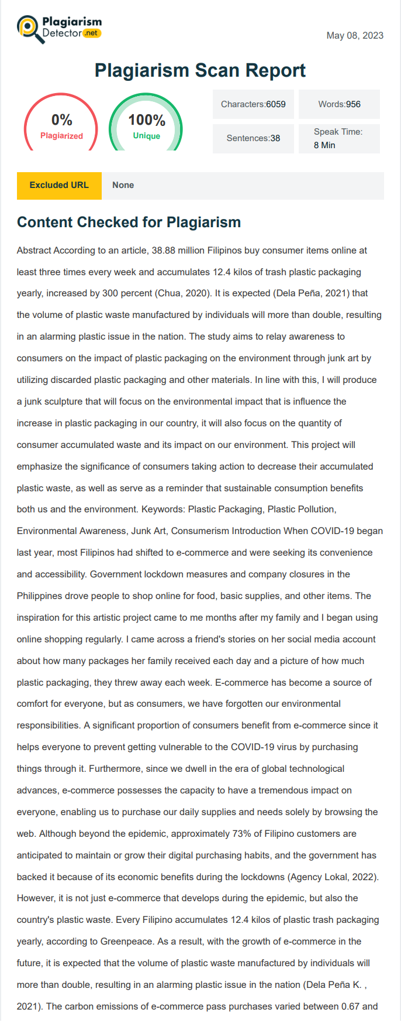
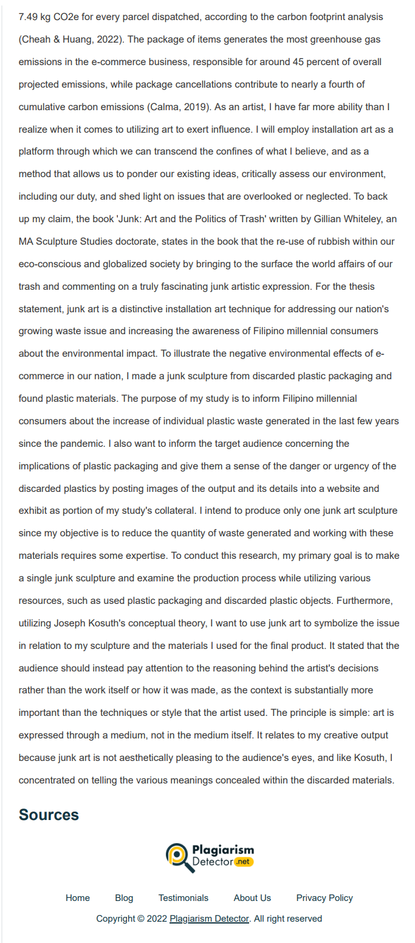
Plagiarism Detector Test Results

Appendix B
Visual References and Studies
Production Assets:
Sketching for the Junk Creature

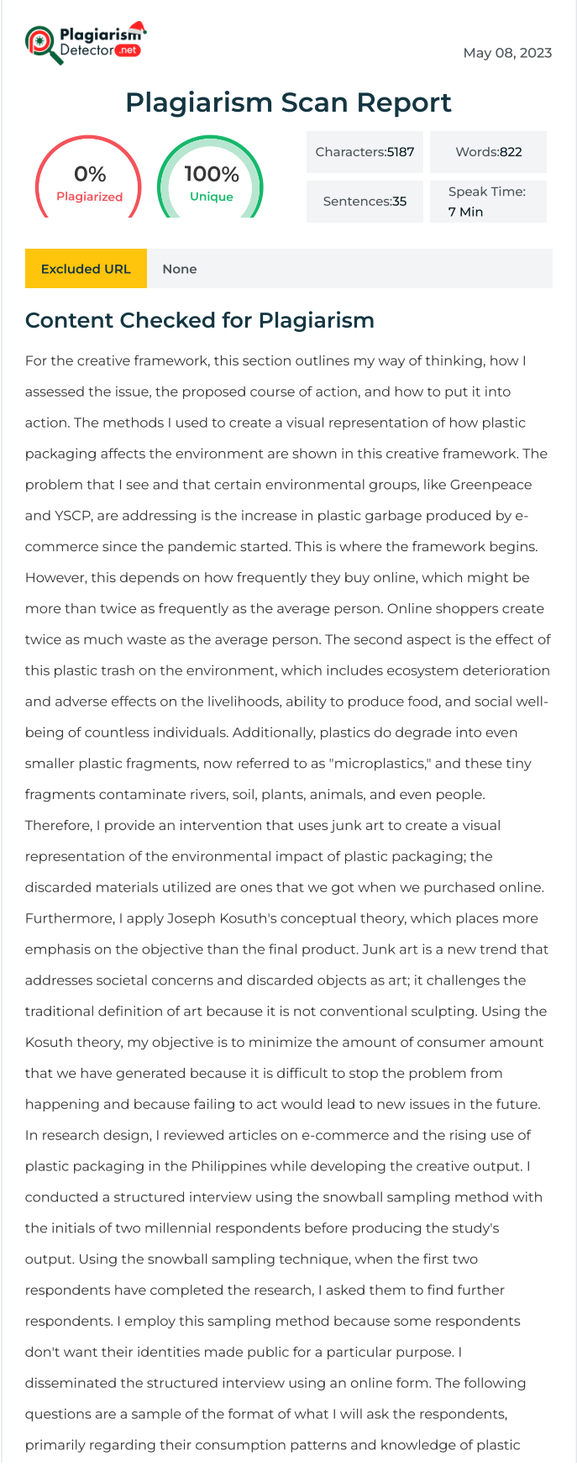
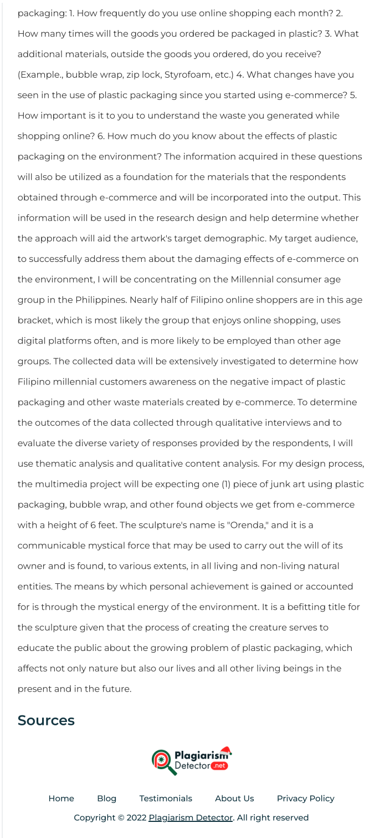

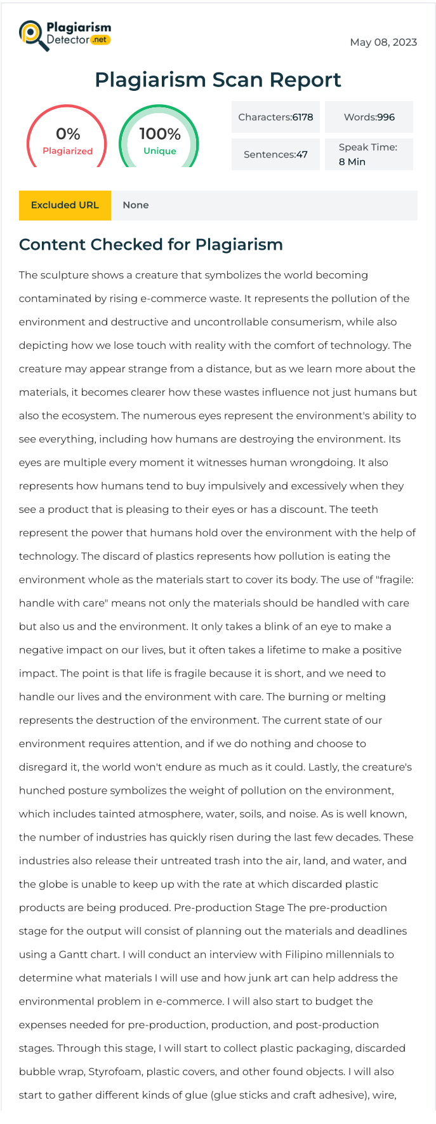
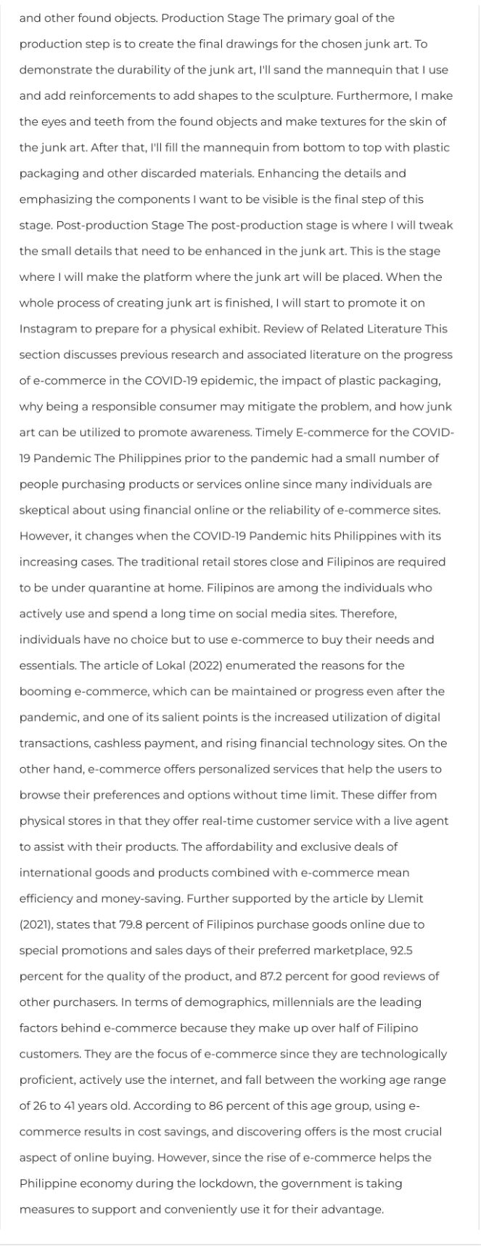


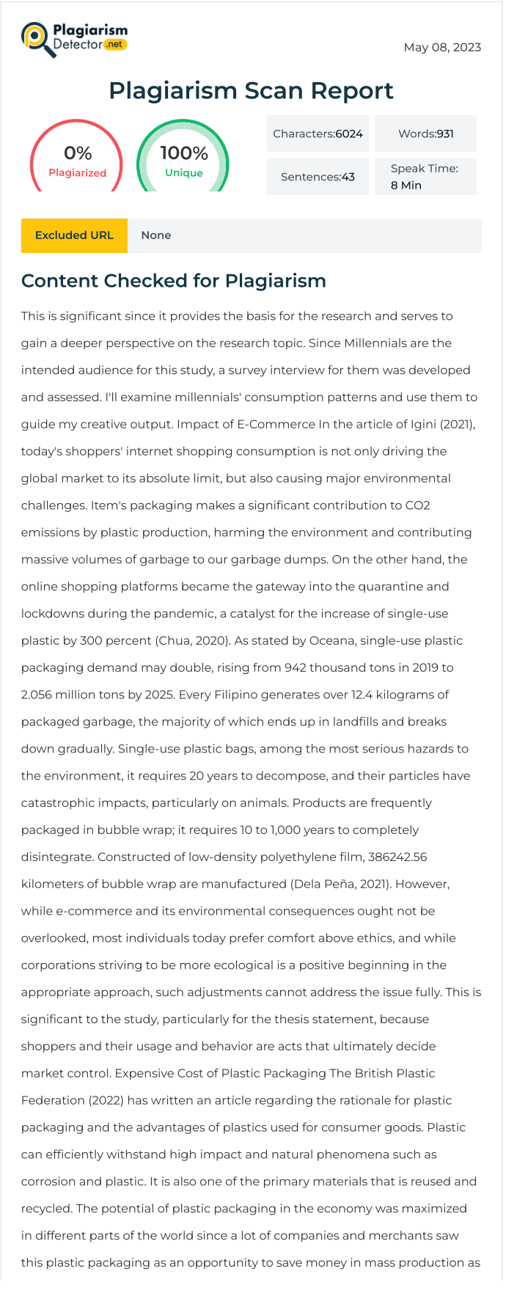
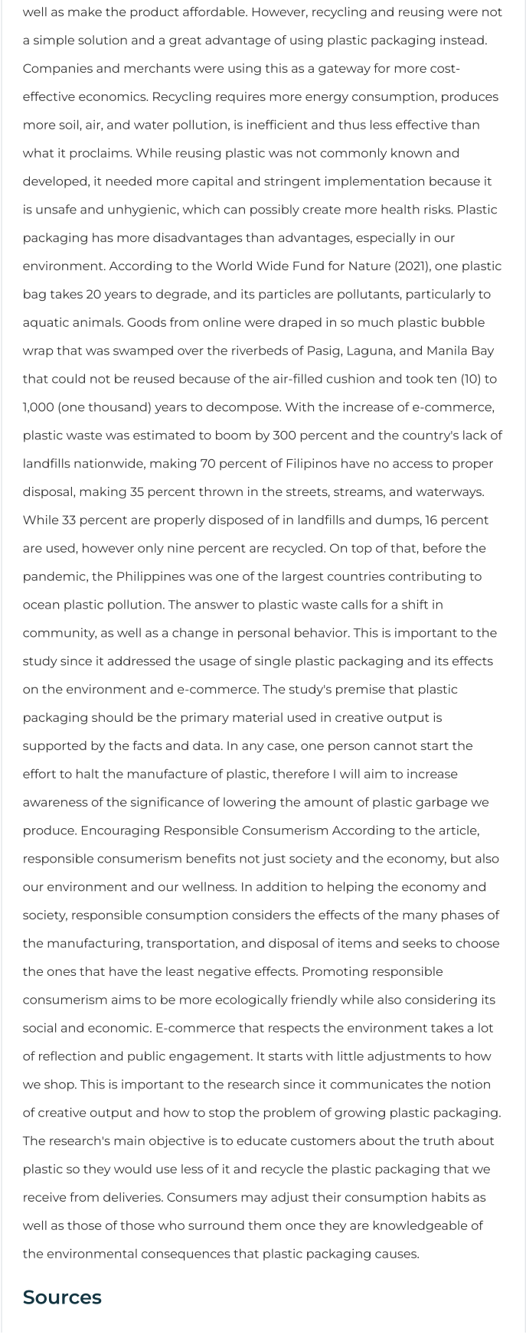
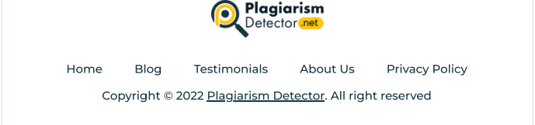

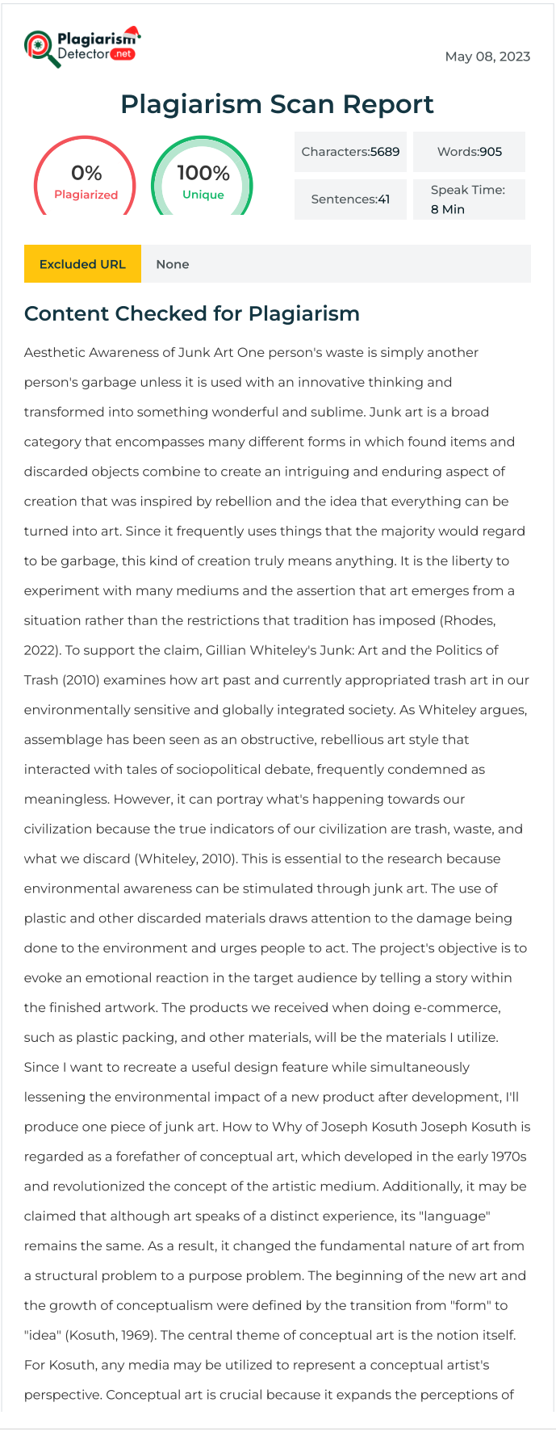
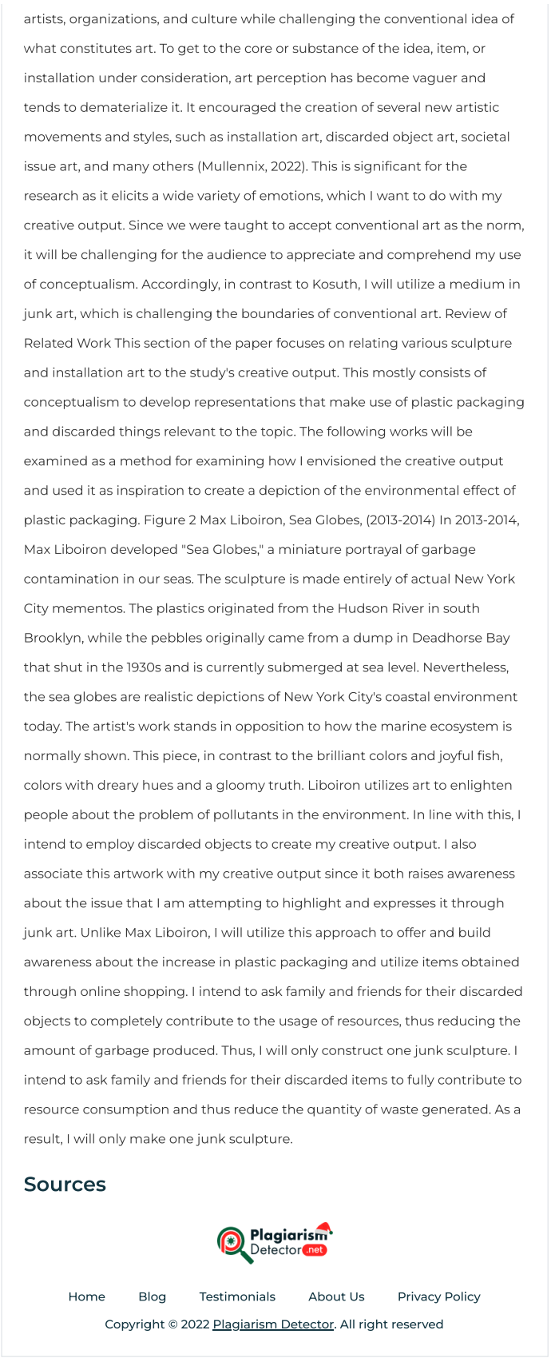

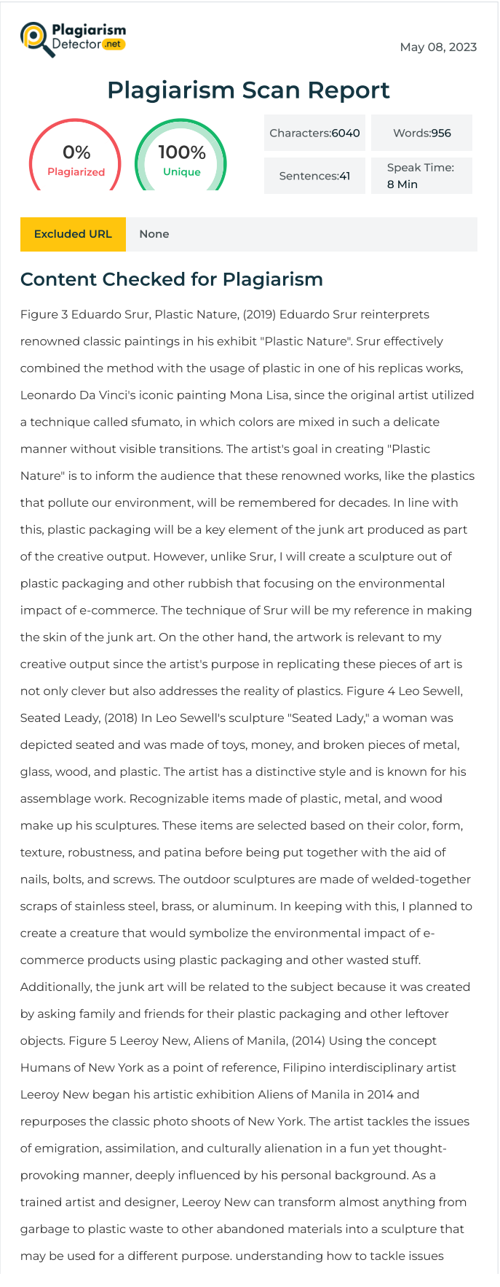
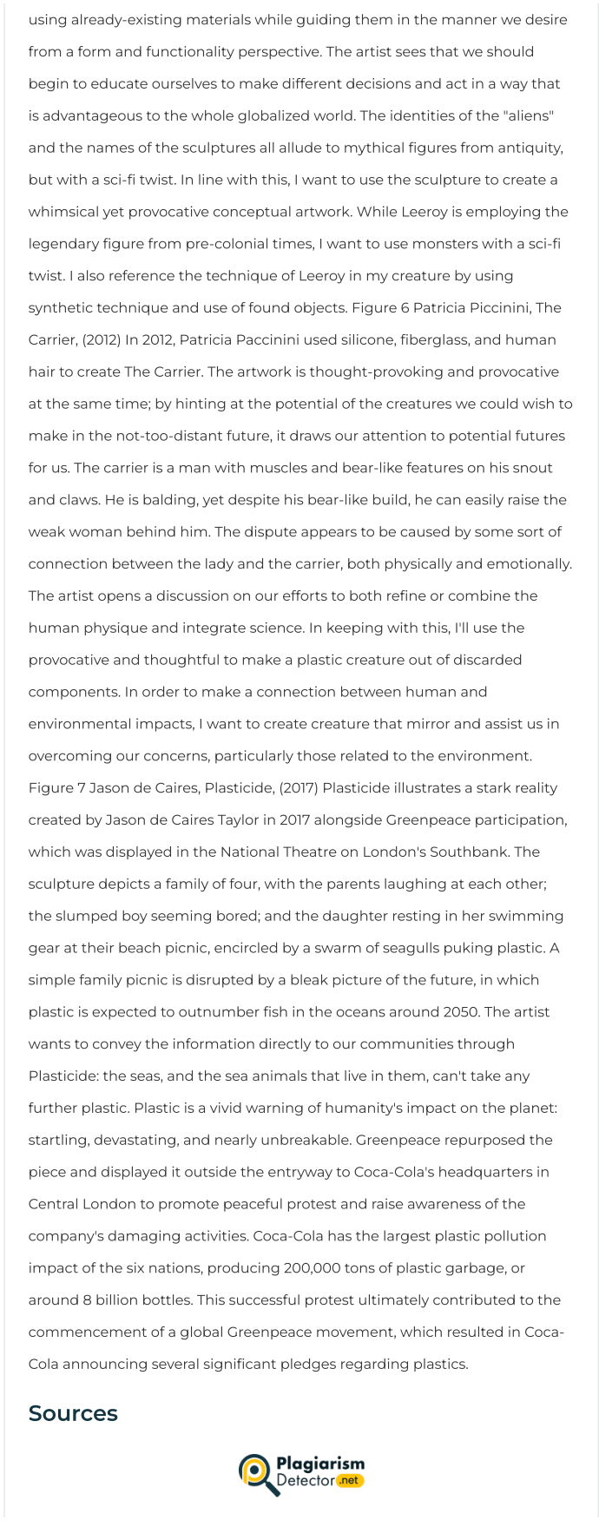


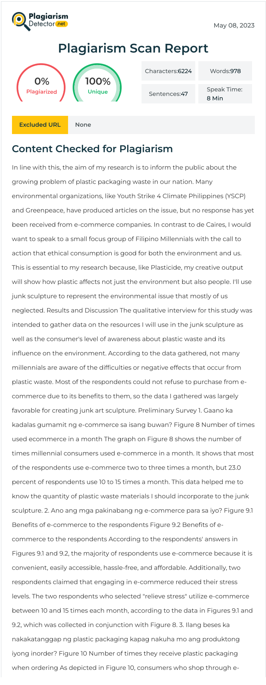
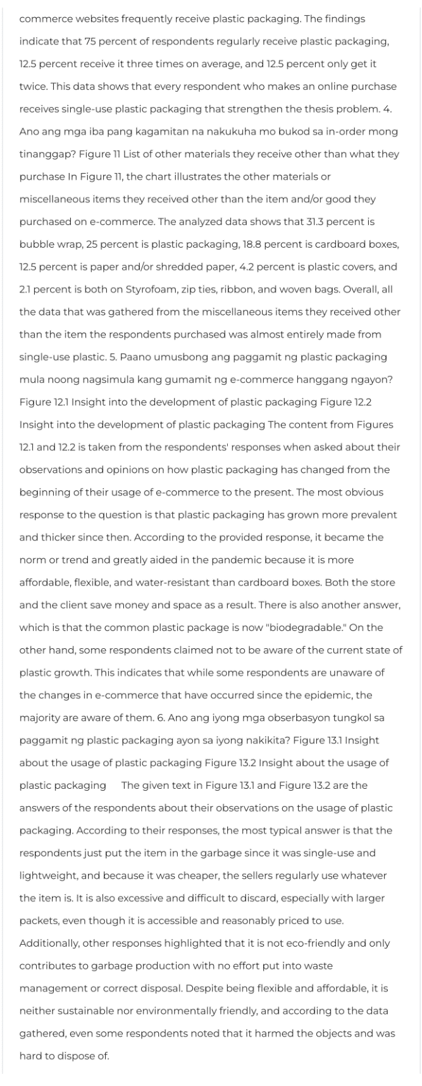


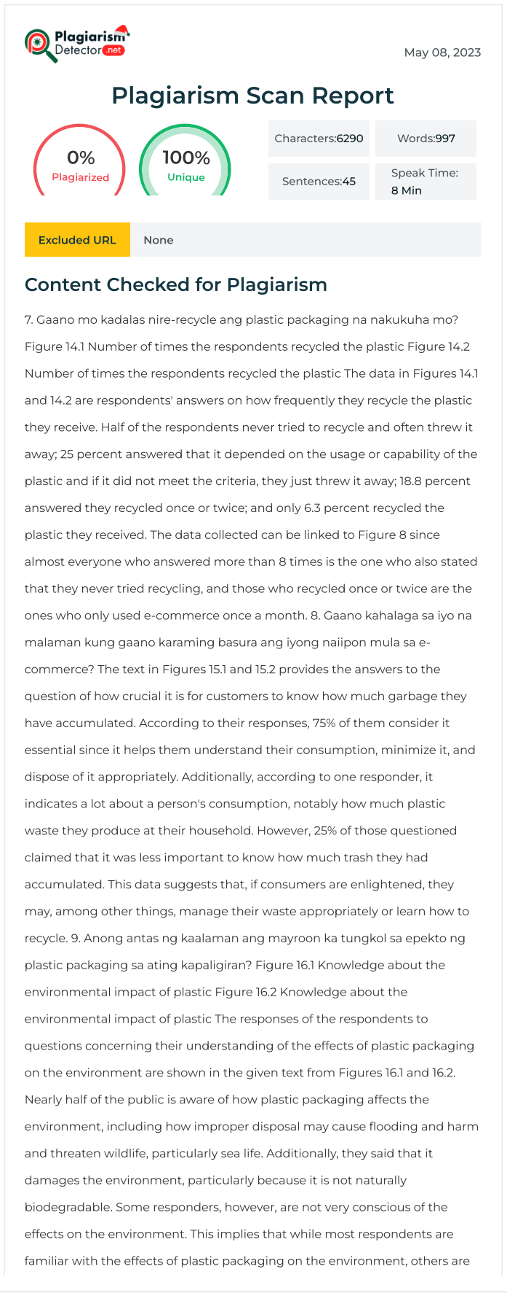
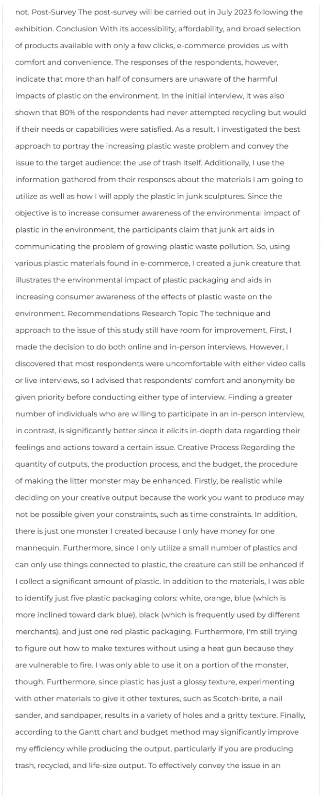
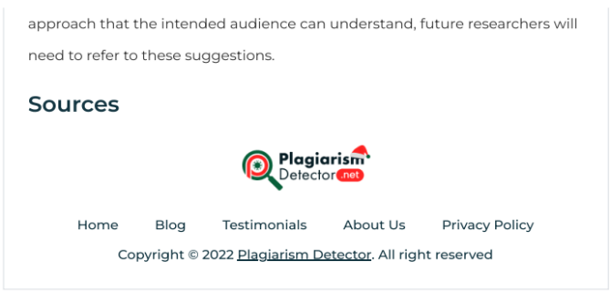

MMAPRO1 GANTT CHART
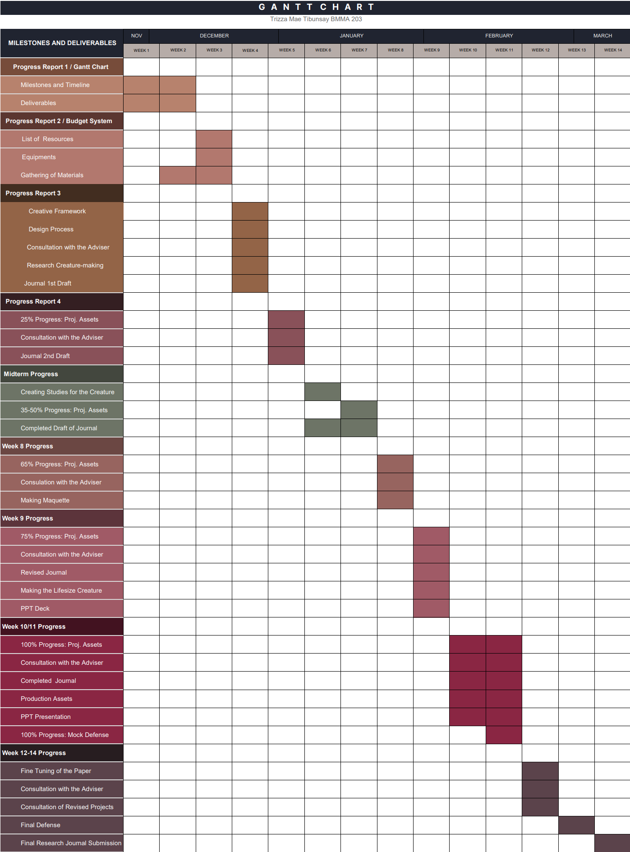

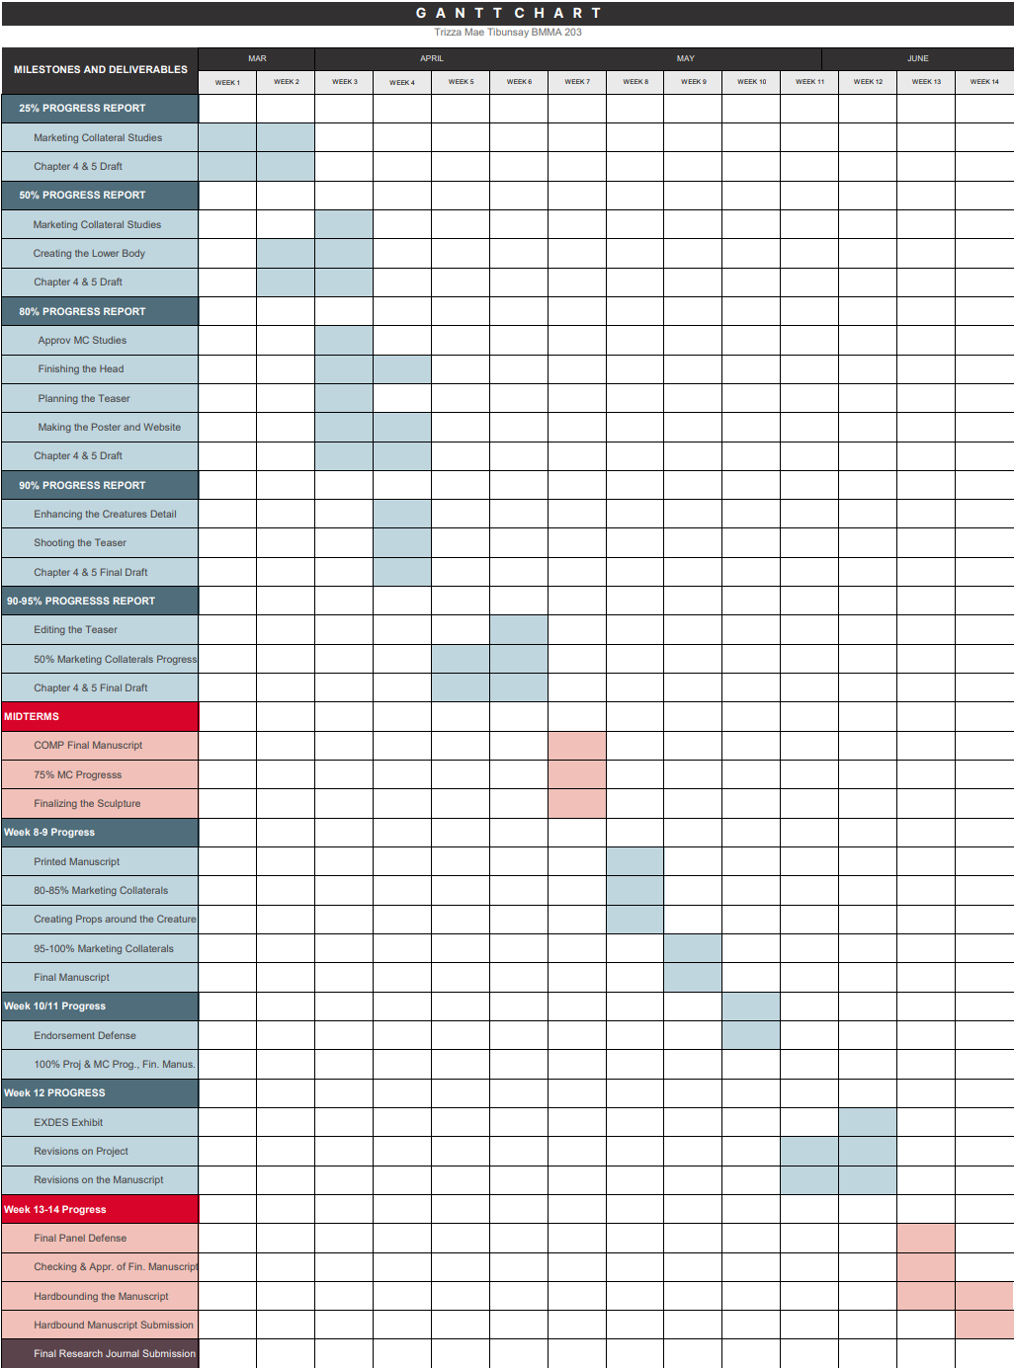
MMAPRO2 GANTT CHART

Appendix B
Visual References and Studies

Production Assets:
Sketching for the Junk Creature
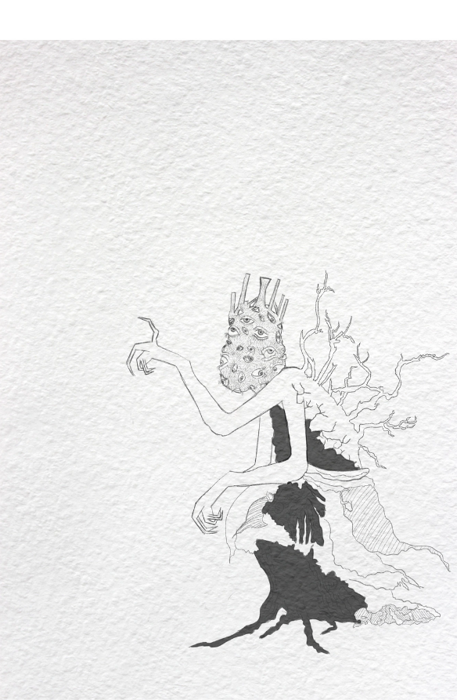
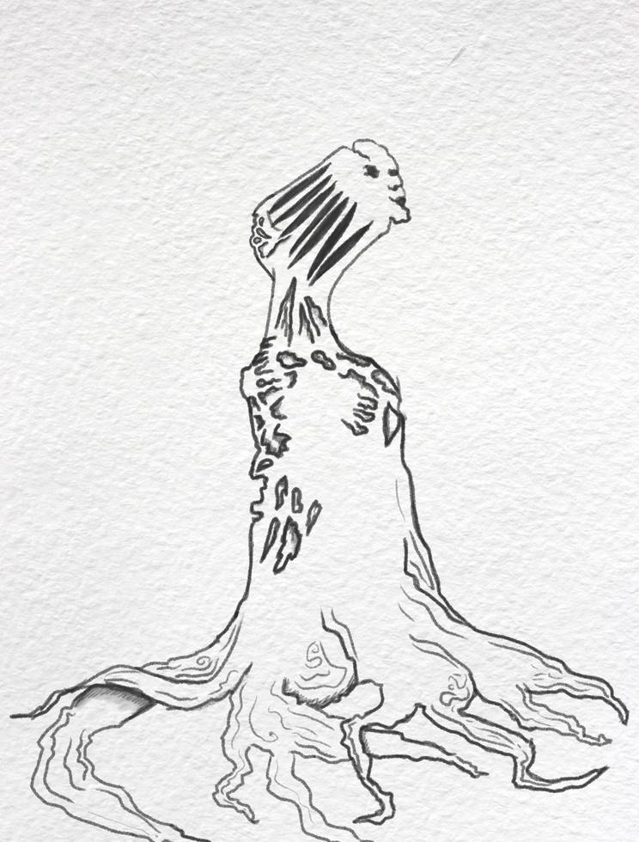
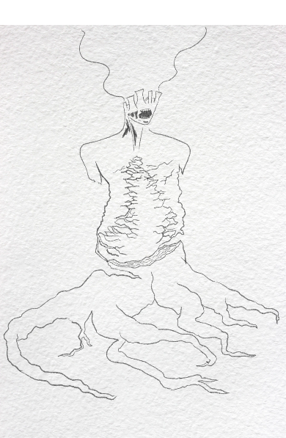
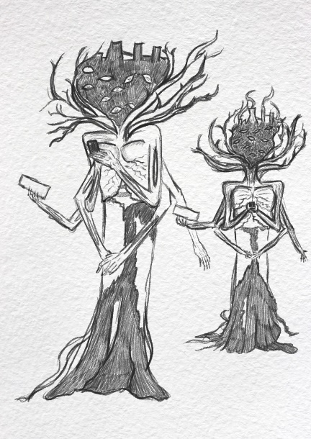
For the Marquette

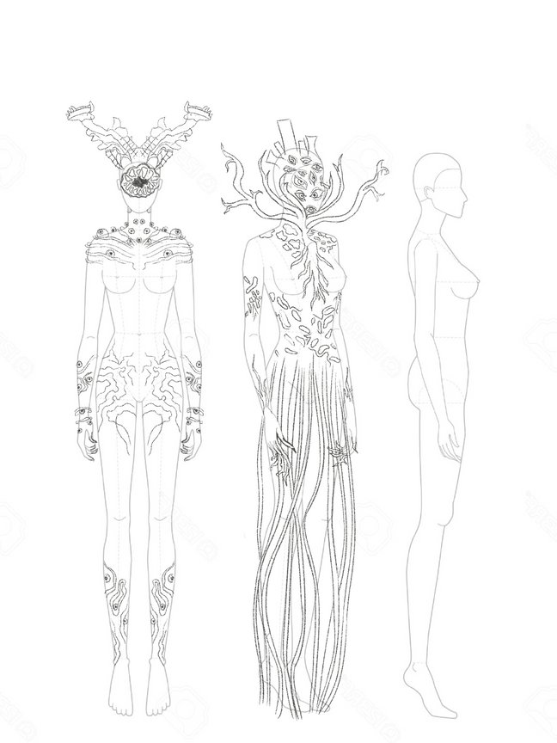
Second Studies: Final Studies:
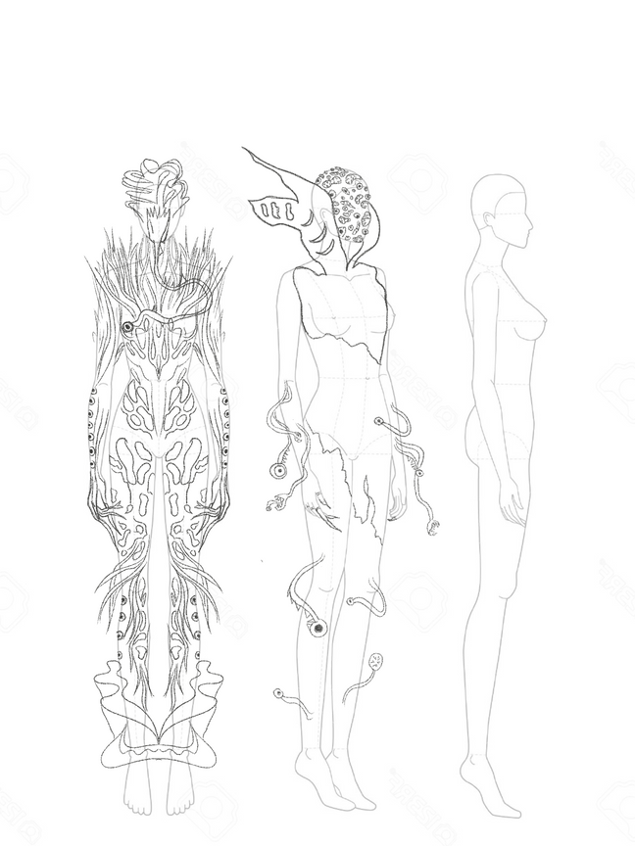
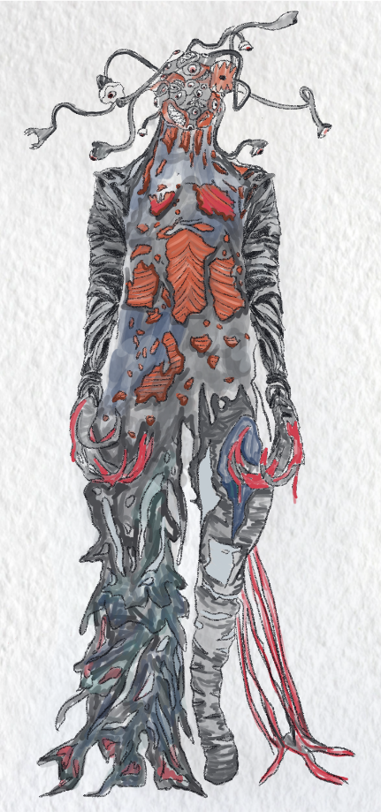
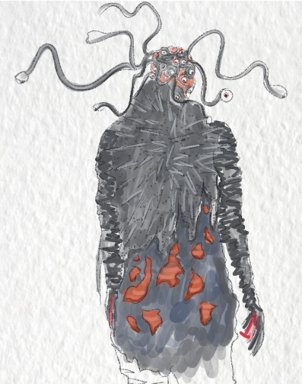

Appendix C
Project Production Documents

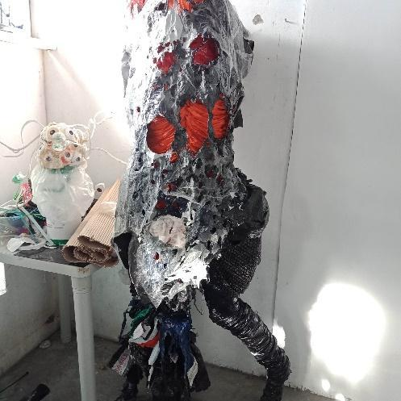

Appendix D
Website and Online Collaterals
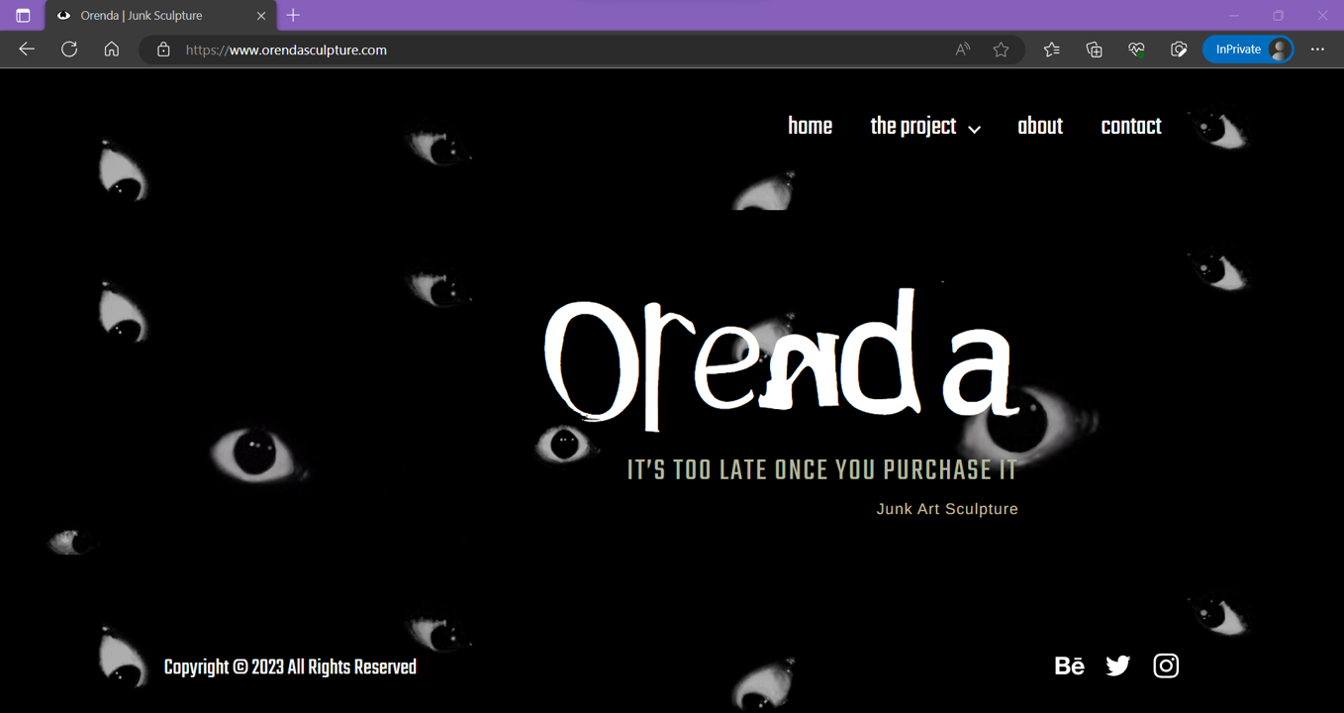

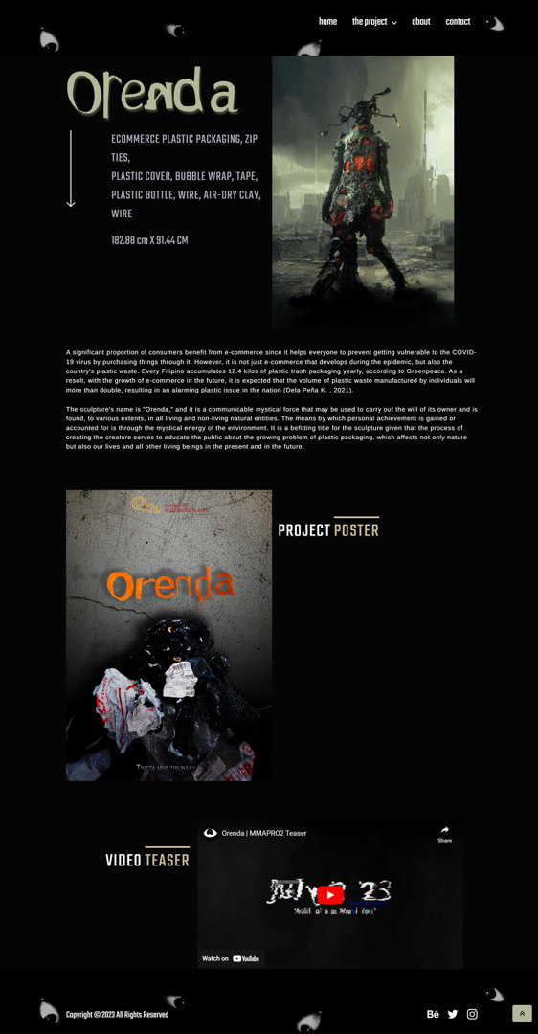

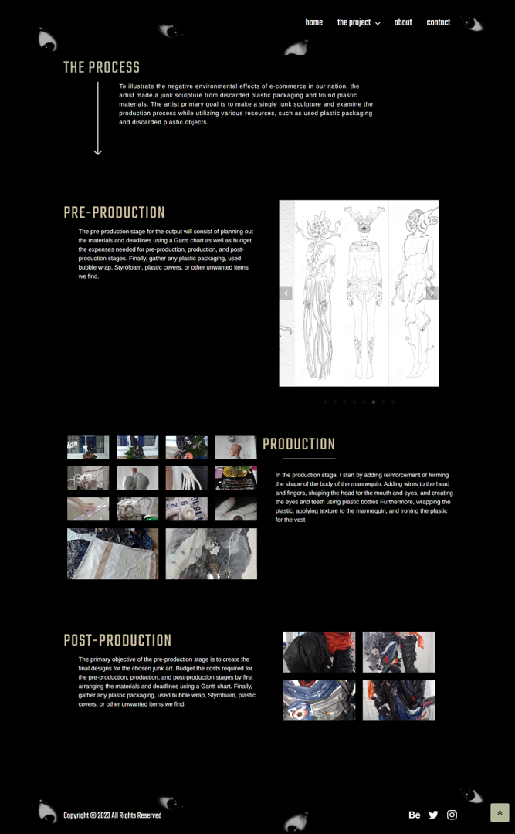

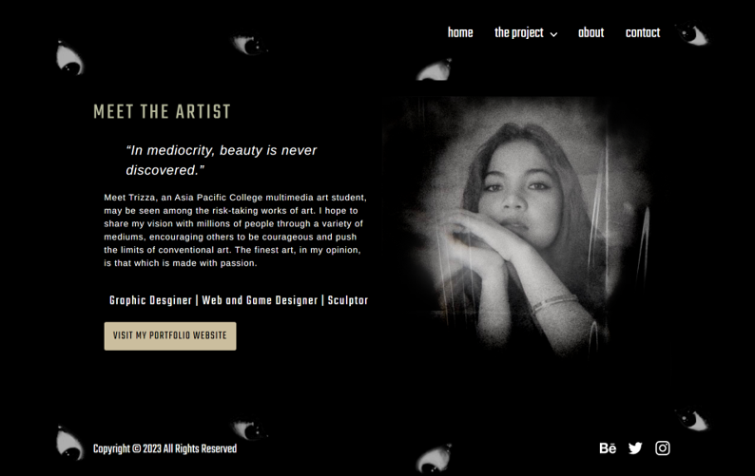

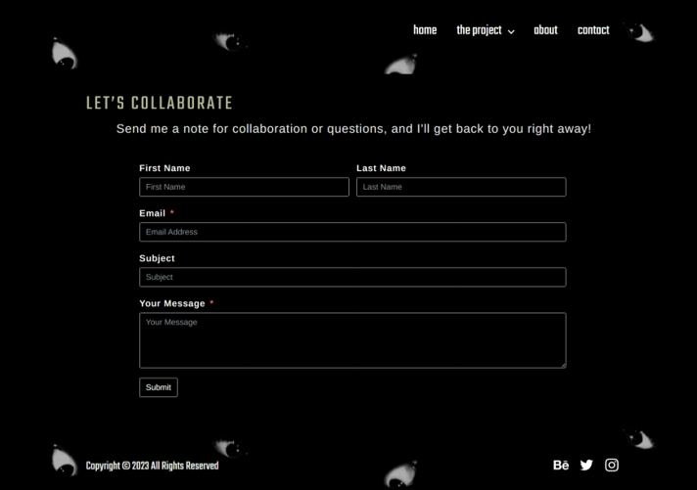

Appendix E

Miscellaneous Documents
Preliminary Assessment Interview
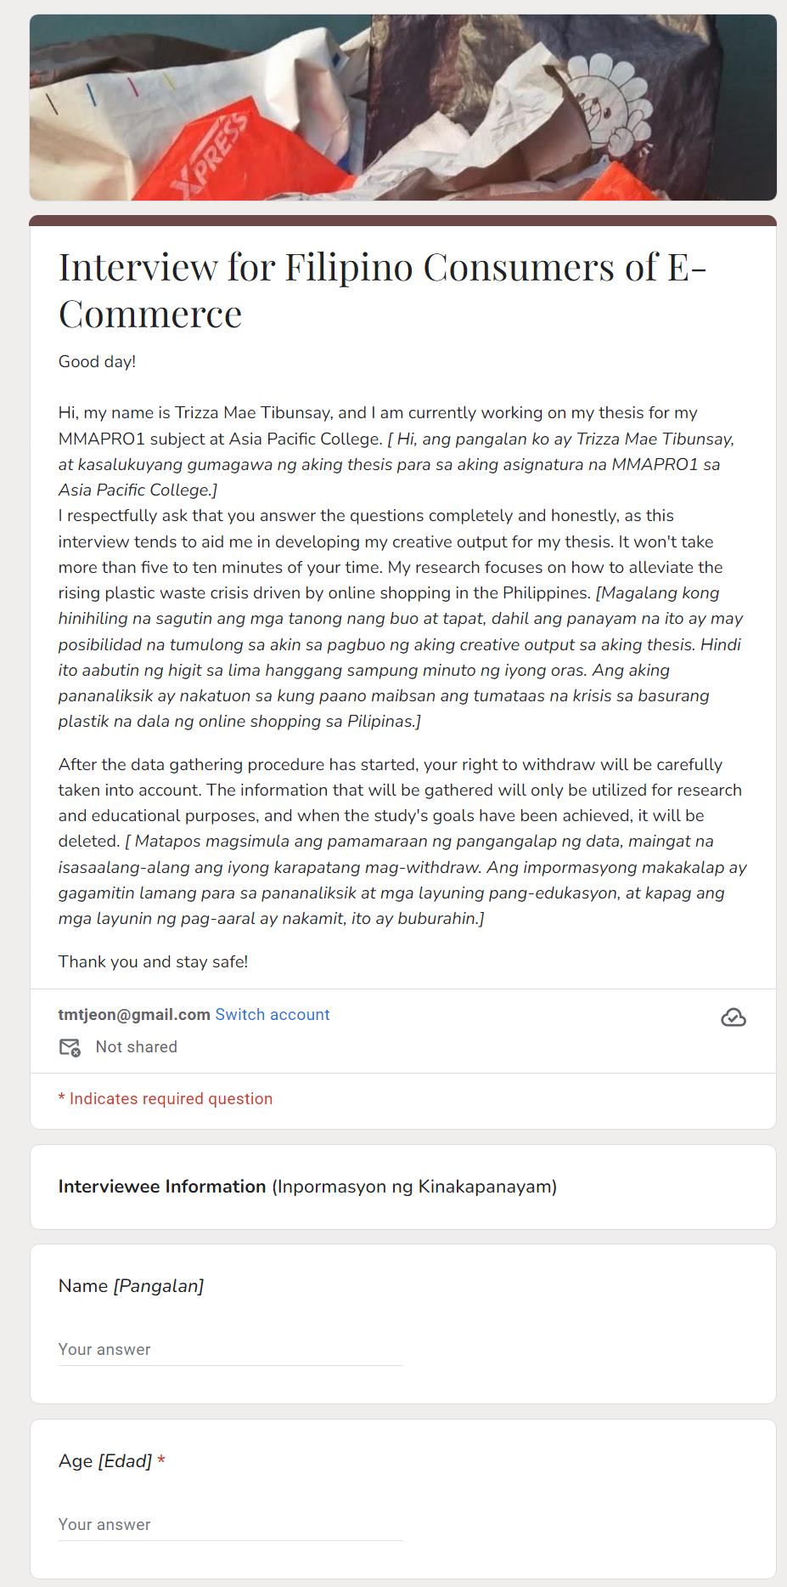

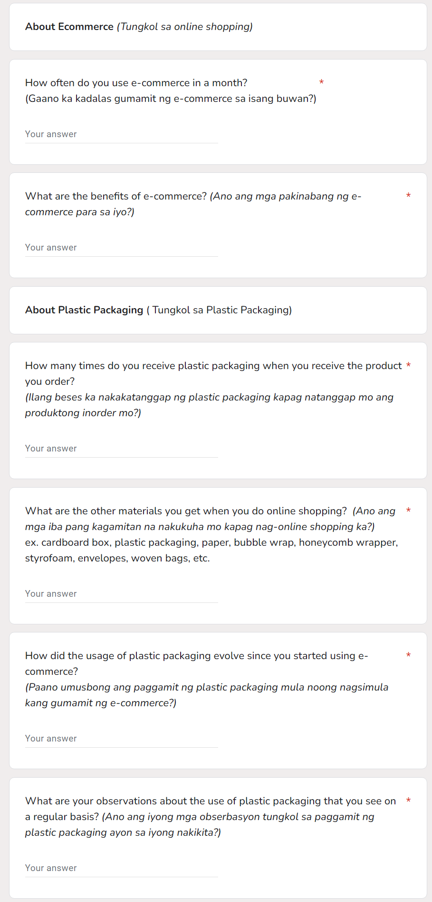

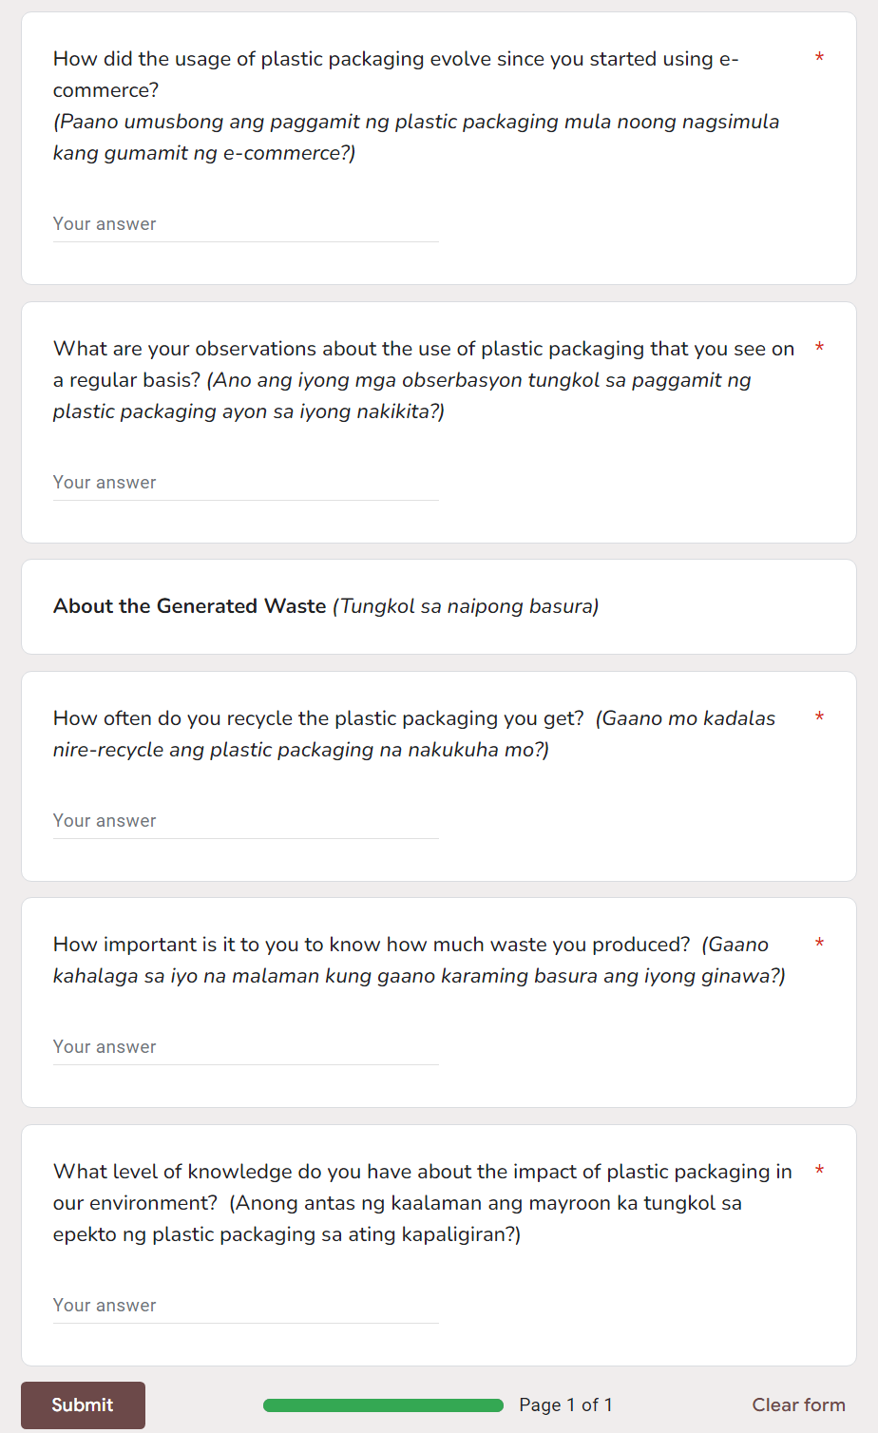

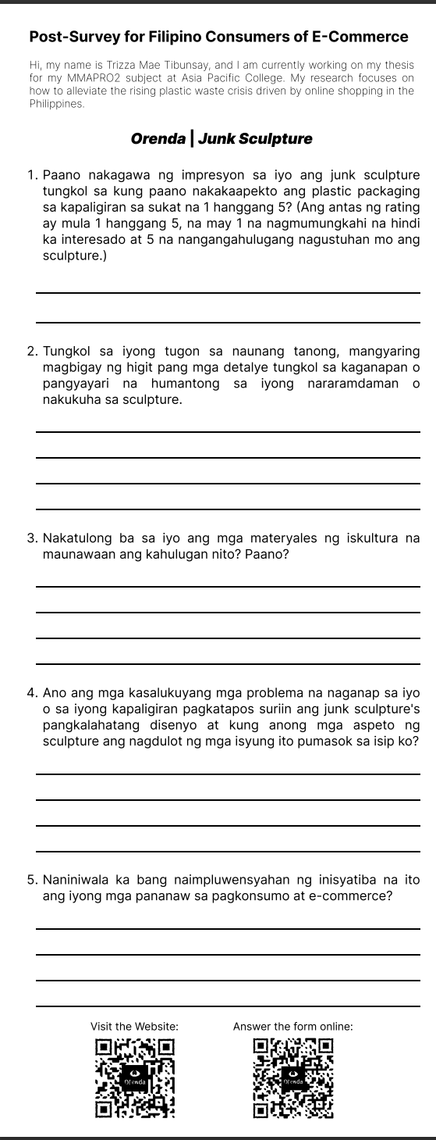
Post-survey Questionnaire

